



# 2025-2029 ANALYSIS OF IMPEDIMENTS TO FAIR HOUSING CHOICE

THIS PAGE INTENTIONALLY LEFT BLANK

## CONTENTS

INTRODUCTION 6

Fair Housing Planning 6

Definitions 8

Data Sources 10

COMMUNITY PARTICIPATION PROCESS 15

Community Engagement Overview 15

Community Meetings 15

Stakeholder Interviews 17

Focus Groups 17

Community Survey 18

Pop-Up Events 19

Public Comment Period and Public Hearing 20

Publicity for Community Engagement Activities 20

COMMUNITY ENGAGEMENT RESULTS 21

Community Workshops, Focus Groups, and Stakeholder Interviews Results 21

Community Survey Results 25

SOCIOECONOMIC PROFILE 31

Demographic Profile 31

Racially and Ethnically Concentrated Areas of Poverty 38

Segregation and Integration 41

ACCESS TO OPPORTUNITY 49

Employment and Workforce Development 49

Education 60

Transportation 66

Low-Poverty Neighborhoods 72

Environmental Quality 73

Food 79

Healthcare 81

HOUSING PROFILE 84

Housing Supply Summary 86

Housing Costs and Affordability 94

Housing Needs 97

Homeownership and Lending 102

Mortgage Lending 105

Mortgage Denials 106

Zoning, Affordability, and Housing Choice 110

City of Fresno Zoning Ordinance Review 113

Impact of Zoning Provisions on Affordable Housing 117

PUBLICLY SUPPORTED HOUSING 124

Supply and Occupancy 126

Geography of Supported Housing 129

HOUSING FOR PEOPLE WITH DISABILITIES 130

Accessible Housing Supply and Affordability 131

Zoning and Accessibility 134

FAIR HOUSING ACTIVITIES 139

Fair Housing Resources 139

Fair Housing Complaints 140

Fair Housing Enforcement through Civil Litigation 146

PAST FAIR HOUSING GOALS AND RELATED ACTIVITIES 154

IDENTIFICATION OF IMPEDIMENTS 160

Impediment #1: Housing affordability and quality issues reduce housing choice 160

Impediment #2: Housing problems and limited access to homeownership disproportionately impact protected classes 161

Impediment #3: Protected classes are disproportionately impacted by barriers to employment, education, and housing choice 162

Impediment #4: Ongoing need for investment and expanded access to opportunity in areas of concentrated Poverty 163

Impediment #5: Fresno has insufficient accessible housing and supportive services for residents with disabilities 164

Impediment #6: Insufficient homeless resources disproportionately impact protected class groups 165

Impediment #7: Continued need for fair housing education 167

Impediment #8: Marketing and communications about planning processes, fair housing education, and housing resources may not adequately reach residents of protected classes 167

## INTRODUCTION

### Fair Housing Planning

Equal access to housing choice is crucial to America’s commitment to equality and opportunity for all. Title VIII of the United States Civil Rights Act of 1968, more commonly known as the Fair Housing Act, provides housing opportunity protection by prohibiting discrimination in the sale or rental of housing on the basis of race, color, religion, sex, and national origin. The Act was amended in 1988 to provide stiffer penalties, establish an administrative enforcement mechanism and to expand its coverage to prohibit discrimination on the basis of familial status and disability. The U.S. Department of Housing and Urban Development (HUD), specifically HUD’s Office of Fair Housing and Equal Opportunity (FHEO), is responsible for the administration and enforcement of the Fair Housing Act and other civil rights laws.

Provisions to affirmatively further fair housing (AFFH) are basic long-standing components of HUD’s housing and community development programs. The AFFH requirements are derived from Section 808(e)(5) of the Fair Housing Act which requires the Secretary of HUD to administer the Department’s housing and urban development programs in a manner to affirmatively further fair housing.1

Grantees, such as Fresno, that receive grant funds from HUD through its entitlement process satisfy this obligation by performing an “Analysis of Impediments to Fair Housing Choice” (AI). In an AI, grantees evaluate barriers to fair housing choice and develop and implement strategies and actions to overcome any identified impediments based on their individual histories, circumstances, and experiences. Through this process, local entitlement communities promote fair housing choices for all persons, including classes protected under the Fair Housing Act; provide opportunities for racially and ethnically inclusive patterns of housing occupancy; identify structural and systemic barriers to fair housing choice; and promote housing that is physically accessible and usable by persons with disabilities.

HUD will presume that the grantee is meeting its obligation and certification to affirmatively further fair housing by taking actions that address the impediments, including:

1 U.S. Department of Housing and Urban Development Office of Fair Housing and Equal Opportunity. Fair Housing Planning Guide: Volume 1 (Chapter 1: Fair Housing Planning Historical Overview, Page 13).

March 1996.

* Analyzing and eliminating housing discrimination within the jurisdiction;
* Promoting fair housing choice for all persons;
* Providing opportunities for racially and ethnically inclusive patterns of housing occupancy;
* Promoting housing that is physically accessible to all persons to include those persons with disabilities; and
* Fostering compliance with the nondiscrimination provisions of the Fair Housing Act.

Through its Community Planning and Development (CPD) programs, HUD’s goal is to expand mobility and widen a person’s freedom of choice. The Department also requires Community Development Block Grant (CDBG) program grantees to document AFFH actions in the Consolidated Annual Performance Evaluation Report (or CAPER), which is an annual performance report submitted to HUD.

In 2015, HUD published a final rule on Affirmatively Furthering Fair Housing, which outlined procedures that grantees and public housing authorities who participate in HUD programs must take to promote access to fair housing and equal opportunity. This rule stipulated that grantees and housing authorities take meaningful actions to overcome patterns of segregation and foster inclusive communities free from barriers that restrict access to opportunity based on protected class characteristics. Under this new regulation, grantees were required to:

* Address disparities in housing need;
* Replace segregated living patterns with integrated and balanced living patterns;
* Transform racially and ethnically concentrated areas of poverty into areas of opportunity; and
* Foster and maintain compliance with civil rights and fair housing laws.

To assist grantees and housing authorities in affirmatively furthering fair housing, HUD provided publicly available data, maps, and an assessment tool to use to evaluate the state of fair housing within their communities and set locally determined priorities and goals. HUD’s final rule mandated that, beginning in 2017, most grantees would use the new tool to prepare and submit to HUD an Assessment of Fair Housing; however, a 2018 HUD notice withdrew the requirement to prepare such assessments. A subsequent notice further required that grantees instead prepare and keep on file a current Analysis of Impediments to Fair Housing Choice. In 2020, HUD further relaxed requirements to complete an AI, allowing grantees to instead simply certify that they were affirmatively

furthering fair housing, without prescribing any specific method for documenting compliance.

As of the time this report was drafted, HUD had published a new proposed regulation describing yet another new process for grantees to evaluate and document compliance with their obligations to affirmatively further fair housing. Reverting to an approach similar to the Assessment of Fair Housing model that was briefly implemented in 2017, this latest regulatory proposal calls for what will be known as an Equity Plan. Until that new regulation is finalized and phased in, grantees must still affirmatively further fair housing, but are not bound to any particular guidelines for doing so. Given the uncertainty, many grantees, the City of Fresno included, have opted to continue using the longstanding Analysis of Impediments format that was required prior to the flurry of regulatory changes beginning in 2015.

Mosaic Community Planning partnered with the City of Fresno to develop this Analysis of Impediments to Fair Housing Choice. This AI follows HUD’s *Fair Housing Planning Guide* but also incorporates elements of HUD’s assessment tool established in the 2015 final rule. In some places, it uses data developed by HUD for use by grantees as part of the Affirmatively Furthering Fair Housing final rule.

### Definitions

##### Affirmatively Further Fair Housing

In keeping with current HUD regulations, Affirmatively Furthering Fair Housing (AFFH) is defined as “taking meaningful actions, in addition to combating discrimination, that overcome patterns of segregation and foster inclusive communities free from barriers that restrict access to opportunity based on protected characteristics.” Specifically, this means “taking meaningful actions that, taken together, address significant disparities in housing needs and in access to opportunity, replacing segregated living patterns with truly integrated and balanced living patterns, transforming racially or ethnically concentrated areas of poverty into areas of opportunity, and fostering and maintaining compliance with civil rights and fair housing laws.”2

##### Fair Housing Choice

This Analysis of Impediments to Fair Housing Choice uses the following definition of Fair Housing Choice:

2 24 CFR Part 5.151.

“Individuals and families have the information, opportunity, and options to live where they choose without unlawful discrimination and other barriers related to race, color, religion, sex, familial status, national origin, or disability. Fair housing choice encompasses:

1. Actual choice, which means the existence of realistic housing options;
2. Protected choice, which means housing that can be accessed without discrimination; and
3. Enabled choice, which means realistic access to sufficient information regarding options so that any choice is informed. For persons with disabilities, fair housing choice and access to opportunity include access to accessible housing and housing in the most integrated setting appropriate to an individual's needs as required under Federal civil rights law, including disability-related services that an individual needs to live in such housing.”

##### Impediments to Fair Housing Choice

As adapted from the HUD *Fair Housing Planning Guide*, impediments to fair housing choice are understood to include: 4

* + Any actions, omissions, or decisions taken *because of* race, color, religion, sex, disability, familial status, or national origin which restrict housing choices or the availability of housing choices.
  + Any actions, omissions, or decisions which *have the effect of* restricting housing choices or the availability of housing choices on the basis of race, color, religion, sex, disability, familial status, or national origin.

##### Protected Classes

The following definition of federally protected classes is used in this document:

Title VIII of the Civil Rights Act of 1968 prohibits housing discrimination based on race, color, national origin or ancestry, sex, or religion. The 1988 Fair Housing Amendments Act added familial status and mental and physical handicap as protected classes.

3 24 CFR Part 5.151.

4 U.S. Department of Housing and Urban Development Office of Fair Housing and Equal Opportunity. Fair Housing Planning Guide: Volume 1 (Chapter 2: Preparing for Fair Housing Planning, Page 2-17). March 1996.

##### Affordable

Though local definitions of the term may vary, the definition used throughout this analysis is congruent with HUD’s definition:

HUD defines "affordable" as housing that costs no more than 30% of a household's total monthly gross income. For rental housing, the 30% amount would be inclusive of any tenant-paid utility costs. For homeowners, the 30% amount would include the mortgage payment, property taxes, homeowners’ insurance, and any homeowners’ association fees.

### Data Sources

##### Decennial Census Data

Data collected by the Decennial Census for 2020, 2010, and 2000 used in this study (older Census data is only used in conjunction with more recent data to illustrate trends). This study uses several Census datasets:

##### 2020 Decennial Census Demographic and Housing Characteristics File

The 2020 Census Demographic and Housing Characteristics File (DHC) includes detailed data tables on the following:

* Subjects: Age, sex, race, Hispanic or Latino origin, household type, family type, relationship to householder, group quarters population, housing occupancy, and housing tenure
* Lowest level of geography: Varies, with many tables at the census block level
* Many of the DHC tables are also available for ZIP Code Tabulation Areas (ZCTA) generalized representations of U.S. Postal Service ZIP Code service routes.

##### 2010 and 2000 Census Summary File 1 (SF 1)

This dataset contains what is known as “100% data,” meaning that it contains the data collected from every household that participated in the Census and is not based on a representative sample of the population. Though this dataset is very broad in terms of coverage of the total population, it is limited in the depth of the information collected. Basic characteristics such as age, sex, and race are collected, but not more detailed information such as disability status, occupation, and income. The statistics are available for a variety of geographic levels with most tables obtainable down to the census tract or block group level.

##### 2000 Census Summary File 3 (SF 3)

Containing sample data from approximately one in every six U.S. households, this dataset is compiled from respondents who received the “long form” Census survey. This comprehensive and highly detailed dataset contains information on such topics as ancestry, level of education, occupation, commute time to work, and home value. The SF 3 dataset was discontinued for the 2010 Census, but many of the variables from SF 3 are included in the American Community Survey.

##### American Community Survey (ACS)

The American Community Survey is an ongoing statistical survey that samples a small percentage of the U.S. population every year, thus providing communities with more current population and housing data throughout the 10 years between censuses. This approach trades the accuracy of the Decennial Census Data for the relative immediacy of continuously polled data from every year. ACS data is compiled from an annual sample of approximately three million addresses rather than an actual count (like the Decennial Census’s SF 1 data) and therefore is susceptible to sampling errors. This data is released in two different formats: single-year estimates and multi-year estimates.

##### ACS Multi-Year Estimates

More current than Decennial Census data, this dataset is one of the most frequently used. Because sampling error is reduced when estimates are collected over a longer period of time, 5-year estimates will be more accurate (but less recent) than 1-year estimates. The 2019-2023 ACS 5-year estimates are used most often in this assessment.

##### Center for Neighborhood Technology Housing + Transportation Affordability Index

The Center for Neighborhood Technology Housing + Transportation Affordability Index provides data for 220,000 neighborhoods to show how affordability is impacted when the traditional measure of affordability is expanded to include transportation costs.

##### Comprehensive Housing Affordability Strategy (CHAS) Data

Comprehensive Housing Affordability Strategy data demonstrates the extent of housing problems and housing needs, particularly for low-income households. Estimates include

5 Center for Neighborhood Technology. (2019). Housing + Transportation Affordability Index. Retrieved from: https://htaindex.cnt.org/

the number of households that have certain housing problems and have incomes low enough to qualify for HUD’s programs (30%, 50%, and 80 % of median income).

##### Home Mortgage Disclosure Act (HMDA) Data

The Home Mortgage Disclosure Act of 1975 (HMDA) requires most mortgage lending institutions to disclose detailed information about their home lending activities annually. The objectives of the HMDA include ensuring that borrowers and loan applicants are receiving fair treatment in the home loan market.

The national 2023 HMDA data consists of information for 10 million home loan applications reported by 5,113 home lenders including banks, savings associations, credit unions, and mortgage companies. HMDA data, which is provided by the Federal Financial Institutions Examination Council (FFIEC), includes the type, purpose, and characteristics of each home mortgage application that lenders receive during the calendar year. It also includes additional data related to those applications including loan pricing information, action taken, property location (by census tract), and information about loan applicants such as sex, race, ethnicity, and income.

##### HUD Affirmatively Furthering Fair Housing Data and Mapping Tool (AFFH-T)

HUD’s AFFH Data and Mapping Tool provides a series of online, interactive maps and data tables to assist grantees in preparing fair housing analyses. Topics covered include demographics and demographic trends; racial and ethnic segregation; housing problems, affordability, and tenure; locations of subsidized housing and Housing Choice Voucher use; and access to educational, employment, and transportation opportunities. This report uses HUD’s latest data and maps, AFFHT0006, which was released in July 2020. HUD’s source data includes the American Community Survey (ACS), Decennial Census / Brown Longitudinal Tract Database (BLTD), Comprehensive Housing Affordability Strategy (CHAS), Longitudinal Employer-Household Dynamics (LEHD), HUD’s Inventory Management System (IMS) / Public and Indian Housing (PIH) Information Center (PIC), and others. For a complete list of data sources, please see HUD’s Affirmatively Furthering Fair Housing Data and Mapping Tool Data Documentation available online at:

https://[www.hud.gov/sites/dfiles/FHEO/documents/AFFH-T-Data-Documentation-](http://www.hud.gov/sites/dfiles/FHEO/documents/AFFH-T-Data-Documentation-) AFFHT0006-July-2020.pdf

6 Consumer Financial Protection Bureau. (2023). Mortgage data (HMDA). Retrieved from: https://[www.consumerfinance.gov/data-research/hmda/](http://www.consumerfinance.gov/data-research/hmda/)

##### HUD Location Affordability Index

HUD’s Location Affordability Index provides estimates of household housing and transportation costs at the neighborhood level along with constituent data on the built environment and demographics.

##### HUD School Proficiency Index

The school proficiency index uses school-level data on the performance of 4th grade students on state exams to describe which neighborhoods have high-performing elementary schools nearby and which are near lower performing elementary schools.

##### Longitudinal Employer-Household Dynamics Origin-Destination Employment Statistics (LODES)

LODES data provide a unique national source of fine-grained data over time by describing the number of jobs by place of work and place of residence. It includes tabulations for many characteristics of workers (race and ethnicity, education, income, and gender) and firms (industry, age, and size). This data is available through the U. S. Census OnTheMap tool at https://onthemap.ces.census.gov/.

##### Trust for Public Land ParkServe Data

The ParkServe database maintains an inventory of parks for every urban area in the U.S., including Puerto Rico. ParkServe calculates a ten-minute walk service area for each park in the database by creating a half-mile ‘walkable’ service area from each of the park’s public access points. To help planners prioritize where to address park access gaps first, TPL provides a prioritization index for all populated areas that are not within a 10-minute walk to a park. The prioritization index is calculated for census block groups and is based on a comprehensive index of six equally weighted demographic and environmental metrics.

7 HUD Location Affordability Index. (2019). Retrieved from: https://[www.hudexchange.info/programs/location-affordability-index/](http://www.hudexchange.info/programs/location-affordability-index/)

8 HUD School Proficiency Index. Retrieved from: https://hudgis- hud.opendata.arcgis.com/maps/11a058178b9d471292ae2571e84d9ca8/about?layer=0

9 Trust for Public Land. About ParkServe. Retrieved from: https://[www.tpl.org/ParkServe/About](http://www.tpl.org/ParkServe/About)

##### U.S. Environmental Protection Agency National Walkability Index

The National Walkability Index provides walkability scores based on a simple formula that ranks selected indicators from the Smart Location Database that have been demonstrated to affect the propensity of walk trips.

##### Zillow Housing Data

This study uses housing data from Zillow to provide up-to-date estimates for typical home values and market rents. The Zillow Home Value Index (ZHVI) is a measure of the typical home value and market changes across a given region and housing type. It reflects the typical value for homes in the 35th to 65th percentile range. The Zillow Observed Rent Index (ZORI) is a smoothed measure of the typical observed market rate rent across a given region. ZORI is a repeat-rent index that is weighted to the rental housing stock to ensure representativeness across the entire market, not just those homes currently listed for-rent.

10 U.S. Environmental Protection Agency. Smart Location Mapping. National Walkability Index. Retrieved from: https://[www.epa.gov/smartgrowth/smart-location-mapping#walkability](http://www.epa.gov/smartgrowth/smart-location-mapping#walkability)

11 Zillow. Housing Data. Retrieved from: https://[www.zillow.com/research/data/](http://www.zillow.com/research/data/)

## COMMUNITY PARTICIPATION PROCESS

### Community Engagement Overview

An important component of the research process for this Analysis of Impediments to Fair Housing Choice involved gathering input from residents and stakeholders regarding fair and affordable housing conditions, needs, and opportunities in Fresno. The project team used a variety of approaches to achieve meaningful community engagement with residents and other stakeholders, including community workshops, stakeholder interviews, resident focus groups, pop-up events, and a community-wide survey.

### Community Meetings

The City of Fresno hosted eight in-person and virtual community workshops to understand issues of fair housing and access to opportunity. Each workshop began with a brief presentation that provided an overview of the Analysis of Impediments to Fair Housing Choice, the community engagement process, the project website and survey, the project timeline, and the types of analysis to be included in the study. The presentations were followed by interactive discussions of fair housing and access to opportunity. Two workshops were held virtually via Zoom— residents could join online or by phone—and six were held in-person at the locations shown below. A total of 66 participants joined a community workshop. Workshop dates and times are shown below and on the following pages:

**Community Meeting #1**

#### FIGURE 1. FLYER FOR COMMUNITY MEETINGS AND SURVEY

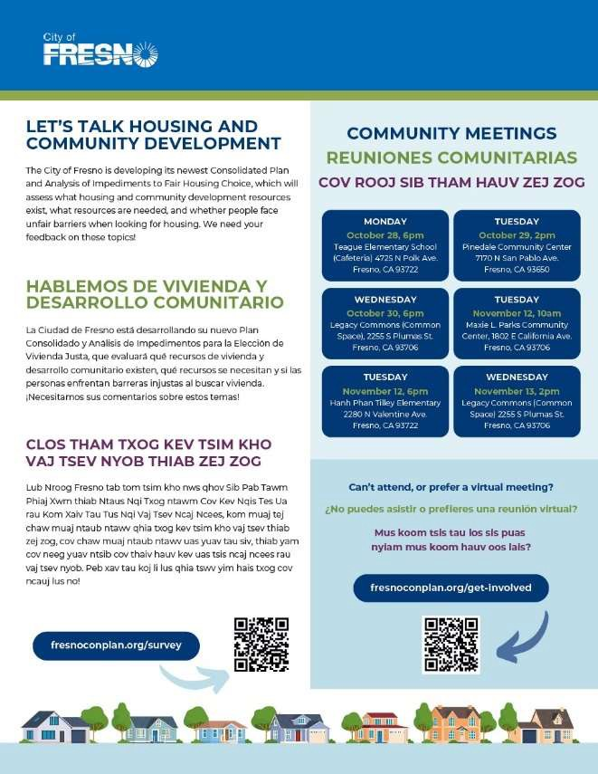

|  |  |
| --- | --- |
| **Date:** | Monday, October 28, 2024 |
| **Time:** | 6:00 PM |
| **Location:** | Teague Elementary School (Cafeteria) 4725 N Polk Ave, Fresno, CA 93722 |

**Community Meeting #2**

|  |  |
| --- | --- |
| **Date:** | Tuesday, October 29, 2024 |
| **Time:** | 2:00 PM |
| **Location:** | Pinedale Community Center  7170 N San Pablo Ave, Fresno, CA 93650 |

**Community Meeting #3**

|  |  |
| --- | --- |
| **Date:** | Wednesday, October 30, 2024 |
| **Time:** | 6:00 PM |
| **Location:** | Legacy Commons (Common Space) 2255 S Plumas St, Fresno, CA 93706 |

**Community Meeting #4**

|  |  |
| --- | --- |
| **Date:** | Thursday, November 7, 2024 |
| **Time:** | 10:00 AM |
| **Location:** | Virtual (via Zoom) |

**Community Meeting #5**

|  |  |
| --- | --- |
| **Date:** | Tuesday, November 12, 2024 |
| **Time:** | 10:00 AM |
| **Location:** | Maxie L. Parks Community Center  1802 E California Ave, Fresno, CA 93706 |

**Community Meeting #6**

|  |  |
| --- | --- |
| **Date:** | Tuesday, November 12, 2024 |
| **Time:** | 6:00 PM |
| **Location:** | Hanh Phan Tilley Elementary School (Cafeteria) 2280 N Valentine Ave, Fresno 93722 |

**Community Meeting #7**

|  |  |
| --- | --- |
| **Date:** | Wednesday, November 13, 2024 |
| **Time:** | 2:00 PM |
| **Location:** | Legacy Commons (Common Space) 2255 S Plumas St, Fresno, CA 93706 |

**Community Meeting #8**

|  |  |
| --- | --- |
| **Date:** | Tuesday, November 19, 2024 |
| **Time:** | 6:00 PM |
| **Location:** | Virtual (via Zoom) |

### Stakeholder Interviews

The planning team also engaged with stakeholders representing a variety of perspectives through in-depth individual and small group interviews. Discussion topics included barriers to housing and community development needs and opportunities, fair housing, housing discrimination, access to opportunity, and fair housing resources. A total of 17 community stakeholders participated in a stakeholder interview, representing a range of viewpoints, including fair housing, affordable housing, community and economic development, neighborhood development, schools and education, youth services, senior services, health and mental health services, homelessness, housing and services for people with disabilities, substance abuse services, refugee and immigrant services, domestic violence services, local government, and others.

### Focus Groups

In addition to stakeholder interviews, the planning team engaged with residents through focus groups facilitated through CASA of Fresno and Madera Counties, an organization that provides services to children and youth in and transitioning out of foster care; County of Fresno Department of Behavioral Health; and Fresno Interdenominational Refugee Ministries (FIRM). Focus groups included an interactive discussion of housing and community development needs, fair housing issues, and access to opportunity. 31 residents participated in a focus group.

**Focus Group #1: CASA of Fresno and Madera Counties**

|  |  |
| --- | --- |
| **Date:** | Tuesday, November 12, 2024 |
| **Time:** | 12:30 PM |
| **Location:** | 2300 Tulare St #210, Fresno, CA 93721 |

**Focus Group #2: County of Fresno Department of Behavioral Health**

|  |  |
| --- | --- |
| **Date:** | Wednesday, November 13, 2024 |
| **Time:** | 9:00 AM |
| **Location:** | Urgent Care Wellness Center  4441 Cesar Chavez Blvd. Fresno, CA 93702 |

**Focus Group #3: Fresno Interdenominational Refugee Ministries (FIRM)**

|  |  |
| --- | --- |
| **Date:** | Wednesday, November 13, 2024 |
| **Time:** | 10:00 AM |
| **Location:** | 2630 E Weldon Ave., Fresno, CA 93703 |

Overall, one or more representatives from more than 20 organizations and agencies participated in a stakeholder interview, community input session, focus group, or written request for information. Organizations and agencies in which one or more staff members or representatives participated in the development of the study include:

* California Civil Rights Department
* CASA of Fresno and Madera Counties
* City of Fresno Department of Transportation -Fresno Area Express (FAX)
* City of Fresno Office of Community Affairs
* Elder Abuse Services, Inc.
* Every Neighborhood Partnership
* For All People There is Hope
* Fresno Community Development Coalition
* Fresno County Department of Behavioral Health
* Fresno County Public Library
* Fresno Housing Authority
* Fresno Interdenominational Refugee Ministries (FIRM)
* Habitat for Humanity Greater Fresno Area
* Legacy Commons
* Marjaree Mason Center
* Pinedale Matters
* Resources for Independence Central Valley
* South Tower Community Land Trust
* U.S. Department of Housing and Urban Development Office of Fair Housing and Equal Opportunity (FHEO)
* WestCare California, Inc.

### Community Survey

The fourth method for obtaining community input was a 29-question survey available to the general public, including people living or working in the city and other stakeholders. Survey questions focused on housing and community development needs and opportunities, fair housing, and access to opportunity. The survey was available online on at the project website and in hard copy in English, Spanish, and Hmong from September 2024 through January 2025. Hard copies were distributed in the three

languages at in-person community meetings, pop-up events, and focus groups. A total of 237 survey responses were received.

### Pop-Up Events

The planning team conducted two pop-up engagement activities, during which facilitators engaged with residents informally in community locations. Pop-up engagement is useful for raising awareness of the plan and obtaining input from residents who may not be sufficiently tuned into fair housing issues to attend a meeting on the subject, but who have opinions to share nonetheless. The planning team held two pop-up events, one at River Park Farmers Market during a trick-or-treat event, and one at Victory Village, a City- owned emergency shelter, during a cookout. During these events, the planning team handed out flyers with information about meeting dates and a link to the community survey, provided paper copies of the survey, engaged residents in an activity focused on housing and community development needs, and offered residents candy at the trick-or- treat event and toiletries at the emergency shelter. Through these pop-up events, the planning team engaged more than 100 residents in the Analysis of Impediments to Fair Housing Choice.

**Pop-Up Event #1: River Park Farmers Market**

|  |  |
| --- | --- |
| **Date:** | Tuesday, October 29, 2024 |
| **Time:** | 5:00 PM |
| **Location:** | Del Centro, 220 Terrado Plaza, Fresno, CA 93720 |

**Pop-Up Event #2: Victory Village**

|  |  |
| --- | --- |
| **Date:** | Wednesday, October 30, 2024 |
| **Time:** | 12:00 PM |
| **Location:** | 959 N Parkway Drive, Fresno CA 93728 |

**FIGURE 2. POP-UP EVENT AT RIVER PARK FARMERS MARKET**

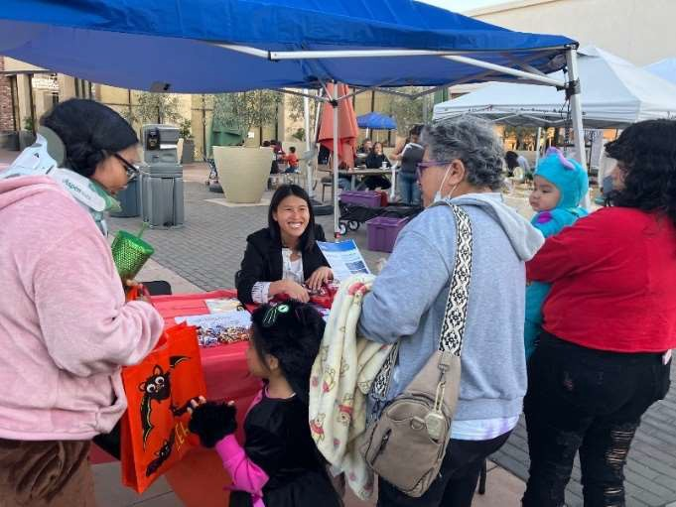

### Public Comment Period and Public Hearing

The City of Fresno will hold a 30-day public comment period to receive comments on the draft Analysis of Impediments to Fair Housing Choice from March 3 to April 3, 2025. During that time, copies of the draft plans will be available for public review on the project website, [www.FresnoConPlan.org,](http://www.FresnoConPlan.org/) and residents and stakeholders can provide written comments. Residents and stakeholders can also mail or deliver written comments to the Community Development Division at 2600 Fresno Street, Fresno, CA 93721, or e-mail comments to [info@mosaiccommunityplanning.com.](mailto:info@mosaiccommunityplanning.com) The City will hold a final public hearing on the draft plans on May 1, 2025. A summary of community engagement results is provided in the following section. Complete survey results and evidence of outreach materials can be found in the appendix. Comments received during the public comment period and public hearing, will be summarized and included in the final draft submitted to HUD.

### Publicity for Community Engagement Activities

Advertisement for the community workshops and survey targeted the general public, as well as nonprofits, service providers, housing providers, and others working with low- and moderate-income households and special needs populations. Public notice of community input opportunities was provided through announcements on the City’s website and social media, the project website, newspaper articles and public notices, e-mails to community stakeholders, and door hangers placed at households within one mile of each community meeting location. Stakeholder interview invitations were sent to more than 100 contacts representing a variety of viewpoints, including elected officials and staff, housing developers, nonprofit organizations, homeless housing and service providers, mental health service providers, organizations serving people with disabilities, family and senior services, workforce development organizations, and others. Meeting advertisements noted that accommodations (including translation, interpretation, or accessibility needs) were available if needed; no requests for accommodations were received.

**FIGURE 3. SOCIAL MEDIA POSTS IN ENGLISH, SPANISH, AND HMONG**

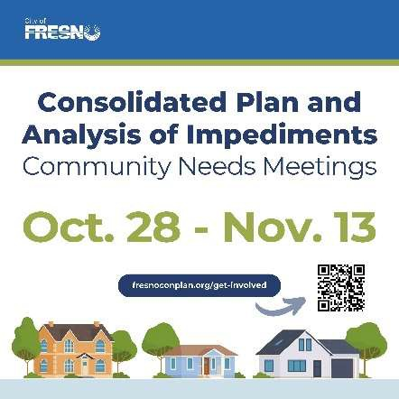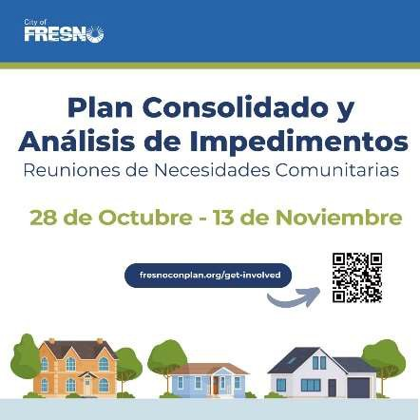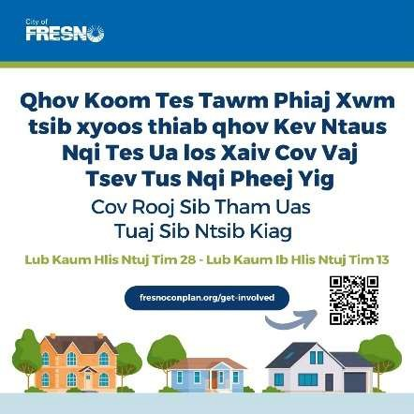

## COMMUNITY ENGAGEMENT RESULTS

The community participation process as described above resulted in broad community feedback from public meetings, focus groups, and interviews. Themes from stakeholder interviews, community workshops, focus groups, and the community survey are summarized below. All input was considered in the development of this AI. Note that these comments reflect independent community sentiment and do not necessarily reflect the views of the City of Fresno government.

### Community Workshops, Focus Groups, and Stakeholder Interviews Results

Detailed below are the prominent themes that emerged from input received from residents and stakeholders during the community workshops, focus groups, and stakeholder interviews.

**TABLE 1. THEMES FROM COMMUNITY WORKSHOPS, FOCUS GROUPS, AND STAKEHOLDER INTERVIEWS**

Residents and stakeholders described high housing costs that have increased in the past five years. Many residents are not able to afford market rents but do not qualify for housing assistance. Young adults, elders, residents on fixed incomes, and people transitioning from homelessness, in particular, find it difficult to afford housing in the city. Many residents end up looking outside the city for affordable housing, which can create barriers to accessing transportation and employment.

**Housing in Fresno has become less affordable in recent years.**

**DETAILS**

**THEME**

There is a need for development of more affordable housing units, which may include smaller single-family homes and ‘missing middle’ housing types, such as duplexes and small multifamily units.

**There is a need to support development of high-quality affordable housing in a diversity of housing types.**

|  |  |
| --- | --- |
| **THEME** | **DETAILS** |
| **There is a need to support access to homeownership in the city.** | Participants noted a need to support access to homeownership for residents through development of affordable starter homes, assistance for first-time homeowners, homebuyer education/ housing navigation programs, and increasing residents’ awareness  of available resources. |
| **There is a need to ensure that rental housing is in good condition.** | Residents and stakeholders noted that many rental housing units in the city are in poor condition and that there is a need to address the issue of landlords maintaining properties poorly. Many residents are afraid to request repairs to rental housing out of fear of  retaliation. |
| **There are significant disparities in availability of quality housing and access to opportunity across the city’s neighborhoods.** | Previous redlining and disinvestment have contributed to a lack of housing in good condition and of retail, resources, and services in the southwest Fresno area in particular.  Residents and stakeholders generally consider north Fresno an area of opportunity, with good access to high-quality housing, high-performing schools, parks, retail, and resources. There is a need to encourage development of affordable housing, retail, grocery stores, and services in areas with lower levels of access. |
| **Barriers often limit residents’ access to housing in high- opportunity neighborhoods.** | Barriers to living in high-opportunity areas include cost of living, lack of access to transportation, and opposition to affordable housing development in some neighborhoods. |
| **Development of affordable housing in areas of the city with access to resources and services should be a priority.** | The City should support development of affordable housing in neighborhoods with access to opportunity, including transportation, grocery stores, schools, parks, retail, and services. |
| **Some of the city’s neighborhoods have experienced gentrification.** | Residents of the Pinedale neighborhood described rapid increases in housing values and rents. Many residents have been asked by investors to sell their homes so that investors could flip the homes and sell them for large profits. Landlords may evict renters so that they can significantly increase rents. |

|  |  |
| --- | --- |
| **THEME** | **DETAILS** |
| **Barriers often prevent residents from accessing housing.** | Large initial deposits for first and last months’ rent and security deposits, requirements that residents’ incomes be three times the rent, application fees, low credit scores, and difficulty finding units that accept Housing Choice Vouchers are barriers that often reduce access to housing. |
| **There is a need to support residents experiencing homelessness, youth transitioning from foster care, and migrant workers in accessing housing, employment, and supportive services.** | There is insufficient emergency shelter and transitional housing in Fresno to meet needs. Emergency shelter space for families with children is a particular need. The lack of affordable housing in the city makes it difficult for shelters and service providers to place people transitioning from homelessness and youth transitioning from foster care into housing they can afford. A Housing First model is needed to reduce barriers to housing for residents experiencing homelessness, while still supporting residents in accessing needed services, such as mental health services and employment navigation. Vacant buildings could be used to develop small housing units as transitional housing. Single-room occupancy units, units with trauma-informed design and services, and units that allow pets are needed. Residents with lived experience should be in positions of leadership in planning related to resources and strategies. |
| **Rental assistance is an ongoing need in preventing homelessness.** | Rental assistance is no longer available through the City as it was during the COVID pandemic. The City should restart its rental assistance program. There is a need for resources to reduce evictions and support residents in maintaining their housing. |
| **There is a continued need for services for survivors of domestic violence, elder abuse,**  **and human trafficking.** | Shelter services, transitional housing, housing navigation, financial assistance, and case management services are particular needs for these populations. |

|  |  |
| --- | --- |
| **THEME** | **DETAILS** |
| **There is a growing need for senior services.** | The growing number of seniors in Fresno necessitates a range of programs and services, including accessible housing modifications, group exercise programs and spaces targeted to seniors, food and wellness programs, and community gardens and related programming. |
| **Accessibility requirements for all housing units would increase access to housing for seniors**  **and residents with disabilities.** | Features such as walk-in bathtubs and other universal design features would make units more accessible. |
| **There is a need to increase walkability and pedestrian safety in the city.** | Much of the city is not walkable or pedestrian friendly. There are many accidents involving vehicles and pedestrians who are trying to cross large roads. Investments in sidewalks, crosswalks, pedestrian safety measures, and more human-scale streets and neighborhoods would increase safety and make the community more accessible and socially connected. |
| **There is a need to invest in public facilities and infrastructure, particularly in south and west Fresno and the downtown area.** | Participants emphasized that the quality and maintenance of public facilities and infrastructure in south and west Fresno and the downtown area is generally lower than that of other areas of the city. Participants described driving to other neighborhoods of the city with better parks and amenities to access these resources. Needed facility and infrastructure improvements include parks, lighting, sidewalks, enhancements for libraries, spaces for youth to gather when they’re not in school, Boys and Girls Clubs, health clinics that accept MediCal, and drinking water stations. Residents and stakeholders noted a need for public infrastructure improvements to increase shade, such as adding to the city’s tree canopy and proving bus shelters. |
| **There is a need for investments in public services to support residents in accessing opportunities.** | Participants noted a need for job training and readiness programs, youth and senior activities and education, youth employment programs and life skills training, community garden spaces and programming, personal finance education, and programs to increase food access. |

Residents and stakeholders noted a need for resources to increase residents’ awareness of available programs and services, such as a comprehensive resource guide of available resources for specific populations, a website focused on housing resources, a hotline related to resource access, and greater messaging and communication about what resources are available.

**There is a need to increase access to information about available resources.**

**DETAILS**

**THEME**

### Community Survey Results

Participants noted a need for door-to-door canvassing and TV and radio advertising about planning processes to increase residents’ involvement.

**There is a need to increase residents’ awareness of planning processes and to facilitate involvement.**

The community survey asked residents and stakeholders about barriers to neighborhood resources, affordable housing, provision of public services, and fair housing access in the city and county. A total of 237 people responded to the survey, representing a range of age groups, income levels, races and ethnicities, and zip codes.

##### Participants’ Thoughts About Housing Needs

When asked about housing needs in Fresno, survey respondents noted the highest levels of need were for construction of new affordable rental units (rated as a high need by 72.6% of respondents), family housing (61.5%), energy efficiency improvements to housing (56.5%), elderly or senior housing (56.3%), and help with rental payments (56.2%) (see Figure 4). In addition to these top housing needs, housing that accepts Housing Choice Vouchers, housing for people with disabilities, rehabilitation of rental housing, help buying a home/downpayment assistance, and help for homeowners to make housing improvement were all rated as high-level needs by 50% or more of survey respondents.

#### FIGURE 4. TOP RESPONSES TO “PLEASE RATE THE FOLLOWING HOUSING NEEDS IN FRESNO ON A SCALE RANGING FROM A LOW NEED TO A HIGH NEED.” FROM THE COMMUNITY SURVEY

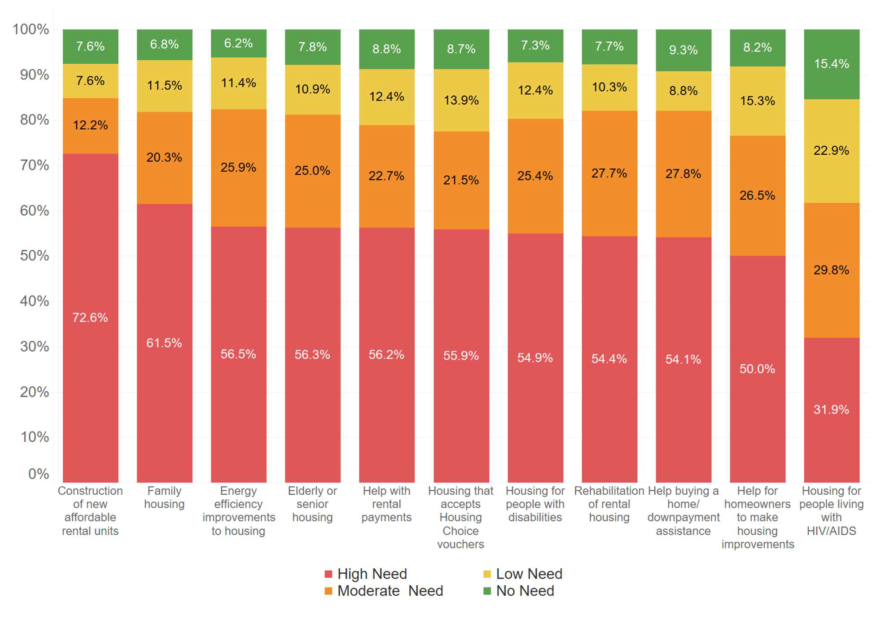

Low Need

No Need

High Need

Moderate Need

Housing for people living with HIV/AIDS

Help for homeowners to make housing improvements

Help buying a home/ downpayment assistance

Rehabilitation of rental housing

Housing for people with disabilities

Housing that accepts Housing Choice vouchers

Help with rental payments

Elderly or senior housing

Energy efficiency improvements to housing

Family housing

Construction of new affordable rental units

##### Participants’ Thoughts About Access to Community Resources

When asked about the distribution and maintenance of community resources, survey participants indicated that a wide range of community resources are not evenly provided or maintained throughout the city’s neighborhoods (see Figure 5). Some respondents rated bus service as the most evenly available and maintained community resource, with 29.5% of respondents describing bus service in the city as equally available across neighborhoods, and 30.5% describing it as equally maintained. Still, greater shares of respondents noted that bus service is not equally provided and maintained across neighborhoods (42.6% and 31.6%, respectively). For all other community resources, fewer than about one in four respondents described the resources as evenly available, and fewer than about one in four respondents described them as equally maintained. Survey respondents rated parks and trails, grocery stores and other shopping, and property maintenance as the least equally available across neighborhoods (about 54% to 59% of respondents described them as not equally available). Respondents rated roads and sidewalks and property maintenance as the least equally maintained community

resources (63% to 65% of respondents described them as not equally maintained across neighborhoods).

#### FIGURE 5. RESPONSES TO “THINKING ABOUT COMMUNITY RESOURCES IN FRESNO, PLEASE CHECK WHETHER YOU THINK EACH OF THE FOLLOWING ARE EQUALLY AVAILABLE AND MAINTAINED IN ALL NEIGHBORHOODS.” FROM THE COMMUNITY SURVEY

**AVAILABILITY OF RESOURCES**

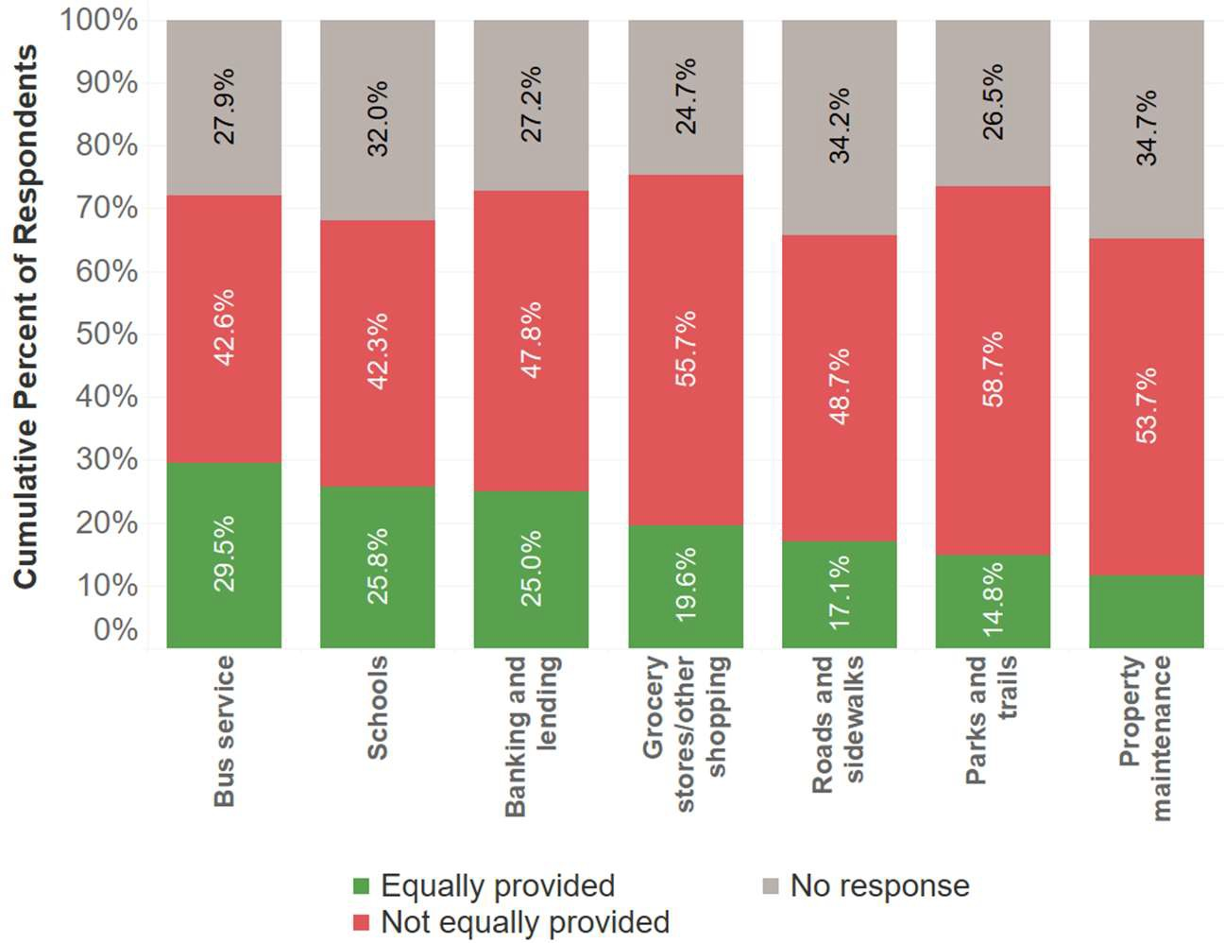

No response

**Cumulative Percent of Respondents**

Equally provided

Not equally provided

**Property maintenance**

**Parks and trails**

**Roads and sidewalks**

**Grocery stores/other shopping**

**Banking and lending**

**Schools**

**Bus service**

**MAINTENANCE OF RESOURCES**

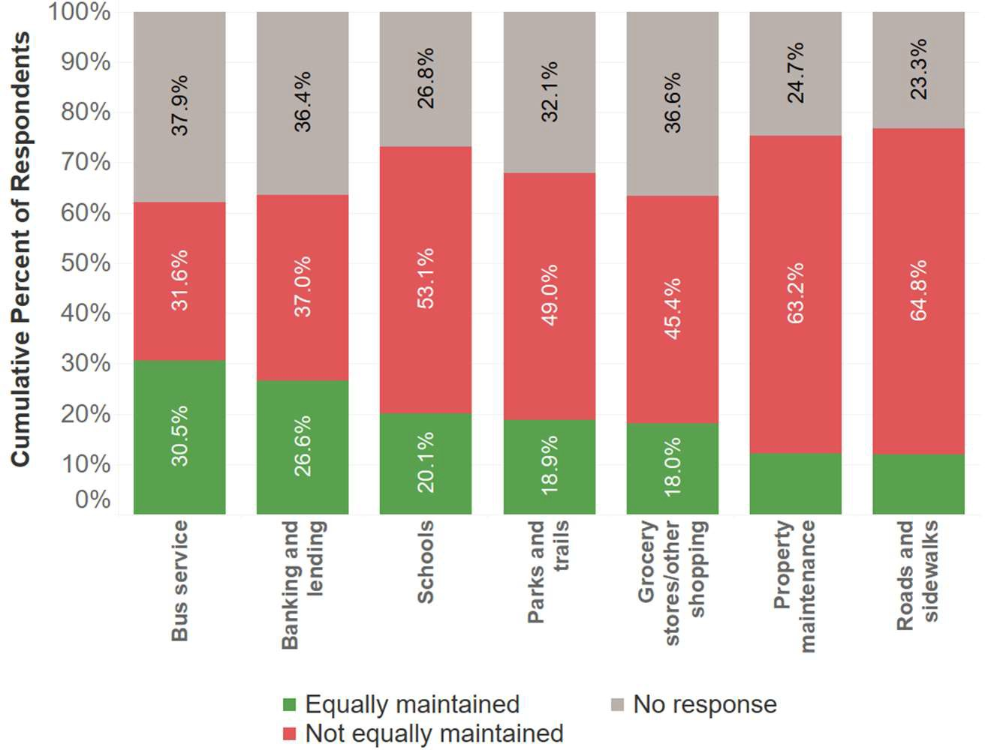

No response

Equally maintained

Not equally maintained

**Roads and sidewalks**

**Property maintenance**

**Cumulative Percent of Respondents**

**Grocery stores/other shopping**

**Parks and trails**

**Schools**

**Banking and lending**

**Bus service**

##### Participants’ Thoughts About Fair Housing

Most survey participants reported understanding or somewhat understanding their fair housing rights (56.6% and 33.3%, respectively; see Figure 6). While just 10.1% of respondents said that they did not know their fair housing rights, 44.1% said they would not know where to file a housing discrimination complaint (see Figure 7).

#### FIGURE 6. RESPONSES TO “DO YOU UNDERSTAND YOUR FAIR HOUSING RIGHTS?” FROM THE COMMUNITY SURVEY

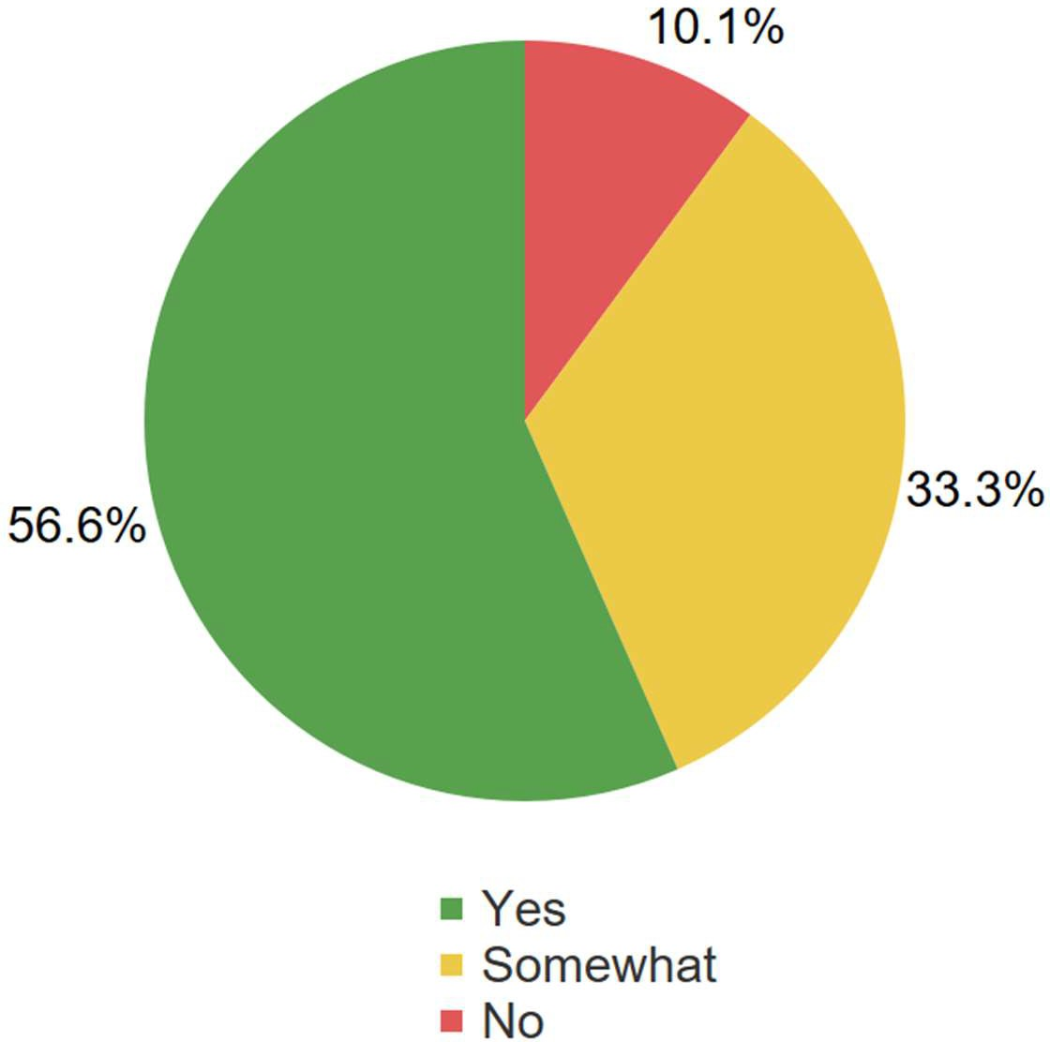

Yes

Somewhat

No

**FIGURE 7. RESPONSES TO “DO YOU KNOW WHERE TO FILE A HOUSING DISCRIMINATION COMPLAINT?” FROM THE COMMUNITY SURVEY**

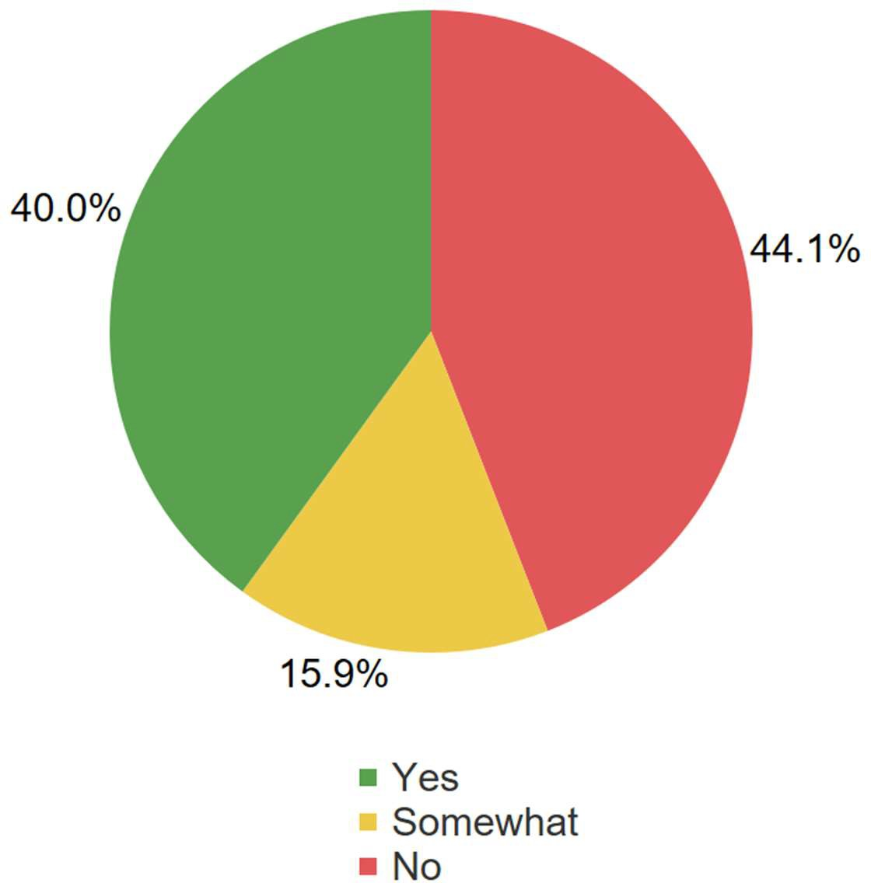

Yes

Somewhat

No

50 survey participants noted experiencing housing discrimination since living in Fresno. Of those 50 people:

* 38 noted that they were discriminated against by a landlord or property manager, 12 were discriminated against by a real estate agent, nine by a City staff person, and seven by a mortgage lender. Nine respondents described other situations, including source of income discrimination based on use of a Housing Choice Voucher, discrimination by low-barrier shelter staff, and others.
* Respondents noted familial status, race, and ethnicity as the most common bases for discrimination (31, 26, and 18 respondents, respectively). Other bases for discrimination included gender (11 respondents), disability (six respondents), national origin (four respondents), and religion (two respondents).

Only three of the 50 respondents who experienced discrimination filed a complaint. Reasons for not filing discrimination complaints included not knowing what good it would do (identified by 26 people), being afraid of retaliation (identified by 14 people), not knowing where to file (identified by 13 people), not realizing discrimination is against the law (identified by five people), the process not being in the respondent’s language (identified by one person), the process not being accessible to the respondent because of a disability (identified by one person), and other reasons (identified by 14 respondents).

Two of every five respondents (40.0%) noted that they believe housing discrimination is an issue in the city, and about one in three (29.7%) said they believe it is somewhat of an issue. Fewer than one in six respondents (13.3%) said they do not believe housing discrimination is an issue in Fresno.

When asked to select any factors that are barriers to fair housing in the city, respondents most often identified the following (see Figure 8):

* + Not enough affordable housing for families (78.1%)
  + Not enough affordable housing for individuals (77.5%)
  + Displacement of residents due to rising housing costs (70.1%)
  + Neighborhoods that need revitalization and investment (59.4%)
  + Community opposition to affordable housing (58.8%)
  + Not enough affordable housing for seniors (57.8%)

Notably, the top responses focused on the need for increasing the supply of affordable housing, reducing the displacement of residents due to rising housing costs, and investing in neighborhood revitalization.

**FIGURE 8. RESPONSES TO “DO YOU THINK ANY OF THE FOLLOWING ARE BARRIERS TO FAIR HOUSING IN FRESNO? (CHECK ALL THAT APPLY.)” FROM THE COMMUNITY SURVEY**

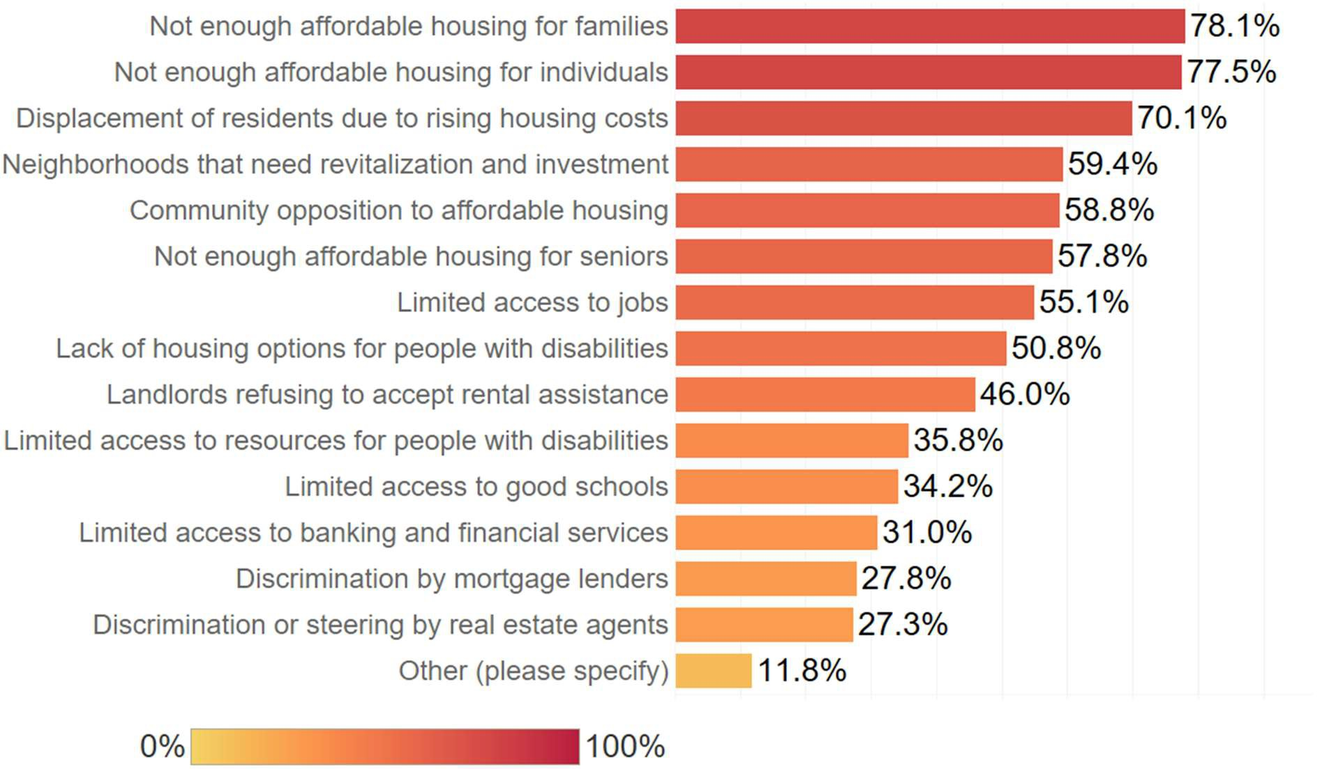

Other (please specify)

Discrimination or steering by real estate agents

Discrimination by mortgage lenders

Limited access to banking and financial services

Limited access to good schools

Limited access to resources for people with disabilities

Landlords refusing to accept rental assistance

Lack of housing options for people with disabilities

Limited access to jobs

Not enough affordable housing for seniors

Community opposition to affordable housing

Neighborhoods that need revitalization and investment

Displacement of residents due to rising housing costs

Not enough affordable housing for individuals

Not enough affordable housing for families

## SOCIOECONOMIC PROFILE

The City of Fresno, California is home to an estimated 543,615 residents, accounting for nearly half (46%) of the 1,170,942 residents in the Fresno Metropolitan Statistical Area (MSA). Fresno has experienced moderate population growth of about 27.3% since the year 2000.

### Demographic Profile

##### Race / Ethnicity

Fresno has experienced significant racial and ethnic demographic shift since the year 2000, with growth among Hispanic/Latino, Asian/Pacific Islander, and multi-racial groups countered by a decline in Black, White, and Native American populations.

Hispanic or Latino residents make up the majority of Fresno’s population, accounting for just over half (50.6%) of all residents. This is a significant increase from their population share of 39.9% in 2000, but a slight decrease from 53.1% in 2010. White residents are the next largest demographic group, making up just under one quarter (24.7%) of the population, a significant decline from their 37.3% population share in 2000.

Asian and Pacific Islander residents account for 14% of the population, a nearly 50% increase from their year 2000 population share, making this the fastest growing demographic within Fresno over the past 20 years. Black residents currently make up about 6% of the population, down from 8% in 2000. There has also been a slight decline in Native American populations, while multi-racial populations and populations listing their race as “other” have grown.

##### National Origin

A significant portion of Fresno’s population is comprised of immigrants, or residents who were born outside of the United States. These residents currently make up 18.9% of the population, down slightly from 20.5% in 2010. The most common country of origin for immigrants in Fresno is Mexico, with Mexican immigrants alone making up nearly 10% of Fresno’s total population. Immigrants from the remaining top 5 represented countries (India, Laos, the Philippines, and Thailand) together comprise just over 5% of all residents.

12 2019-2023 American Community Survey, Table DP05

**LEP**

English is Fresno’s primary spoken language; however, a large immigrant population contributes to significant diversity in local languages. 16% of Fresno’s population is considered to have Limited English Proficiency, or LEP, meaning that they self-report speaking English at a level less than” very well”. Nearly 10% of Fresno’s total population speaks primarily Spanish, while just over 5% have a different non-English primary language. Like immigrant populations, this number has also decreased slightly in the past two decades.

##### Disability

Just under 15% of Fresno residents have at least one disability, which is higher than California’s overall 11.3% disability rate.

The most common disability type in Fresno is a cognitive difficulty (8.0%), followed by an independent living difficulty (7.0%) and an ambulatory difficulty (6.5%). Self-care (3.4%), vision (3.3%) and hearing (3.2%) difficulties are less common. Note that some residents may have more than one disability, meaning that the sum of individual disability counts may exceed the total number of disabled residents.

##### Age

The share of Fresno’s population who are children has declined by six percentage points since the year 2000 (from 32.9% to 26.9%), while the share of senior residents has increased by about three percentage points (9.3% to 12.7%). The population share of working-aged adults (aged 18 to 64) has increased slightly since 2000 but has remained stable since 2010 (about 60%). An increase in senior residents as a share of the population warrants fair housing considerations centered around accessibility and aging support.

##### Sex

Fresno has a fairly even split between male (49.3%) and female residents (50.7%), which has remained consistent over time.

##### Family Type

The most common household type in Fresno is a single female householder with no children, accounting for 22.3% of all households, followed by married couples without children (21.2%) and married couples with children (19.5%). Single male householders are also common, comprising 18.6% of all households. Overall, 37.9% of Fresno households have children (down from 44.8% in 2000), and 27% have one or more senior members (aged 65+).

#### TABLE 2. DEMOGRAPHIC OVERVIEW

|  |  |  |  |  |  |  |
| --- | --- | --- | --- | --- | --- | --- |
| **Fresno**  **Demographic Indicator** | | | | **Fresno, CA MSA** | | |
|  |  | **#** | **%** |  | **#** | **%** |
| **RACE / ETHNICITY** | | | | | | |

|  |  |  |  |  |
| --- | --- | --- | --- | --- |
| Non-Hispanic | 268,798 | 49.4% | 527,438 | 45.0% |
| White | 134,214 | 24.7% | 322,291 | 27.5% |
| Black | 34,477 | 6.3% | 45,906 | 3.9% |
| Asian or Pacific Islander | 76,117 | 14.0% | 114,252 | 9.7% |
| Native American | 2,529 | 0.5% | 4,907 | 0.4% |
| Two or More Races | 19,137 | 3.5% | 35,320 | 3.0% |
| Other | 2,324 | 0.4% | 4,762 | 0.4% |

|  |  |  |  |  |  |  |
| --- | --- | --- | --- | --- | --- | --- |
| Hispanic or Latino |  | 274,817 | 50.6% |  | 643,504 | 55.0% |
| **Total Population** |  | **543,615** | **100.0%** |  | **1,170,942** | **100.0%** |
| **NATIONAL ORIGIN** | | | | | | |

|  |  |  |  |  |  |  |
| --- | --- | --- | --- | --- | --- | --- |
| #1 Country of Origin | Mexico | 50,578 | 9.3% | Mexico | 145,230 | 12.3% |
| #2 Country of Origin | India | 12,714 | 2.3% | India | 17,484 | 1.5% |
| #3 Country of Origin | Laos | 6,836 | 1.3% | Laos | 8,960 | 0.8% |
| #4 Country of Origin | Philippines | 5,012 | 0.9% | Philippines | 8,840 | 0.7% |
| #5 Country of Origin | Thailand | 3,906 | 0.7% | El Salvador | 7,031 | 0.6% |

|  |  |  |  |  |  |
| --- | --- | --- | --- | --- | --- |
| **Total Foreign-Born Population** | **103,019** | **18.9%** |  | **231,966** | **19.7%** |

|  |  |  |  |  |  |  |  |
| --- | --- | --- | --- | --- | --- | --- | --- |
| **Demographic Indicator** |  | **Fresno** | | | **Fresno, CA MSA** | | |
|  |  | | **#** | **%** |  | **#** | **%** |
| **LIMITED ENGLISH PROFICIENCY (LEP) LANGUAGE** | | | | | | | |
| #1 LEP Language | Spanish |  | 52,584 | 9.6% | Spanish | 148,739 | 12.6% |

#2 LEP Language Asian/Pacific Islander languages

#3 LEP Language

Other Indo-European 8,724

1.6%

Other Indo-

European

12,707

1.1%

17,103 3.1% Asian/Pacific Islander languages

24,746 2.1%

|  |  |  |  |  |  |  |
| --- | --- | --- | --- | --- | --- | --- |
|  | Languages |  |  | Languages |  | |
| #4 LEP Language | Other | 2,299 | 0.4% | Other | 3,484 | 0.3% |

|  |  |  |  |  |  |  |
| --- | --- | --- | --- | --- | --- | --- |
| **Total LEP Population** |  | **80,710** | **16.0%** |  | **189,676** | **17.4%** |
| **DISABILITY TYPE** | | | | | | |

|  |  |  |  |  |
| --- | --- | --- | --- | --- |
| Hearing Difficulty | 17,348 | 3.2% | 40,898 | 3.5% |
| Vision Difficulty | 18,019 | 3.3% | 33,249 | 2.9% |
| Cognitive Difficulty | 40,251 | 8.0% | 71,640 | 6.6% |
| Ambulatory Difficulty | 32,468 | 6.5% | 71,158 | 6.6% |
| Self-Care Difficulty | 17,205 | 3.4% | 34,908 | 3.2% |

|  |  |  |  |  |  |  |
| --- | --- | --- | --- | --- | --- | --- |
| Independent Living Difficulty |  | 27,492 | 7.0% |  | 54,573 | 6.5% |
| **Total Population with a**  **Disability** |  | **80,028** | **14.8%** |  | **160,654** | **13.9%** |

|  |  |  |  |  |  |  |
| --- | --- | --- | --- | --- | --- | --- |
| **Fresno**  **Demographic Indicator** | | | | **Fresno, CA MSA** | | |
|  |  | **#** | **%** |  | **#** | **%** |
| **SEX** | | | | | | |

|  |  |  |  |  |
| --- | --- | --- | --- | --- |
| Male | 269,207 | 49.3% | 591,550 | 50.1% |
| Female | 276,510 | 50.7% | 588,470 | 49.9% |
| **AGE** |  |  |  |  |
| Under 18 | 146,960 | 26.9% | 323,204 | 27.4% |
| 18 to 64 | 329,562 | 60.4% | 698,307 | 59.2% |
| 65+ | 69,195 | 12.7% | 158,509 | 13.4% |
| **HOUSEHOLD TYPE** |  |  |  |  |
| Married Couple, Children | 34,953 | 19.5% | 80,276 | 21.9% |
| Unmarried Couple, Children | 8,084 | 4.5% | 16,288 | 4.4% |
| Single Female Householder, Children | 13,750 | 7.7% | 25,985 | 7.1% |

|  |  |  |  |  |
| --- | --- | --- | --- | --- |
| Single Male Householder, Children | 3,142 | 1.7% | 5,378 | 1.5% |
| **Total Households with Children** | **68,181** | **37.9%** | **147,474** | **40.2%** |

Married Couple, No Children

38,021 21.2% 93,438 25.5%

|  |  |  |  |  |  |  |
| --- | --- | --- | --- | --- | --- | --- |
| **Demographic Indicator** | **Fresno** | | | **Fresno, CA MSA** | | |
|  |  | **#** | **%** |  | **#** | **%** |
| Unmarried Couple, No Children |  | 8,172 | 4.5% |  | 14,987 | 4.1% |

Single Female Householder, No Children

40,135 22.3% 72,105 19.7%

|  |  |  |  |  |
| --- | --- | --- | --- | --- |
| Single Male Householder, No Children | 33,427 | 18.6% | 58,219 | 15.9% |
| **Total Households without Children** | **111,503** | **62.1%** | **219,202** | **59.8%** |

Households with One or More Members Aged 65+

48,470 27.0% 107,345 29.3%

|  |  |  |  |  |
| --- | --- | --- | --- | --- |
| Person Aged 65+ Living Alone | 6,368 | 3.5% | 12,641 | 3.4% |
| **TOTAL HOUSEHOLDS** | **179,684** | **100.0%** | **366,676** | **100.0%** |

*Data Source: 2019-2023 5-Year American Community Survey, Tables S1810, B05006, S1601, DP05, DP02.*

*NOTE: All % represent a share of the total population within the jurisdiction or region, except family type, which is out of total families. The most populous places of birth and languages at the city and regional levels may not be the same and are thus labeled separately.*

#### TABLE 3. DEMOGRAPHIC TRENDS

|  |  |  |  |  |
| --- | --- | --- | --- | --- |
| **Demographic Indicator** | **2000** | | **2010** | |
|  | **#** | **%** | **#** | **%** |
| **Fresno Population**  **Race / Ethnicity** | **427,652** | **100%** | **494,665** | **100%** |

|  |  |  |  |  |
| --- | --- | --- | --- | --- |
| White, Non-Hispanic | 159,473 | 37.3% | 148,598 | 30.0% |
| Black, Non-Hispanic | 34,357 | 8.0% | 37,885 | 7.7% |
| Hispanic | 170,520 | 39.9% | 262,610 | 53.1% |
| Asian or Pacific Islander, Non- 47,563 11.1% 61,602 12.5% | | | | |
| Hispanic |  |  |  |  |
| Native American, Non-Hispanic | 3,259 | 0.8% | 3,127 | 0.6% |
| Other | 728 | 0.2% | 984 | 0.2% |
| 2+ Races | 11,752 | 2.7% | 10,414 | 2.1% |
| **National Origin** |  |  |  |  |
| Foreign-Born | 86,937 | 20.3% | 101,178 | 20.5% |
| **LEP** |  |  |  |  |
| Limited English Proficiency | 76,442 | 17.9% | 79,126 | 16.0% |
| **Sex** |  |  |  |  |
| Male | 208,757 | 48.8% | 243,124 | 49.1% |
| Female | 218,467 | 51.1% | 251,541 | 50.9% |
| **Age** |  |  |  |  |
| Under 18 | 140,791 | 32.9% | 148,823 | 30.1% |
| 18 to 64 | 247,287 | 57.8% | 299,741 | 60.6% |
| 65+ | 39,574 | 9.3% | 46,101 | 9.3% |
| **Household Type** |  |  |  |  |
| Families with Children | 62,700 | 44.8% | 67,332 | 43.1% |
| **Total Households** | **140,079** | **100.0%** | **156,226** | **100.0%** |

*Data Sources: U.S. Census 2000 SF1 Tables P008, P012, and P019; SF3 Table PCT012; SF4 Table DP2; U.S. Census 2010 SF1 Tables P5 and P12; 2006-2010 5-Year American Community Survey, Tables DP02, S1601, and B05012.*

*NOTE: All % represent a share of the total population within the jurisdiction or region for that year, except family type, which is out of total families. Limited English Proficiency is assessed for the population aged 5 years and older.*

### Racially and Ethnically Concentrated Areas of Poverty

This study uses a methodology developed by HUD that combines demographic and economic indicators to identify racially or ethnically concentrated areas of poverty (R/ECAPs). These areas are defined as census tracts that have an individual poverty rate of 40% or more (or an individual poverty rate that is at least three times that of the tract average for the metropolitan area, whichever is lower) and a non-White population of 50% or more. Using a metric that combines demographic and economic indicators helps to identify a jurisdiction’s most vulnerable communities.

The racial and ethnic composition of neighborhoods with concentrations of poverty is disproportionate relative to the U.S. population overall. According to the U.S. Department of Health and Human Services, Black and Hispanic populations comprise nearly 80% of the population living in areas of concentrated poverty in metropolitan areas, but only account for 42.6% of the total poverty population in the U.S. Overrepresentation of these groups in areas of concentrated poverty can exacerbate disparities related to safety, employment, access to jobs and quality education, and conditions that lead to poor health.

Identification of R/ECAPs is significant in determining priority areas for reinvestment and services to ameliorate conditions that negatively impact R/ECAP residents and the larger region. Since 2000, the prevalence of concentrated poverty has expanded by nearly 75% in both population and number of neighborhoods. The majority of concentration of poverty is within the largest metro areas, but suburban regions have experienced the fastest growth rate.

As of 2023 Fresno contained eleven census tracts meeting the definition of a R/ECAP, as depicted below. Poverty rates in these tracts ranged from 40 to 57%, and Hispanic or Latino residents were the primary racial or ethnic group present. Black residents were disproportionately represented in several R/ECAP tracts, particularly those in south Fresno.

Seven of the eleven tracts are located in south Fresno near the downtown area, with the other four dispersed throughout central Fresno. Notably, all but one are located in direct proximity to one or more large highways. This is particularly relevant to the southernmost cluster of seven census tracts, which are located in a historically Black area of Fresno (see figures 9-11) and near the intersections of multiple highways.

HUD notes that “Urban renewal efforts and the development of the Interstate Highway System contributed to the decline of urban neighborhoods in many American cities, particularly Black neighborhoods. Typically, urban renewal projects included the removal of homes and businesses in or near the urban core of cities to make way for highways. Often, the housing removed was replaced with large public housing complexes. As a result, neighborhoods targeted for urban renewal experienced concentrated poverty and

became disconnected from jobs and services in the urban core. These processes also exacerbated issues of environmental racism, as race maps closely with elevated environmental health threats such as pollution”13. This is particularly relevant to R/ECAP tracts located around downtown Fresno: a UC Berkeley study on the impacts of urban renewal on downtown Fresno notes that “in the late 1950s to early 1960s, Urban Renewal projects in Downtown dramatically changed its physical and social landscape. In 1957, the California Department of Highways devised a plan to construct a freeway loop around Downtown, which was implemented in phases over decades. This resulted in the displacement of hundreds of residents from Downtown and surrounding neighborhoods while creating a physical boundary between Fresno’s outlying suburbs and its central core”14.

Yale Law School further discusses this phenomenon in the context of an ongoing legal battle in Fresno attempting to halt further highway expansion in these areas, stating that “transportation infrastructure, and specifically the construction of State Route 99 in the ’50s and ’60s, left the city of Fresno racially and economically divided, with whiter wealthier residents residing in North Fresno, and lower income people of color living in South Fresno. Today, South Fresno is more than 90% people of color, and most residents are low-income”15. Opponents of the proposed highway expansion allege that communities in the area were intentionally excluded from the feedback process – a pattern which contributed to the initial development of today’s R/ECAP tracts and maintains the potential to further racial, ethnic, and economic divides in impacted areas.

13https://[www.hudexchange.info/programs/fair-housing/fheo-table-talks/reconnecting-](http://www.hudexchange.info/programs/fair-housing/fheo-table-talks/reconnecting-)

neighborhoods-divided-by-urban-renewal-infrastructure/

14 https://[www.urbandisplacement.org/wp-content/uploads/2022/03/Fresno.pdf](http://www.urbandisplacement.org/wp-content/uploads/2022/03/Fresno.pdf)

15https://law.yale.edu/yls-today/news/clinic-files-petition-california-highway-construction-case

**FIGURE 9. RACIALLY AND ETHNICALLY CONCENTRATED AREAS OF POVERTY IN FRESNO, 2023**

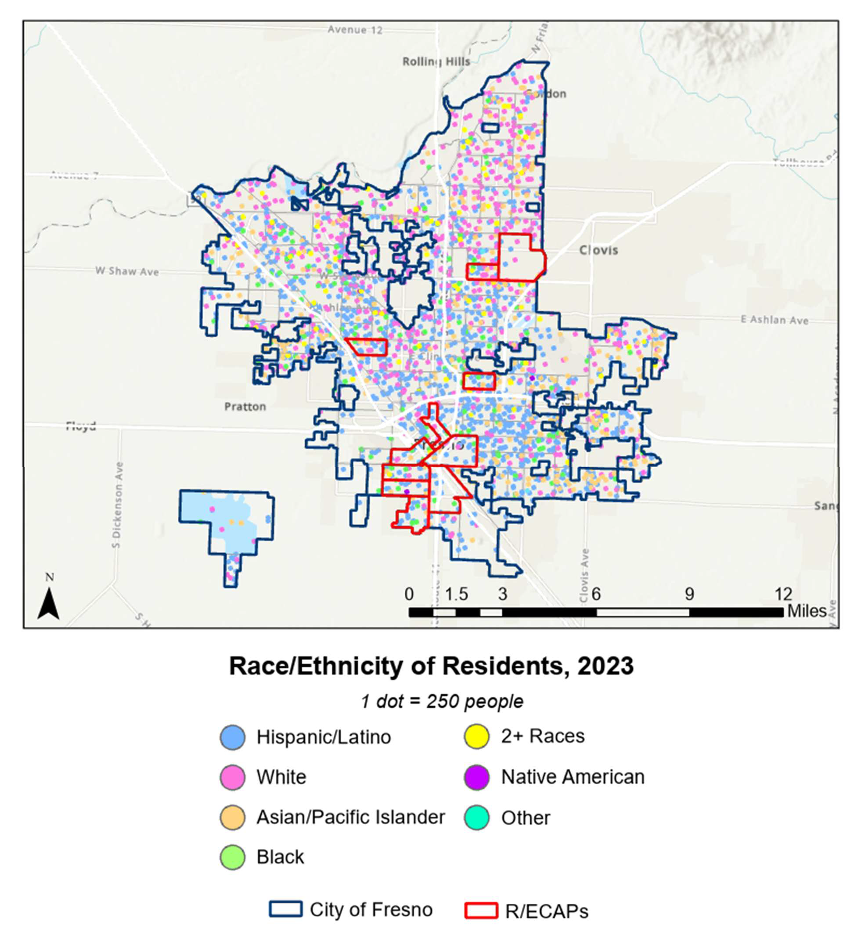

R/ECAPs

City of Fresno

Other

Native American

2+ Races

Black

Asian/Pacific Islander

White

Hispanic/Latino

**Race/Ethnicity of Residents, 2023**

1 dot = 250 people

### Segregation and Integration

Communities experience varying levels of segregation between different racial, ethnic, and socioeconomic groups. High levels of residential segregation often lead to conditions that exacerbate inequalities among population groups within a community. Increased concentrations of poverty and unequal access to jobs, education, and other services are some of the consequences of high residential segregation.16

Federal housing policies and discriminatory mortgage lending practices prior to the Fair Housing Act of 1968 not only encouraged segregation, but mandated restrictions based on race in specific neighborhoods. The Fair Housing Act of 1968 outlawed discriminatory housing practices but did little to address the existing segregation and inequalities. Other federal housing policies and programs, like Section 8 and HOPE VI, have been implemented in an effort to ameliorate the negative effects of residential segregation and reduce concentrations of poverty. Despite these efforts, the repercussions of the discriminatory policies and practices continue to have a significant impact on residential patterns today.

##### Race and Ethnicity

Hispanic or Latino residents make up just over half of Fresno’s population, followed by White, Asian, and Black residents at 24.7%, 14.0%, and 6.3%, respectively. Since the year 2000, White and Black populations have decreased while Hispanic/Latino and Asian populations have increased. This shift is depicted in maps 3-5 below, which show the racial and ethnic composition of Fresno’s neighborhoods over time as well as 2019-2023 R/ECAP census tracts.

As shown below, racial and ethnic clustering within Fresno has visually decreased over time. In 2000, White residents dominated the northern half of Fresno while Hispanic residents dominated the southern half, with Black residents having several distinct neighborhoods in far south Fresno clustered within R/ECAP tracts. By 2023, although White residents were still more heavily present in north Fresno than in other areas, neighborhood lines were much more blurred. This is especially true for several neighborhoods in south Fresno which had a high concentration of Black residents in 2000, but now show significantly higher levels of racial and ethnic diversity.

16 Massey, D. (1990). American Apartheid: Segregation and the Making of the Underclass. *American Journal of Sociology, 96*(2), 329-357. Retrieved from [http://www.jstor.org/stable/2781105.](http://www.jstor.org/stable/2781105)

**FIGURE 10. POPULATION BY RACE AND ETHNICITY IN FRESNO, 2019-2023**

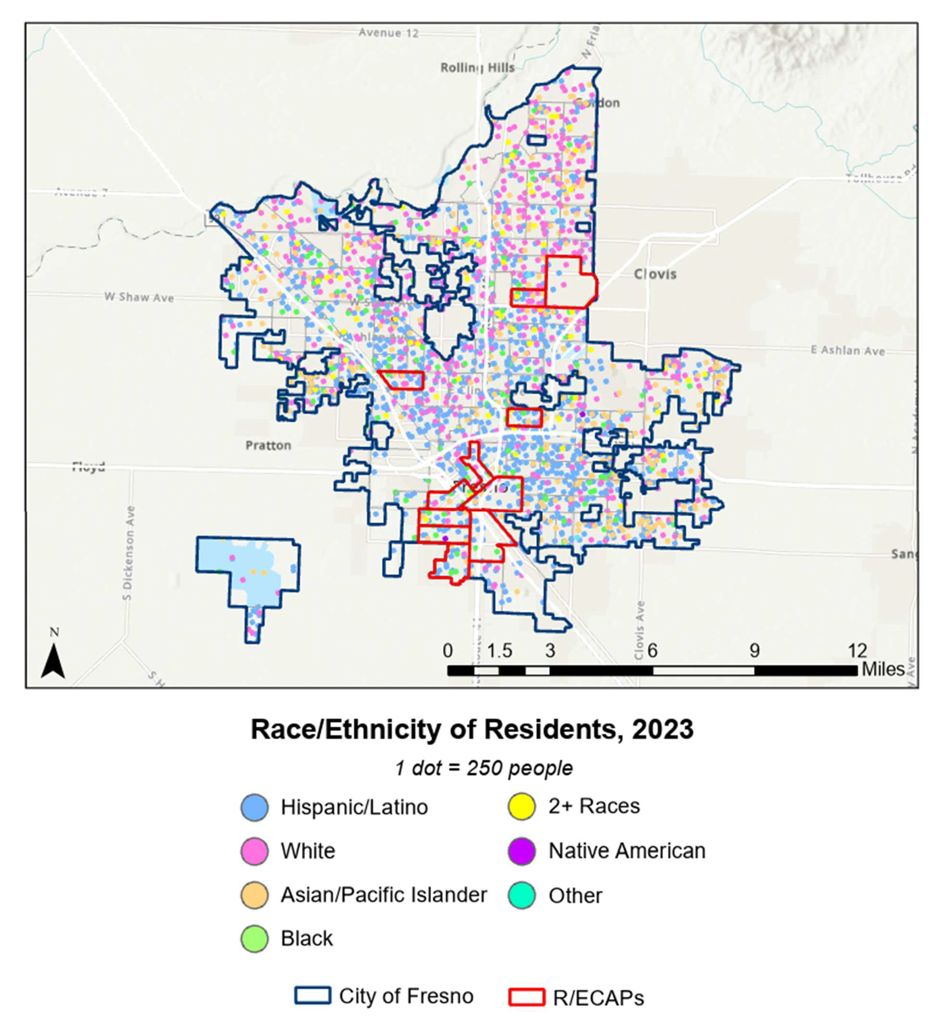

Black

R/ECAPs

City of Fresno

Other

Native American

2+ Races

Asian/Pacific Islander

White

Hispanic/Latino

**Race/Ethnicity of Residents, 2023**

1 dot = 250 people

**FIGURE 11. POPULATION BY RACE AND ETHNICITY IN FRESNO, 2010**

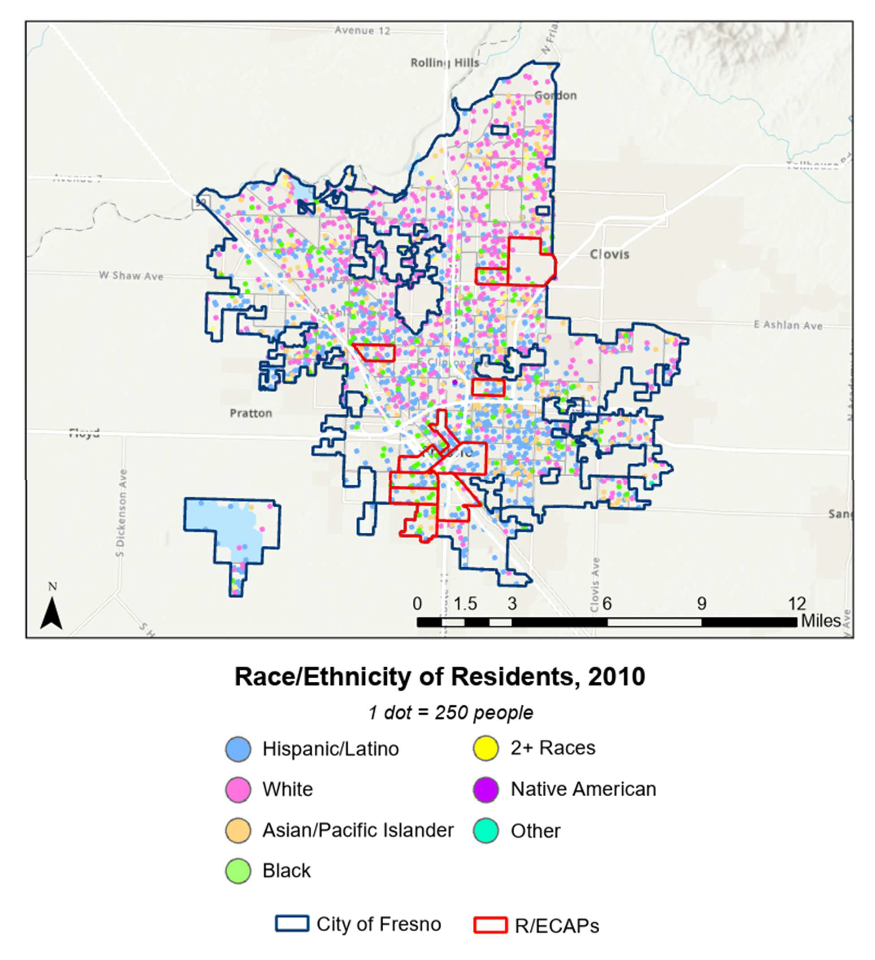

Other

Native American

2+ Races

Black

Asian/Pacific Islander

Hispanic/Latino

White

**Race/Ethnicity of Residents, 2010**

1 dot = 250 people

R/ECAPs

City of Fresno

**FIGURE 12. POPULATION BY RACE AND ETHNICITY IN FRESNO, 2000**

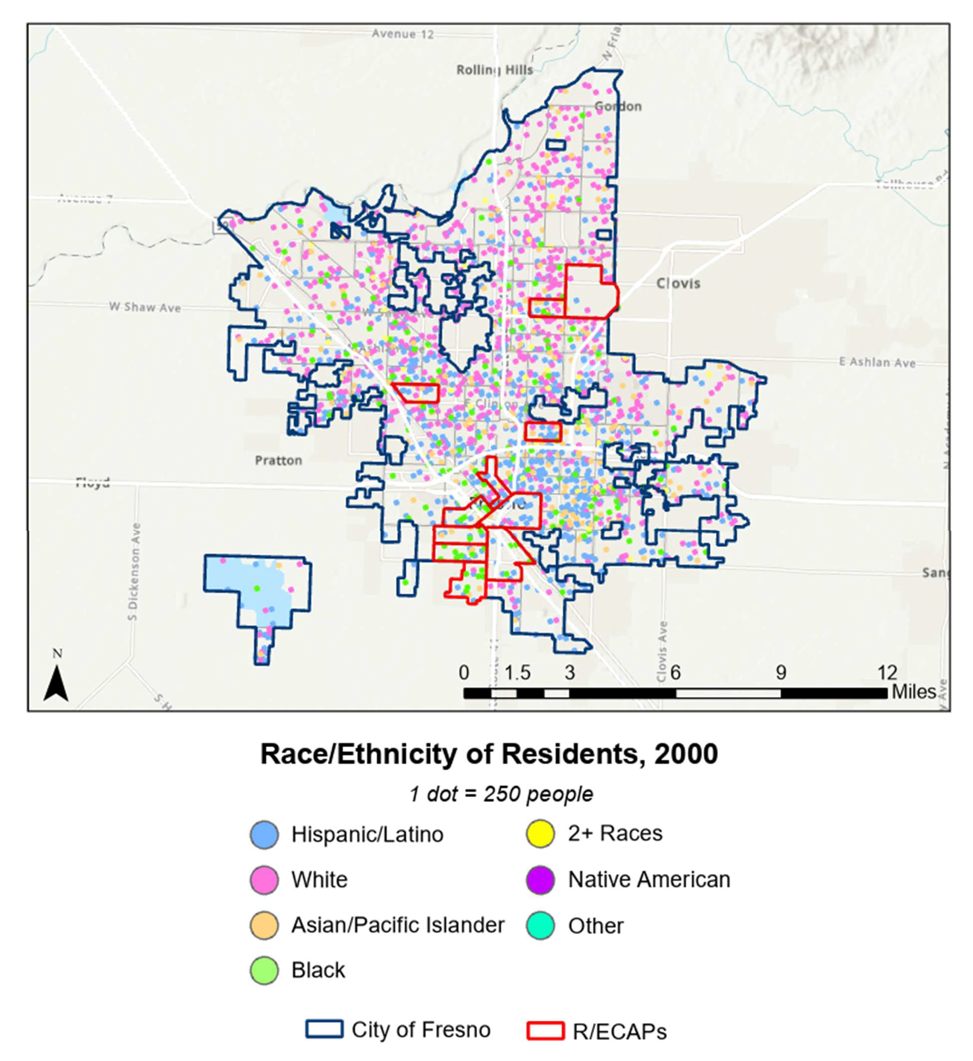

Other

Native American

2+ Races

Black

Asian/Pacific Islander

White

Hispanic/Latino

R/ECAPs

City of Fresno

**Race/Ethnicity of Residents, 2000**

1 dot = 250 people

##### Segregation Levels

In addition to visualizing racial and ethnic compositions of the area with the preceding maps, this study also uses a statistical analysis – referred to as dissimilarity – to evaluate how residential patterns vary by race and ethnicity, and how these patterns have changed since 1990. The Dissimilarity Index (DI) indicates the degree to which a minority group is segregated from a majority group residing in the same area because the two groups are

not evenly distributed geographically. The DI methodology uses a pair-wise calculation between the racial and ethnic groups in the region. Evenness, and the DI, are maximized and segregation minimized when all small areas have the same proportion of minority and majority members as the larger area in which they live. Evenness is not measured in an absolute sense but is scaled relative to the other group. The DI ranges from 0 (complete integration) to 100 (complete segregation). HUD identifies a DI value below 40 as low segregation, a value between 40 and 54 as moderate segregation, and a value of 55 or higher as high segregation.

The proportion of the minority population group can be small and still not segregated if evenly spread among tracts or block groups. Segregation is maximized when no minority and majority members occupy a common area. When calculated from population data broken down by race or ethnicity, the DI represents the proportion of minority members that would have to change their area of residence to match the distribution of the majority, or vice versa.

The table below shares the dissimilarity indices for three pairings in Fresno. This table presents values for 1990, 2000, 2010, and current, all calculated using census tracts as the area of measurement.

Segregation values between all pairings have decreased since 1990. Segregation among Hispanic/White and Black/White residents is considered moderate by HUD definitions, while segregation between Asian/White residents and overall non-White/White residents is considered low. However, it is relevant to note that the DI index measures segregation specifically between White and non-White residents and may therefore be more useful in contexts where White residents make up the majority of the population; in Fresno, White residents currently make up less than one-quarter of the population, meaning that measuring only segregation between White and non-White residents is overlooking a significant portion of the population and does not account for segregation between different groups of non-White residents.

#### TABLE 4. RACIAL AND ETHNIC DISSIMILARITY INDEX TRENDS IN FRESNO

|  |  |  |  |
| --- | --- | --- | --- |
| **RACE/ ETHNICITY** | **1990** | **2000** | **2010** |
| Non-White/ White | 43.88 | 39.65 | 38.82 |
| Black / White | 52.06 | 42.37 | 41.31 |
| Hispanic / White | 43.19 | 42.30 | 42.04 |
| Asian or Pacific Islander / White | 48.86 | 36.86 | 35.78 |

*Data Source: HUD Affirmatively Furthering Fair Housing Data and Mapping Tool, AFFHT0004, Released November 2017, https://egis.hud.gov/affht/.*

##### National Origin and Limited English Proficiency Population

Settlement patterns of immigrants significantly impact the composition and landscape of communities across the United States. Large central cities have the largest population of foreign-born residents, but growth of immigrant populations in suburban areas has now outpaced urban growth rates.17 Clusters of immigrants of the same ethnicity form for a variety of reasons. Social capital in the form of kinship ties, social network connections, and shared cultural experiences often draw new immigrants to existing communities. Settling in neighborhoods with an abundance of social capital is less financially burdensome for immigrants and provides opportunities to accumulate financial capital through employment and other resources that would otherwise be unattainable.18

Populations with limited English proficiency (LEP) are typically composed of foreign-born residents that originate from countries where English is not the primary language, however, a substantial portion (19%) of the national LEP population is born in the United States. Nationally, the LEP population has lower levels of education and is more likely to live in poverty compared to the English proficient population.19 Recent studies have also found that areas with high concentrations of LEP residents have lower rates of homeownership.20

Communities of people sharing the same ethnicity and informal networks are able to provide some resources and opportunities, but numerous barriers and limited financial capital influence residential patterns of foreign-born and LEP populations.

As of the 2019-2023 American Community Survey, an estimated 19% of Fresno’s population was born outside of the United States, and 16% of the population has limited English proficiency. As depicted below, the most common country of origin for foreign- born residents is Mexico. The most common language spoken by LEP residents is Spanish, while the second-most common is Asian or Pacific Islander languages, including Hmong. While immigrant and LEP residents are present throughout the city, they are more concentrated in the central and southern portions of Fresno than in the northern,

17 https://[www.pewresearch.org/social-trends/2018/05/22/demographic-and-economic-trends-in-urban-](http://www.pewresearch.org/social-trends/2018/05/22/demographic-and-economic-trends-in-urban-) suburban-and-rural-communities/

18 https://wol.iza.org/articles/ethnic-enclaves-and-immigrant-economic-integration/long

19 <http://www.migrationpolicy.org/article/limited-english-proficient-population-united-states>

20 https://[www.urban.org/research/publication/limited-english-proficiency-barrier-homeownership](http://www.urban.org/research/publication/limited-english-proficiency-barrier-homeownership)

eastern, and western outskirts. Mexican immigrants and primary Spanish speakers, in particular, are most concentrated in central and southern Fresno, while immigrants from other countries and other language speakers are somewhat more widely dispersed.

**FIGURE 13. FOREIGN-BORN POPULATION BY NATIONALITY IN FRESNO, 2019 TO 2023**

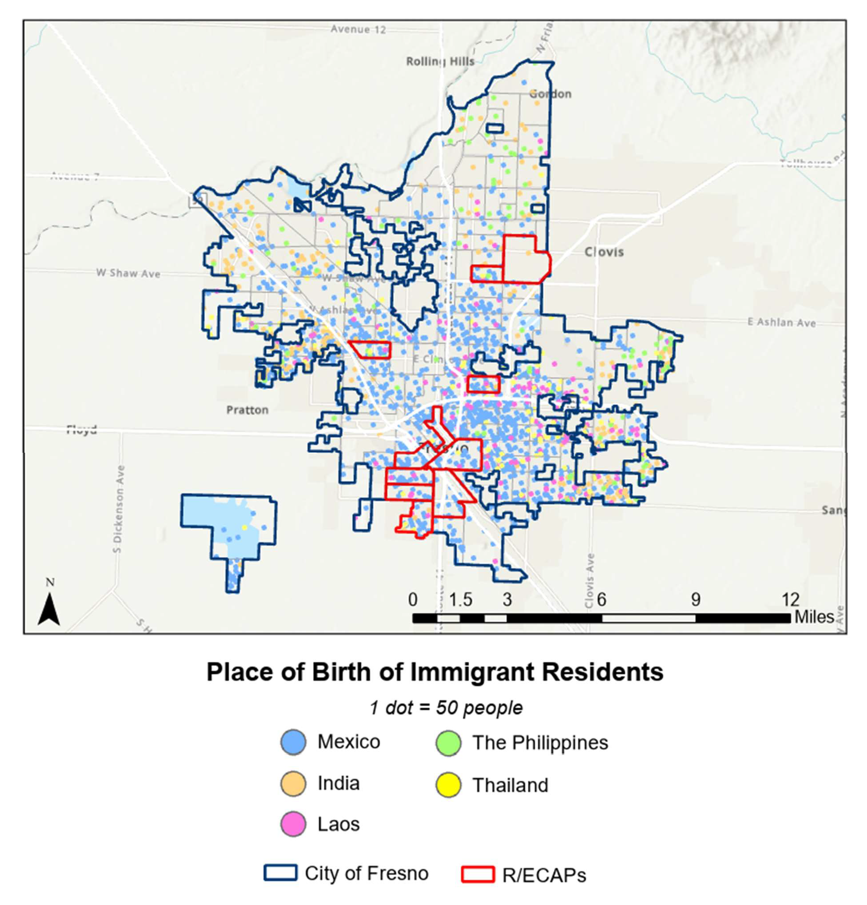

R/ECAPs

City of Fresno

Thailand

The Philippines

Laos

India

Mexico

**Place of Birth of Immigrant Residents**

1 dot = 50 people

**FIGURE 14. POPULATION WITH LIMITED ENGLISH PROFICIENCY IN FRESNO, 2019 TO 2023**

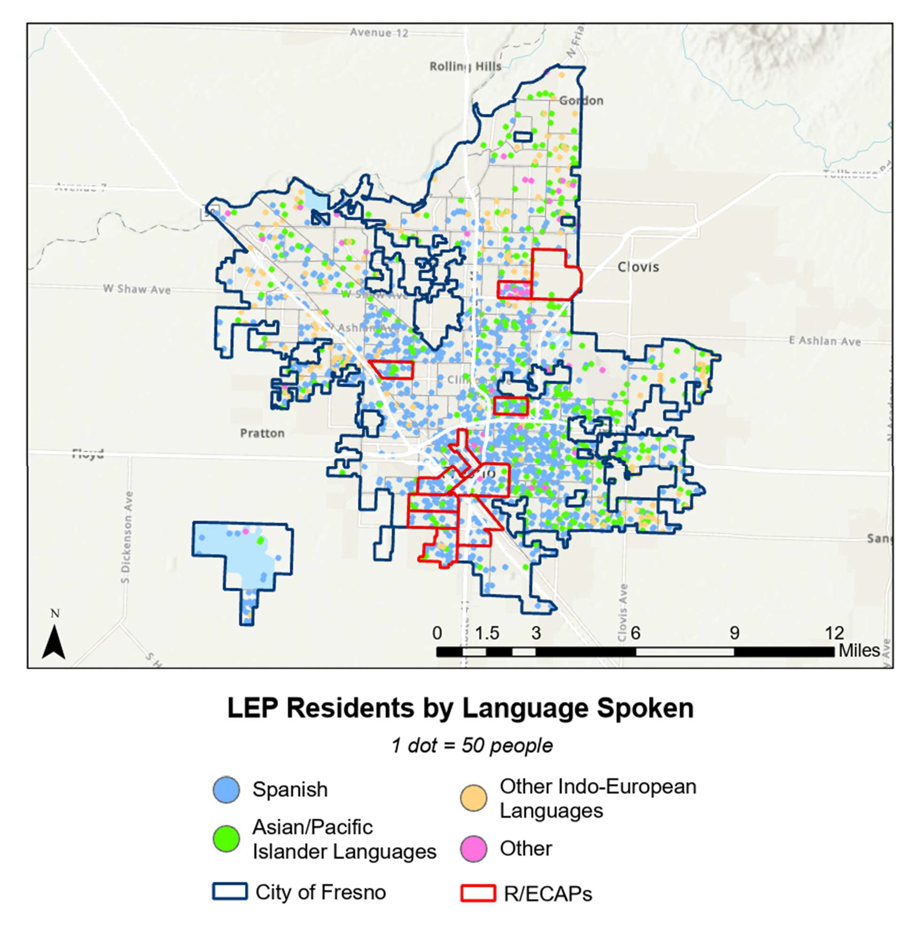

R/ECAPs

City of Fresno

Other

**LEP Residents by Language Spoken**

1 dot = 50 people

Other Indo-European Languages

Asian/Pacific Islander Languages

Spanish

## ACCESS TO OPPORTUNITY

Where people live shapes prospects for economic mobility and access to resources and services such as high-quality education; affordable transportation; a healthy environment; fresh, affordable food; and healthcare. However, neighborhood or housing choices are often limited by discrimination in housing markets or public policies that result in concentrated poverty, disinvestment, and a lack of affordable housing in neighborhoods with access to high-performing schools and jobs that pay living wages. In this way, limited housing choices reduce access to opportunity for many protected classes.

In addition to proximity, access to opportunity is also shaped by economic, social, and cultural factors. For example, residents may live in locations with high numbers of jobs but may be unable to obtain them due to gaps in education or skills, a lack of reliable transportation, or childcare needs.

The strategy to improve access to opportunity through housing and community development programs has been two-pronged. Programs such as tenant-based housing vouchers provide recipients with mobility to locate in lower-poverty areas, while programs such as the Community Development Block Grant and Choice Neighborhoods Initiative provide funds to increase opportunities in low- or moderate-income neighborhoods. The following sections detail access to opportunity in the city of Fresno, including employment and workforce development, education, transportation, low-poverty neighborhoods, environmental quality, fresh food, and healthcare.

### Employment and Workforce Development

Neighborhoods with high numbers of jobs nearby are often assumed to have good access to those jobs. However, other factors—transportation options, the types of jobs available in the area, or the education and training necessary to obtain them—may also shape residents’ access to available jobs. For example, residents of a neighborhood in close proximity to a high number of living-wage jobs may not have the skills or education required for those jobs, and thus may continue to experience high levels of unemployment, work in low-wage positions, or need to commute long distances to access employment. Labor market engagement and jobs proximity, when considered together, often offer a better indication of how accessible jobs are for residents.

##### Labor Market Engagement

Educational attainment, labor force participation, and unemployment are indicators of residents’ engagement with the labor market. In the city of Fresno, 16.7% of residents aged 25 and over hold a bachelor’s degree or higher, a slightly higher share than that of the Fresno metropolitan area (15.1%) and lower than that of the state of California overall (22.4%). Geographic disparities in educational attainment exist, with the percentage of

residents with bachelor’s degrees or higher ranging from 1.6% to 69.7% across the city’s census tracts. Residents of parts of north Fresno, including areas such as Fort Washington, Gordon, and Woodward Park, tend to have the highest levels of educational attainment. In three census tracts in these areas, the share of residents aged 25 and over with a bachelor’s degree or higher is 60% or higher. Educational attainment tends to be lowest in central and south Fresno, including census tracts in and around Mayfair, the Fresno Airport, and downtown (see Figure 15).

#### FIGURE 15. EDUCATIONAL ATTAINMENT, CITY OF FRENSO, 2019-2023

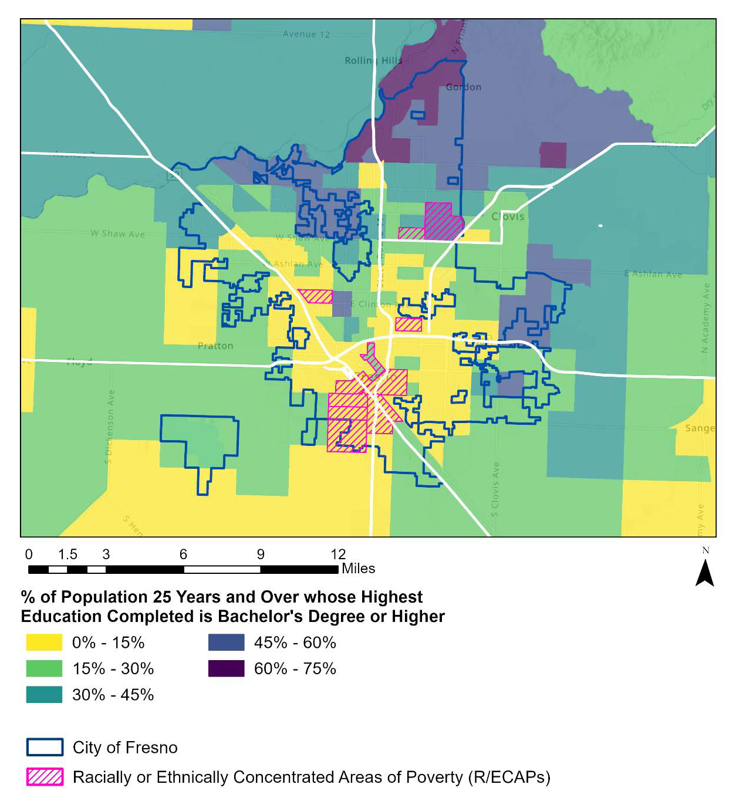

Racially or Ethnically Concentrated Areas of Poverty (R/ECAPs)

City of Fresno

Miles

**% of Population 25 Years and Over whose Highest Education Completed is Bachelor’s Degree or Higher**

*Data Source: 2019-2023 American Community Survey Five-Year Estimates*

Disparities in educational attainment also exist by race and ethnicity in the city. White and Asian residents tend to have higher levels of educational attainment (an estimated 37.2%

and 32.7% have a bachelor’s degree or higher, respectively), while Native American residents, residents of some other race, and Hispanic or Latino residents are least likely to have higher levels of education (10.1%, 13.2%, and 14.2% have a bachelor’s degree or higher, respectively).

#### FIGURE 16. EDUCATIONAL ATTAINMENT BY RACE/ETHNICITY, CITY OF FRESNO, 2019-2023

40%

35%

37.2%

32.7%

20.6%

19.9%

18.3%

14.2%

13.2%

10.1%

**% of Population with a Bachelor's Degree or Higher**

30%

25%

20%

15%

10%

5%

0%

**White Black or**

**African American**

**Native American**

**Asian Pacific Islander**

**Some Other Race**

**Two or More Races**

**Hispanic or Latino**

*Data Source: 2019-2023 American Community Survey Five-Year Estimates*

An estimated 62.6% of the population aged 16 and over in the city of Fresno participates in the labor force, a slightly higher share than that of the Fresno metropolitan area (60.6%) but slightly lower than that of the state of California overall (63.9%). As with educational attainment, geographic disparities exist, with labor force participation rates ranging from 12.5% to 77.9% in census tracts across the city. The census tract with the lowest labor force participation rate (Tract 1) is located in downtown Fresno, bordered by H St. and M St. The other tract with a low labor force participation rate (under 40%) is located near Sunnyside, just north of the Braley Canal. Labor force participation is above 40% in all other tracts in the city, with the highest rates in parts of north, east, and west Fresno (see Figure 17). In these areas, the labor force participation rate is 70% or higher.

#### FIGURE 17. LABOR FORCE PARTICIPATION RATE, CITY OF FRESNO, 2019-2023

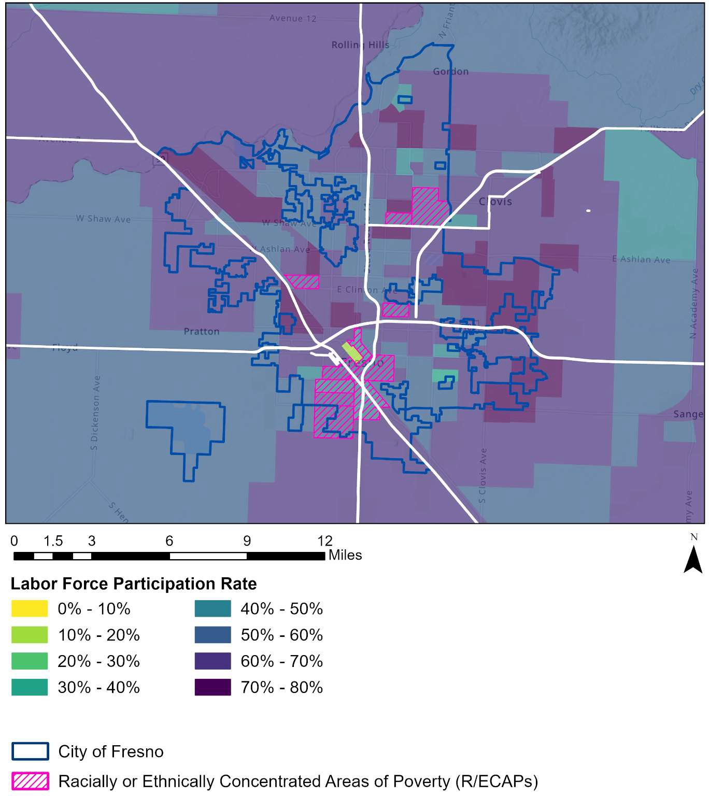

Racially or Ethnically Concentrated Areas of Poverty (R/ECAPs)

City of Fresno

Miles

**Labor Force Participation Rate**

*Data Source: 2019-2023 American Community Survey Five-Year Estimates*

Labor force participation is highest among Hispanic or Latino residents and residents of two or more races, who participate in the labor force at rates of 65.8% and 66.3%, respectively. Participation is lowest among White residents (58.1%).

#### FIGURE 18. LABOR FORCE PARTICIPATION BY RACE/ETHNICITY, CITY OF FRESNO, 2019-2023

70%

65%

66.3%

65.8%

63.7%

62.6%

62.6%

59.1%

59.1%

58.1%

60%

**Labor Force Participation Rate**

55%

50%

**White Black or**

**African American**

**Native American**

**Asian Pacific Islander**

**Some Other Race**

**Two or More Races**

**Hispanic or Latino**

*Data Source: 2019-2023 American Community Survey Five-Year Estimates*

An estimated 8.7% of Fresno residents were unemployed as of the 2019 to 2023 ACS five-year estimates, a rate nearly identical to that of the Fresno MSA (8.8%). However, this unemployment rate remains higher than California’s overall unemployment rate (6.4%). More recent data from the California Employment Development Department (EDD) shows the unemployment rate in the Fresno MSA is 7.7% as of November 2024, which is slightly lower than 2019-2023 estimates but still higher than the unemployment rates at the state level (5.3%).

As with educational attainment and labor force participation, unemployment varies by area, ranging from 0% to 37.3% in census tracts across the city. Unemployment is highest in central Fresno, including the downtown area and areas near Hyde Park and Nielsen Park. In three census tracts in these areas, unemployment is greater than 20%. The areas with the lowest levels of unemployment are clustered in north Fresno, including Fort Washington and areas surrounding Old Fig Garden.

#### FIGURE 19. UNEMPLOYMENT RATE, CITY OF FRESNO, 2019-2023

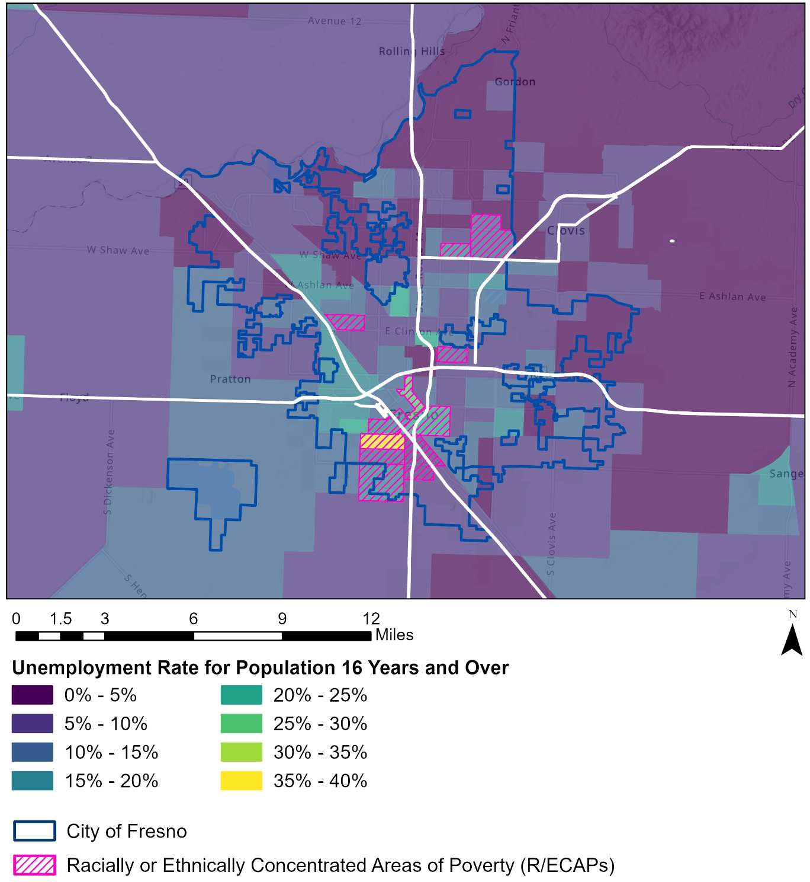

**Unemployment Rate for Population 16 Years and Over**

Miles

City of Fresno

Racially or Ethnically Concentrated Areas of Poverty (R/ECAPs)

*Data Source: 2019-2023 American Community Survey Five-Year Estimates*

The unemployment rate is highest among Native American and Black or African American residents (15.3% and 12.8%, respectively) and lowest among Pacific Islander and White residents (2.3% and 6.1% respectively; see Figure 20).

#### FIGURE 20. UNEMPLOYMENT RATE FOR POPULATION AGED 16+ BY RACE/ETHNICITY, CITY OF FRESNO, 2019-2023

18%

16%

14%

15.3%

12.8%

10.3%

9.7%

8.9%

7.1%

6.1%

2.3%

**Unemployment Rate Among Population 16+**

12%

10%

8%

6%

4%

2%

0%

**White Black or**

**African American**

**Native American**

**Asian Pacific Islander**

**Some Other Race**

**Two or More Races**

**Hispanic or Latino**

*Data Source: 2019-2023 American Community Survey Five-Year Estimates*

Household income is another indicator of access to employment and jobs that pay living wages. The median household income in Fresno was $66,804 as of the 2019-2023 American Community Survey five-year estimates, lower than that of both the Fresno metropolitan area and the state of California overall ($71,897 and $96,334, respectively). Median household incomes are lowest in central Fresno, where they fall below $20,000 in two census tracts considered R/ECAPs (tracts 9.02 and 1). Incomes are highest in the areas near or within Fort Washington, Sunnyside, Tarpey Village, and Old Fig Garden, where the median household income is above $100,000 in 28 census tracts.

#### FIGURE 21. MEDIAN HOUSEHOLD INCOME, CITY OF FRESNO, 2019-2023

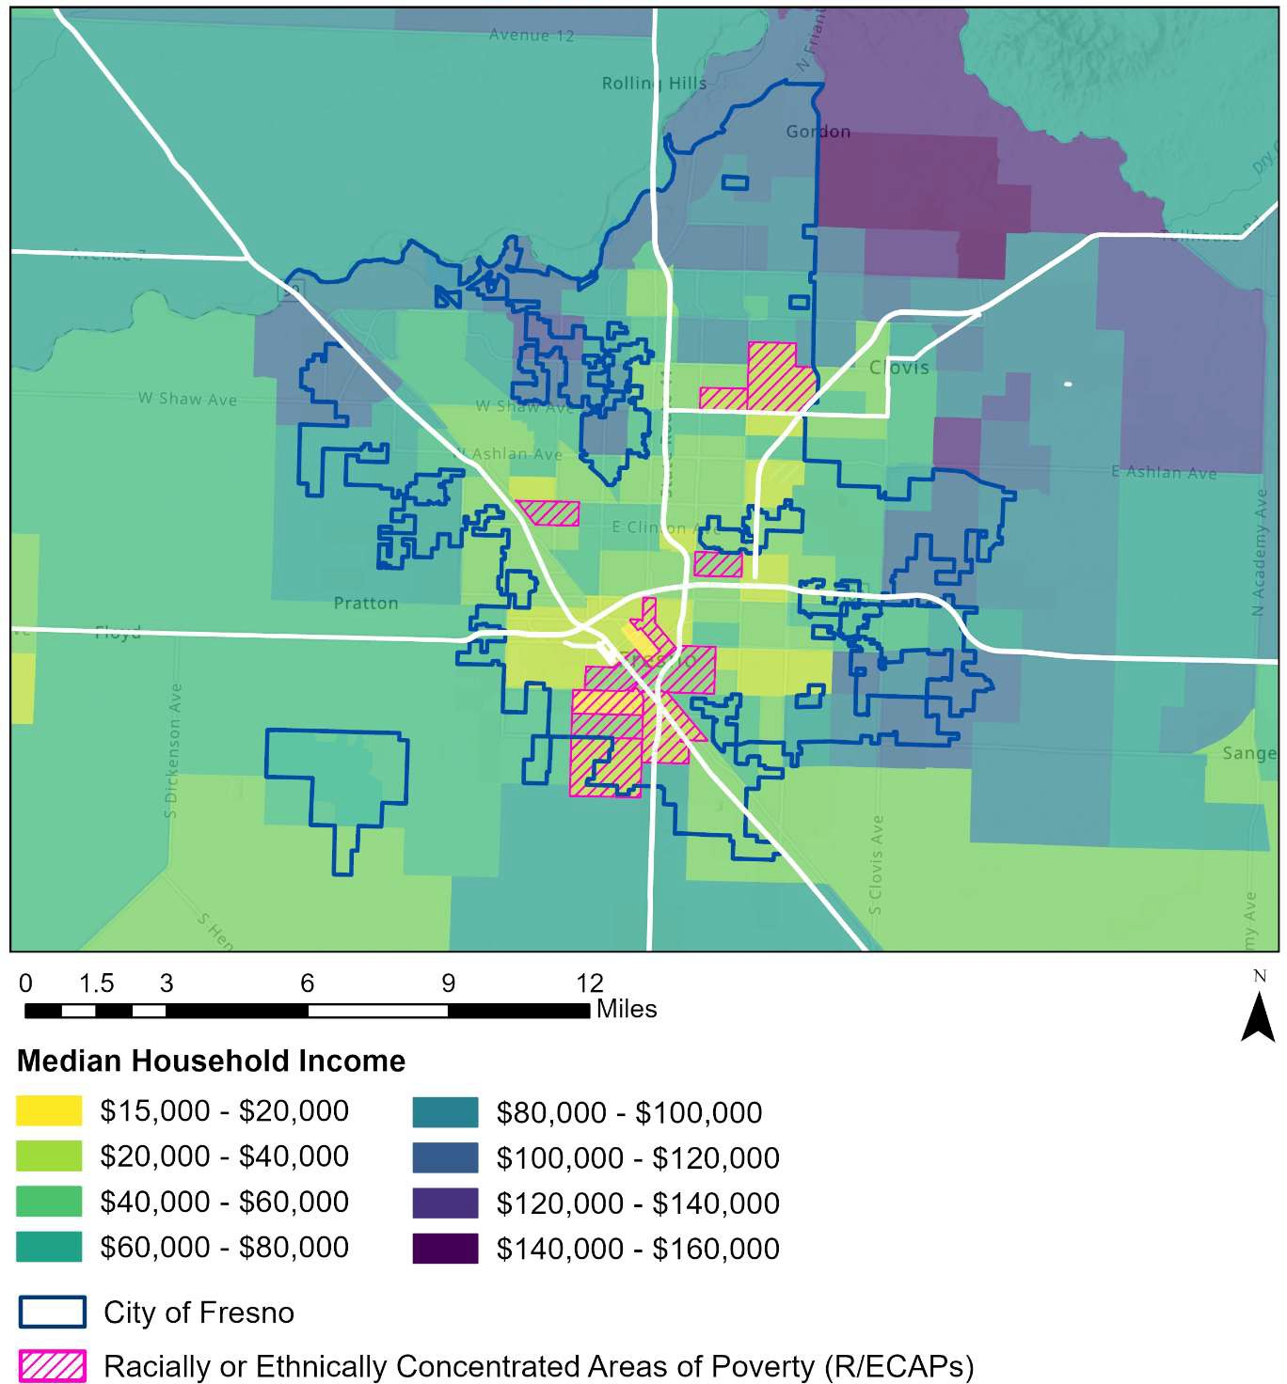

City of Fresno

Racially or Ethnically Concentrated Areas of Poverty (R/ECAPs)

Miles

**Median Household Income**

*Data Source: 2019-2023 American Community Survey Five-Year Estimates*

Median household incomes are highest for Asian residents, ($83,106) and lowest for Black or African American residents ($46,392, see Figure 22).

#### FIGURE 22. MEDIAN HOUSEHOLD INCOME BY RACE/ETHNICITY, CITY OF FRESNO, 2017-2021

$90,000

$80,000

$83,106

$76,703

$63,011

$63,106

$60,986

$57,582

$56,604

$46,392

$70,000

**Median Household Income**

$60,000

$50,000

$40,000

$30,000

$20,000

$10,000

$0

**White Black or**

**African American**

**Native American**

**Asian Pacific Islander**

**Some Other Race**

**Two or More Races**

**Hispanic or Latino**

*Data Source: 2019-2023 American Community Survey Five-Year Estimates*

Low median household incomes in many of the city’s census tracts highlight the fact that a high proportion of households do not have sufficient incomes to afford basic needs. Costs for a family of two working adults and one child in Fresno, including housing, childcare, healthcare, food, transportation, taxes, and other miscellaneous costs, are estimated at about $6,236 per month (or $74,841 annually). Yet, 17.5% of primary jobs held by residents pay $1,250 per month or less ($15,000 or less per year), and 34.4% of primary jobs pay between $1,251 and $3,333 (between $15,000 and $39,996 per year).

21 MIT Living Wage Calculator. (2024 Update). City of Fresno. Retrieved from: https://livingwage.mit.edu/metros/23420

22 U.S. Census OnTheMap. (2022). Retrieved from: https://onthemap.ces.census.gov/

##### Jobs Proximity

Using HUD’s jobs proximity index, which quantifies the accessibility of a neighborhood as a function of its distance to all job locations within a Core Based Statistical Area (CBSA), residents living in central Fresno and the Pinedale neighborhood have the highest accessibility to employment opportunities (see Figure 23). Areas with the lowest accessibility to jobs include most of the areas bordering Fresno city limits to the north, east, and west. These include areas such as Fort Washington, Herndon, and Goldleaf.

#### FIGURE 23. JOB PROXIMITY, CITY OF FRESNO, 2020

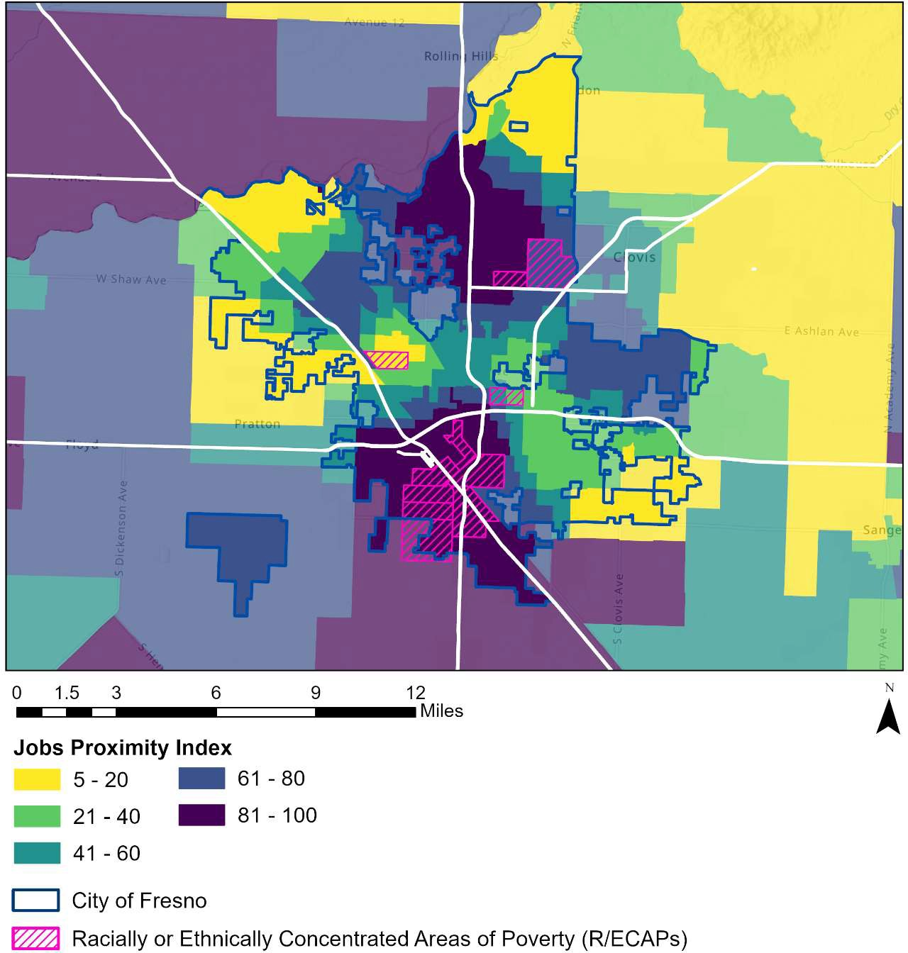

**Jobs Proximity Index**

Miles

City of Fresno

Racially or Ethnically Concentrated Areas of Poverty (R/ECAPs)

*Data Source: HUD, Jobs Proximity Index 2020. https://hudgis- hud.opendata.arcgis.com/datasets/HUD::jobs-proximity-index-2020/about*

Longitudinal Employer-Household Dynamics data also indicate that a little under half of

residents living in the city of Fresno work outside of the city. Specifically, an estimated 214,544 employed residents live in the city of Fresno. These include 120,463 residents (56.1%) who both live and work in Fresno and 94,081 residents who live in Fresno but are employed outside of the city (43.9%). Similarly, of the 258,216 workers employed in the city of Fresno, 137,753 (53.3%) live outside of the city. The high level of commuting across jurisdictions indicates that limited access to vehicles and a lack of frequent public transportation in some areas are often barriers for residents in accessing employment.

#### TABLE 5. INFLOW AND OUTFLOW OF WORKERS (PRIMARY JOBS), CITY OF FRESNO, 2022

|  |  |  |
| --- | --- | --- |
| **Inflow and Outflow of Workers** | **#** | **%** |
| **LIVING IN THE CITY OF FRESNO 214,544 100.0%** | | |

Living in the City of Fresno but Employed Outside of the City 94,081 43.9%

|  |  |  |
| --- | --- | --- |
| Living and Employed in the City of Fresno | 120,463 | 56.1% |
| **EMPLOYED IN THE CITY OF FRESNO** | **258,216** | **100.0%** |
| Employed in the City of Fresno but Living Outside of the City | 137,753 | 53.3% |

Employed and Living in the City of Fresno 120,463 46.7%

*Data Source: Longitudinal Employer Household Dynamics (LODES) data, 2022*

### Education

School proficiency is an indication of the quality of education that is available to residents of an area. High-quality education is a vital community resource that can lead to more opportunities—such as employment and increased earnings—and improve quality of life. Most public schools within the city of Fresno fall within the Fresno Unified School District, which includes 106 schools that serve more than 65,000 students. Some areas of the city are served by Central Unified or Clovis Unified, and the Washington, Fowler, and Sanger districts also intersect the city limits (see Figure 24).

#### FIGURE 24. CITY OF FRESNO SCHOOL DISTRICTS

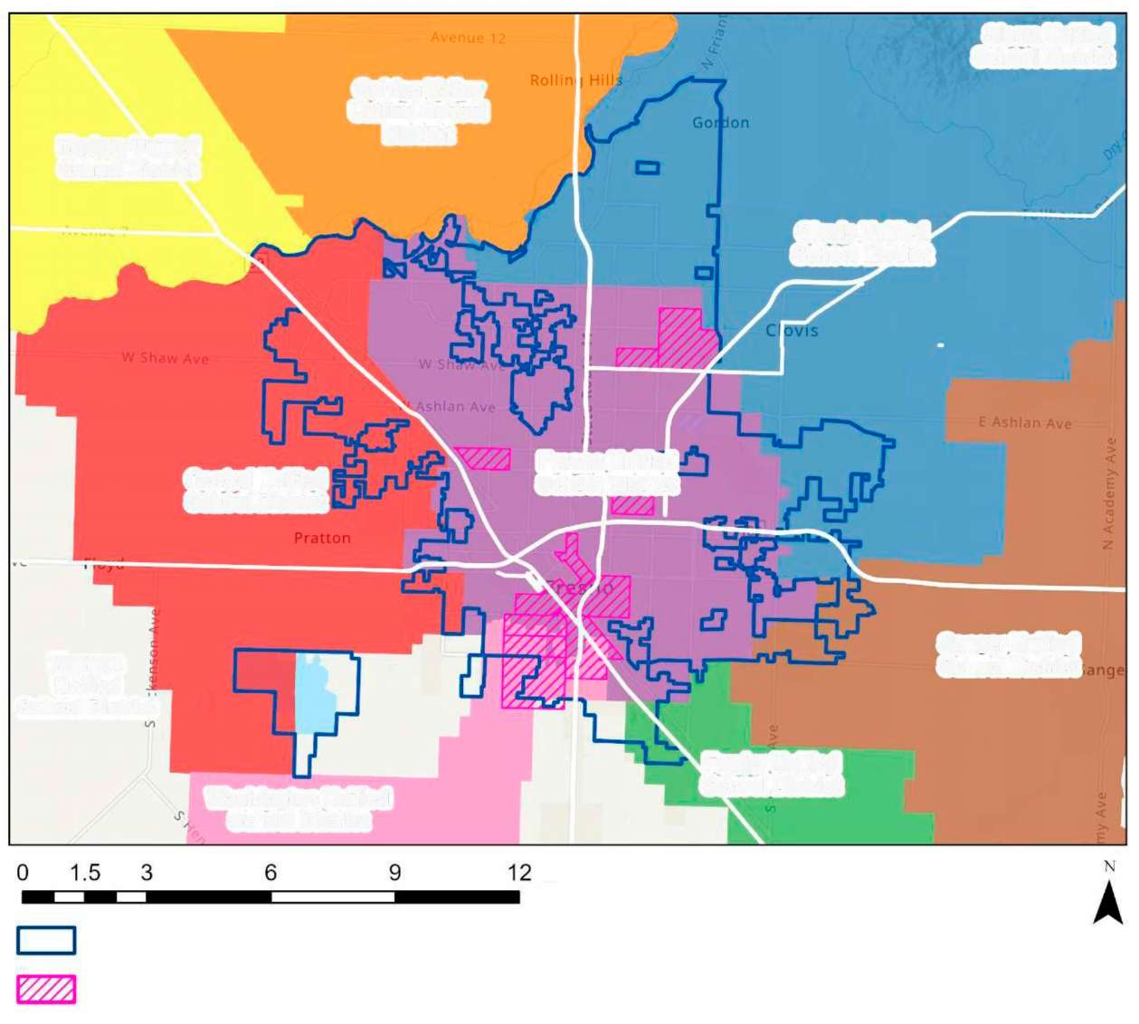

**Sierra Unified**

**School District**

**Clovis Unified**

**School District**

**Unified School**

**District**

**Golden Valley**

**School District**

**Madera Unified**

**Central Unified**

**School District**

**School District**

**Fresno Unified**

**School District**

**Sanger Unified**

**School District**

**Fowler Unified**

**Washington Unified**

**School District**

Miles

City of Fresno

Racially or Ethnically Concentrated Areas of Poverty (R/ECAPs)

**School District**

**Kerman Unified**

The majority of students attending Fresno Unified district schools are Hispanic (70%). Asian and Pacific Islander students comprise approximately 11% of district students, while Black and White students each make up 7.4% of the district student population. An

estimated 88.2% of students in the district are economically disadvantaged, 13.7% have a disability, and 20.6% are English learners, according to the California Department of Education (see Table 6).

The Central Unified school district population is also majority Hispanic (61.3%), with Asian and Pacific Islander students representing the second largest share at 16.7%. White students make up 10.8% of the student population and Black students comprise 7.7%. Approximately 81% of the district population is economically disadvantaged, 10.9% have a disability, and 13.9% are English learners.

Comparatively, in the Clovis Unified school district, Hispanic students make up less than half the population (41.2%) while White students make up slightly less than one-third (31.4%). Asian and Pacific Islander students comprise 15.7% of the district’s population and Black students make up 3.2%. Less than half of the district population is economically disadvantaged (46.4%), 10% have a disability, and 4.8% are English learners.

Content mastery is low in Fresno Unified and Central Unified, which exhibit content mastery scores lower than the state averages in language arts and math across all grade levels. In contrast, Clovis Unified has significantly higher scores than the state averages and other area school districts across all grades and subjects. The graduation rates at Fresno Unified and Central Unified are similar to the state average (86.2%, 89%, and 86.7%, respectively), while the rate at Clovis Unified is higher at 95.9%.

While these data indicate overall low levels of access to proficient schools across the city, analysis of school proficiency by geography details specific locations with lower- and higher-performing schools (see Figure 25). Block groups that rank highest on HUD’s School Proficiency Index—indicating better access to proficient schools—tend to be located in north Fresno. Of the 13 block groups in Fresno that have school proficiency index scores of over 90, 12 of these 13 groups are located in the Fort Washington area, which overlaps with the Clovis Unified School District.

Block groups that rank lowest on the index are clustered in west and central Fresno,

23 Content Mastery addresses whether students are achieving at the level necessary to be prepared for the next grade, college, or career. It includes achievement scores in English language arts, mathematics, science, and social studies based on student performance on the California Assessment of Student Performance and Progress (CAASPP) System and Smarter Balanced Assessment System.

24 The school proficiency index uses school-level data on the performance of 4th grade students on state exams to describe which neighborhoods have high-performing elementary schools nearby and which are near lower performing elementary schools. The school proficiency index is a function of the percent of 4th grade students proficient in reading (r) and math (m) on state test scores for up to three schools (i=1,2,3) within 1.5 miles of the block-group centroid. Values are percentile ranked and range from 0 to 100. The higher the score, the higher the school system quality is in a neighborhood.

including block groups within and near the Fresno-Chandler Executive Airport, Edison neighborhood, and Downtown Fresno within six of the city’s R/ECAPs. Seventy-two block groups in these areas have school proficiency index scores of 10 or lower, indicating very low levels of access to proficient schools for many Fresno residents. The majority of these neighborhoods overlap with areas served by the Fresno Unified School District.

These data support stakeholder engagement claims about discrepancies in school demographics, funding, access, and educational opportunity across the city, with many parents expressing interest in their children attending Clovis Unified schools. Survey responses on fair housing and access to opportunity also support that disparities in access to proficient schools are a primary concern among residents. Among all survey respondents, 25% said that schools are equally provided across neighborhoods in the city of Fresno, while 42% said that they are not equally provided.

#### TABLE 6. DISTRICT DEMOGRAPHICS AND PERFORMANCE

|  |  |  |  |  |
| --- | --- | --- | --- | --- |
| **NUMBER OF STUDENTS** | **Fresno Unified** | **Clovis Unified** | **Central Unified** | **State of California** |
| 68,246 | 42,624 | 15,956 | 5,837,690 |
| **NUMBER OF SCHOOLS** | 66 | 49 | 25 | 9,997 |
| **DEMOGRAPHICS** |  |  |  |  |
| **Black** | 7.4% | 3.2% | 7.7% | 4.9% |
| **Hispanic** | 70.0% | 41.2% | 61.3% | 56.1% |
| **Asian or Pacific Islander** | 10.8% | 15.7% | 16.7% | 4.6% |
| **Multi-Racial** | 3.0% | 4.5% | 2.1% | 4.6% |
| **White** | 7.4% | 31.4% | 10.8% | 20.3% |
| **Native American** | 0.7% | 0.6% | 0.5% | 0.4% |
| **Economically Disadvantaged** | 88.2% | 46.4% | 81.0% | 62.7% |
| **English Learners** | 20.6% | 4.8% | 13.9% | 18.4% |
| **Students with a Disability**  **CONTENT MASTERY – MATH** | 13.7% | 10.0% | 10.9% | 13.7% |
| **Elementary** | 30 | 56 | 33 | 40 |
| **Middle** | 22 | 49 | 28 | 33 |
| **High** | 14 | 48 | 17 | 27 |
| **CONTENT MASTERY – LANGUAGE ARTS** | | | | |
| **Elementary** | 32 | 60 | 39 | 44 |
| **Middle** | 34 | 68 | 41 | 46 |
| **High** | 44 | 80 | 54 | 55 |
| **GRADUATION RATE** | 86.2 | 95.9 | 89.0 | 86.7 |

*Source: California School Dashboard, 2024, and Smarter Balanced Test Results.*

# 63

#### FIGURE 25. SCHOOL PROFICIENCY INDEX, CITY OF FRESNO, 2023

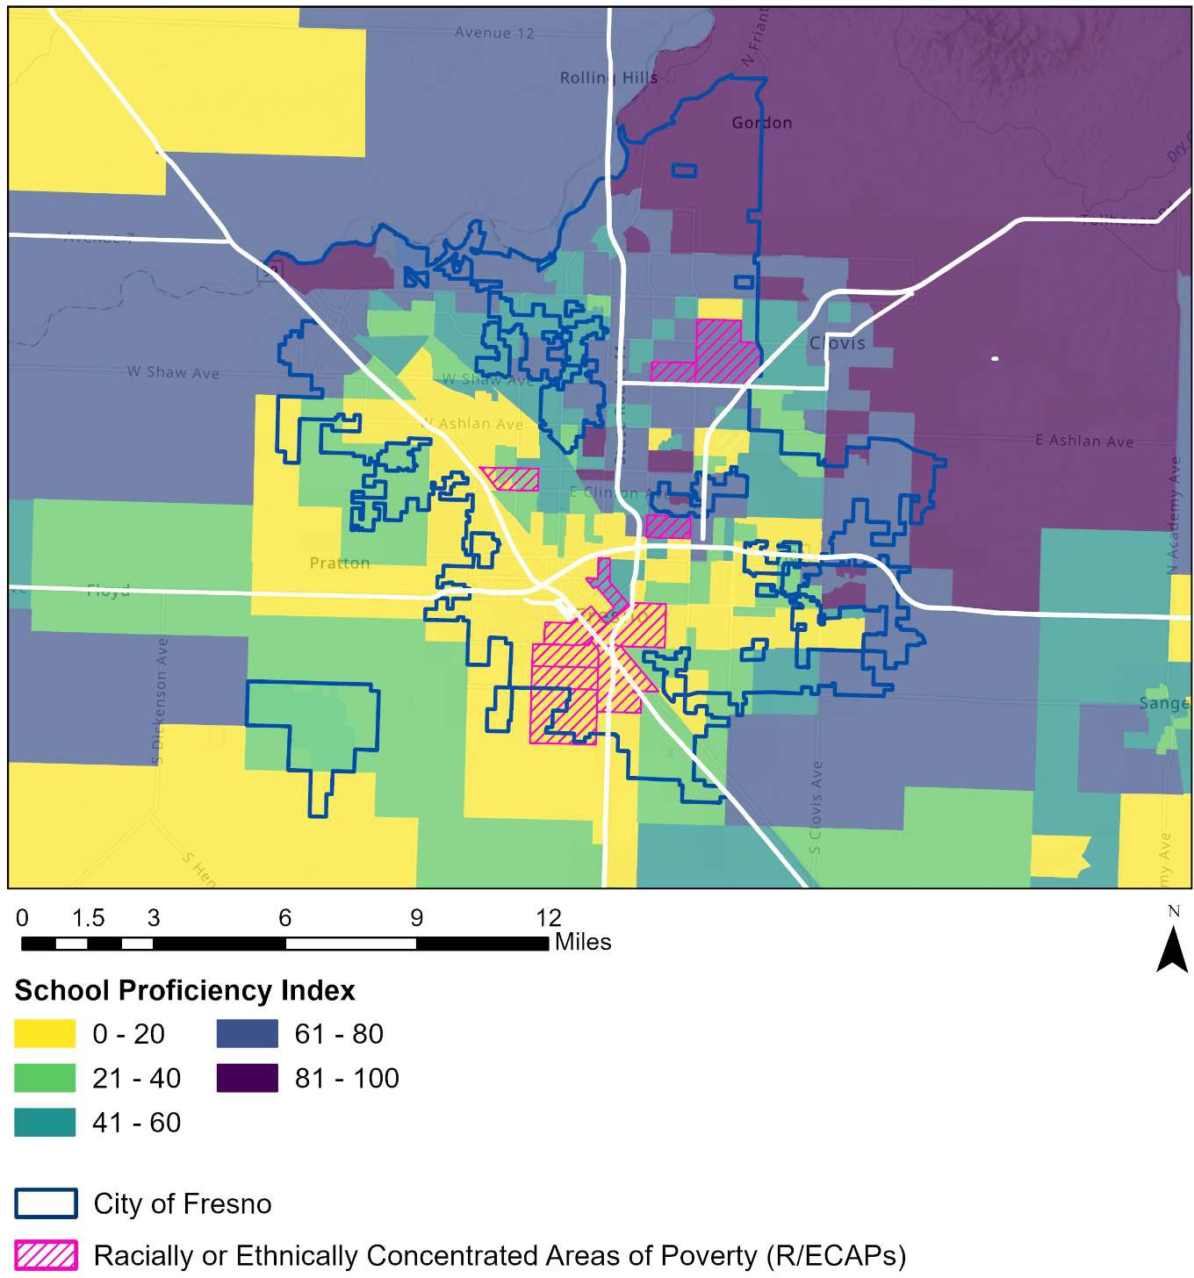

**School Proficiency Index**

Miles

City of Fresno

Racially or Ethnically Concentrated Areas of Poverty (R/ECAPs)

*Source: HUD School Proficiency Index, https://hudgis-hud.opendata.arcgis.com/maps/school-proficiency-index*

Low school proficiency index scores across the city points to a high level of need for strategies to meet the needs of students. Approaches to education that seek to meet students’ needs, such as the community schools model, may provide additional support to help students succeed in school, including:

* Expanded and enriched learning time, including after-school programs, summer programs, and culturally relevant, real-world learning opportunities;
* Active family and community engagement, including service provision and meaningful partnership with students, families, and community members;
* Collaborative leadership and practices, including coordination of community school services; site-based, cross-stakeholder leadership teams; teacher learning communities; and the ongoing sharing and use of early warning data; and
* Integrated student support, mental and physical health care, nutrition support, and housing assistance, which are often provided through strategic community partnerships.25

Funding for similar programs that provide collaborative, integrated support for students can help increase access to proficient schools for residents who may lack the opportunity to move to higher-performing schools or zones.

25 Center for Universal Education at Brookings. (2021). Addressing education inequality with a next generation of community schools: A blueprint for mayors, states, and the federal government; Maier, Daniel, Oakes, and Lam. (2017). Community Schools as an Effective School Improvement Strategy: A Review of the Evidence. Learning Policy Institute and National Education Policy Center.

### Transportation

Affordable, accessible transportation makes it easier for residents to access a range of opportunities, providing connections to employment, education, fresh food, healthcare, and other services. Low-cost public transit can facilitate access to these resources, while a lack of access to affordable transportation poses barriers to meeting key needs, particularly in areas with low levels of walkability and a lack of access to vehicles.

##### Access to Affordable Transportation

The Fresno Area Express (FAX) provides bus and mobility service in the city of Fresno (see Figure 26). As of 2024, it currently operates 17 fixed routes and one bus rapid transit (BRT) route through FAX Q, which began service in 2018.

When asked whether bus service is equally provided throughout all communities in the city, 42% of survey respondents said no, while 29% said yes.

#### FIGURE 26. FAX BUS SERVICE IN CITY OF FRESNO

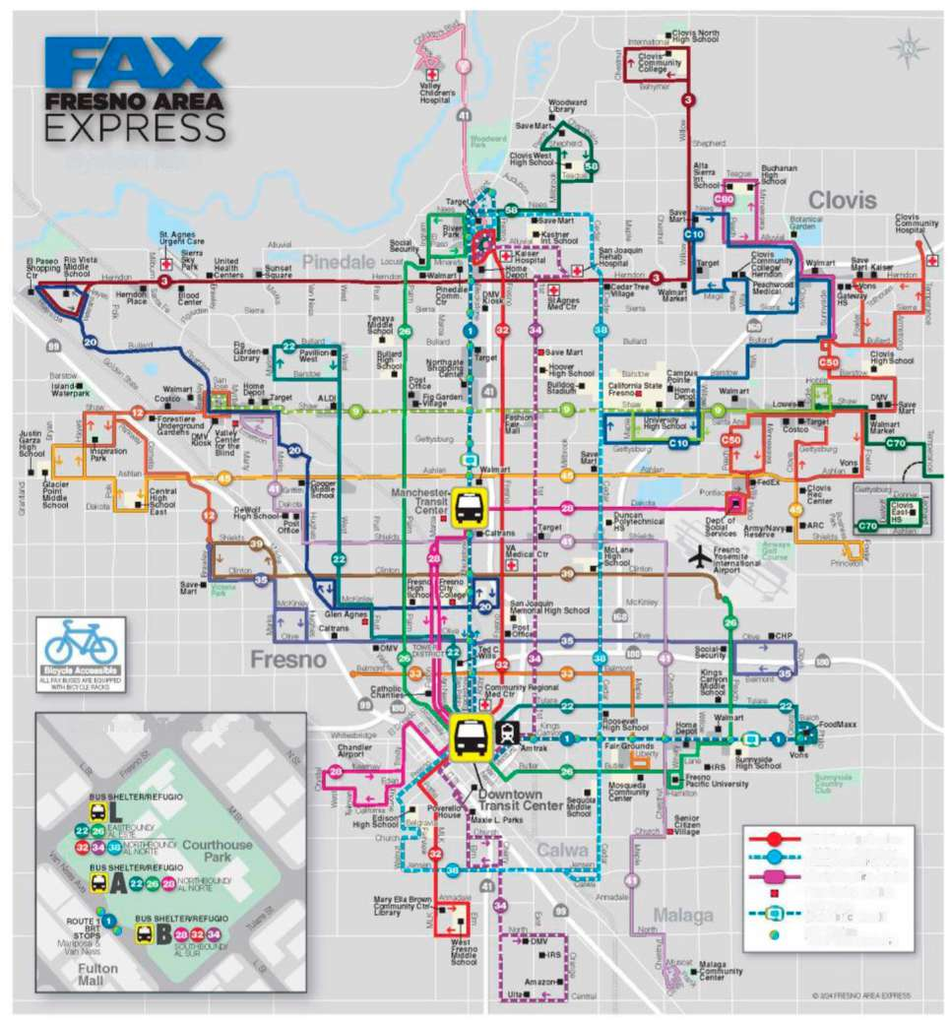

**System Map**

**Downtown Transit Center**

FAX Weekday Service

15 Minute Frequency WEEKDAY FROM 6AM TO 6PM

Clovis Stageline Service

Pass Outlet Location

BRT Route

(Bus Rapid Transit)

BRT Station:

TICKET VENDING MACHINE

HUD’s Location Affordability Index models the numbers of public transit trips for households by census tract. Estimates for moderate-income three-person households with income at 80% of the area median show that transit use is most common in central Fresno in the downtown region, while households near the outskirts of the city tend to use public transit less frequently (see Figure 27).

#### FIGURE 27. NUMBER OF ANNUAL TRANSIT TRIPS FOR MODERATE-INCOME HOUSEHOLDS (80% AMI)

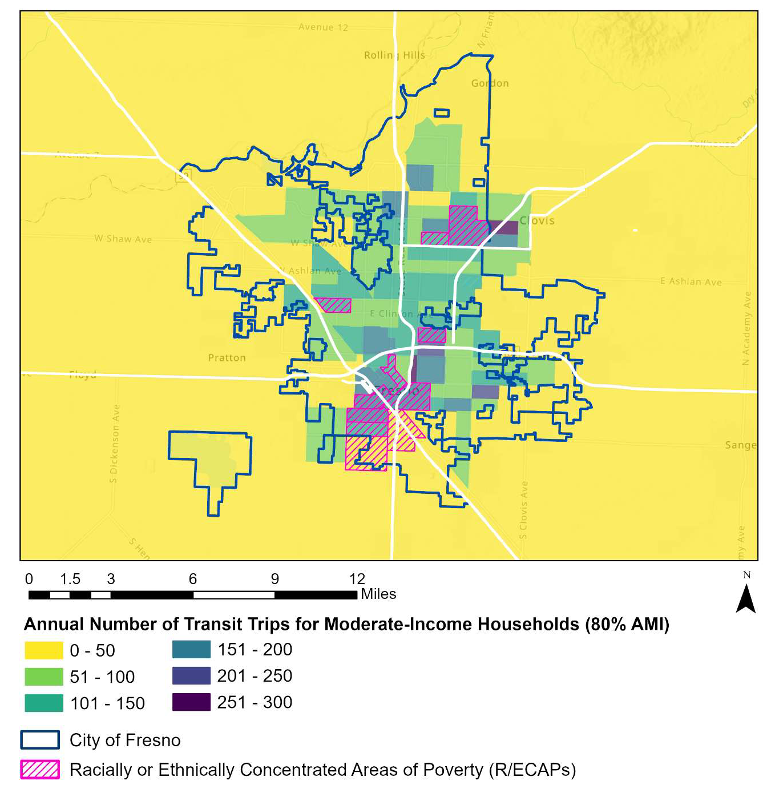

Miles

City of Fresno

Racially of Ethnically Concentrated Areas of Poverty (R/ECAPs)

**Annual Number of Transit Trips for Moderate-Income Households (80% AMI)**

*Data Source: HUD Location Affordability Index V3, https://hudgis- hud.opendata.arcgis.com/datasets/HUD::location-affordability-index-v-3/about*

Considering transportation costs together with housing costs can provide an expanded view of a neighborhood’s affordability. The Center for Neighborhood Technology sets an affordability benchmark for housing and transportation costs at no more than 45% of a household’s income. There is only one census tract in the city of Fresno that falls below this affordability threshold – tract 1 in central Fresno, where the combined housing and transportation cost makes up approximately 42% of moderate-income household expenses.

Combined housing and transportation costs tend to make up a greater share of household income in the outskirts of the city. Dark purple areas in Figure 28 indicate tracts where housing and transportation costs comprise 65% or more of household income. In these areas, the combination of lower proximity to jobs and transit and higher shares of household income spent on transportation presents barriers to obtaining and maintaining employment and housing.

#### FIGURE 28. HOUSING AND TRANSPORTATION COSTS AS PERCENT OF INCOME FOR MODERATE-INCOME HOUSEHOLDS (80% AMI)

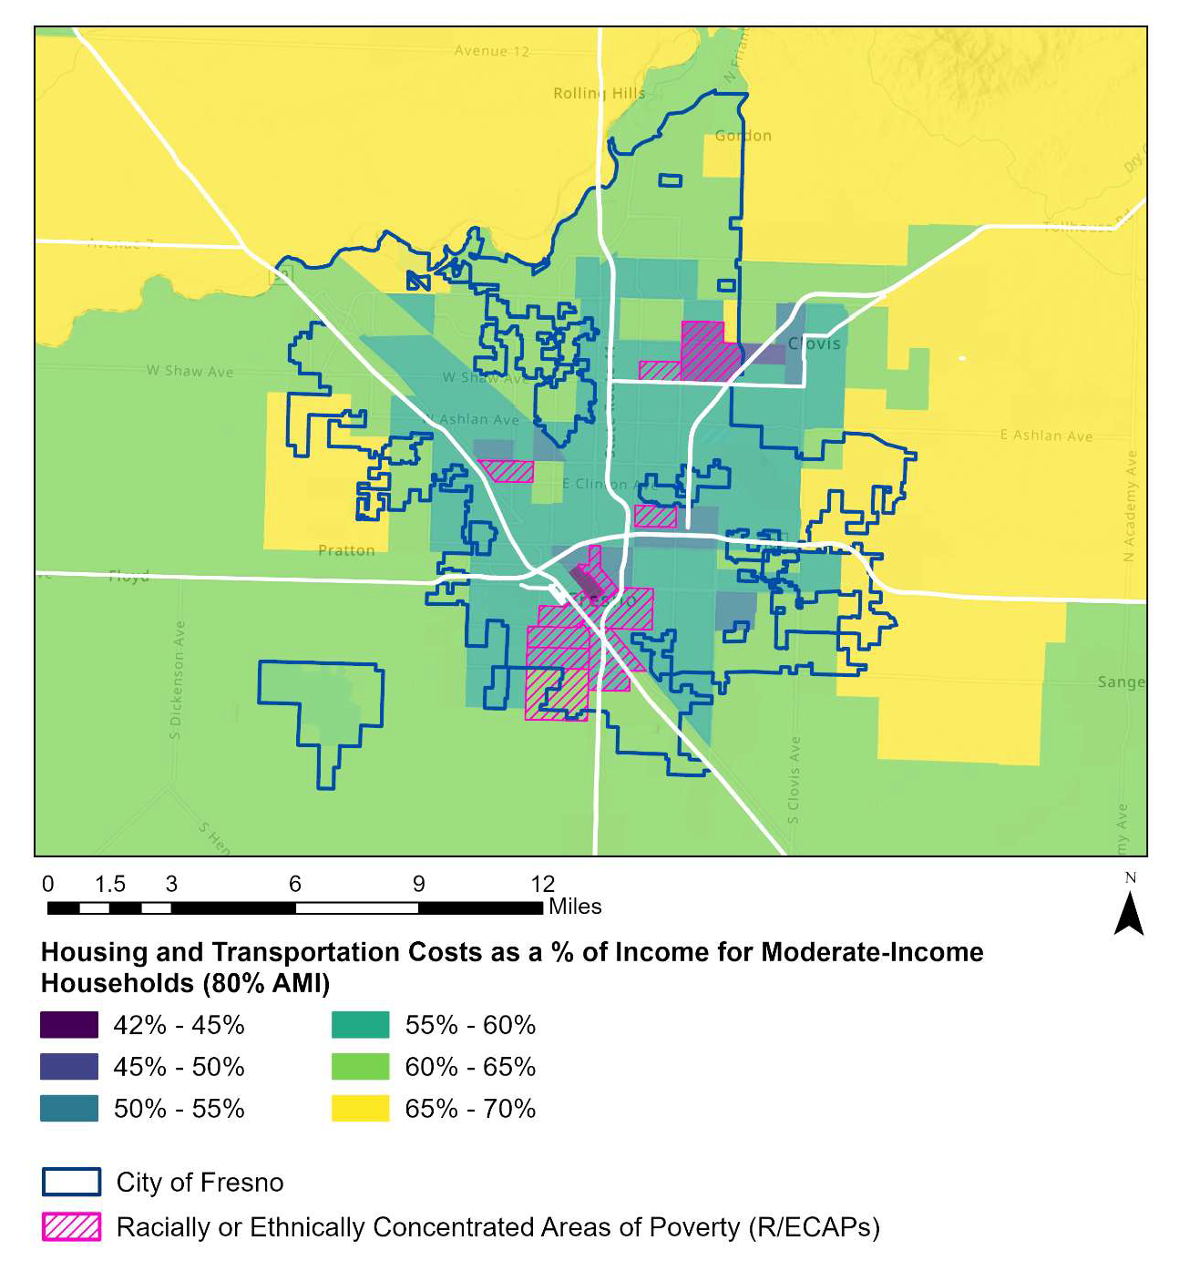

City of Fresno

Racially of Ethnically Concentrated Areas of Poverty (R/ECAPs)

**Housing and Transportation Costs as a % of Income for Moderate-Income Households (80% AMI)**

Miles

*Data Source: HUD Location Affordability Index V3, https://hudgis- hud.opendata.arcgis.com/datasets/HUD::location-affordability-index-v-3/about*

##### Vehicle Access

Access to vehicles also shapes residents’ ability to connect to employment and education opportunities, resources, and services, particularly in areas with limited access to public transit. An estimated 8.5% of households in the city of Fresno do not have a vehicle, according to American Community Survey five-year estimates for 2019-2023. While vehicle access is high overall, disparities exist by geography and reflect access to bus

service in the city. Vehicle access is lowest in central Fresno, with tract 1 (also identified in the previous section) exhibiting the lowest access to vehicles – over 50% of households living in this tract do not have access to a vehicle. Vehicle access is comparatively high across the rest of the city, especially in areas near or surrounding Highway City, Sunnyside, and Fort Washington.

Residents and stakeholders who participated in this planning process emphasized that a lack of access to vehicles is often a barrier to employment for residents living in areas with low proximity to jobs and with limited access to public transportation. A lack of access to vehicles also creates barriers to accessing needed services in areas in which those services are not located within walking distance and transit access is limited. In this way, residents without access to vehicles often find their housing choices limited to locations where bus service is most accessible.

#### FIGURE 29. VEHICLE ACCESS, CITY OF FRESNO, 2019-2023

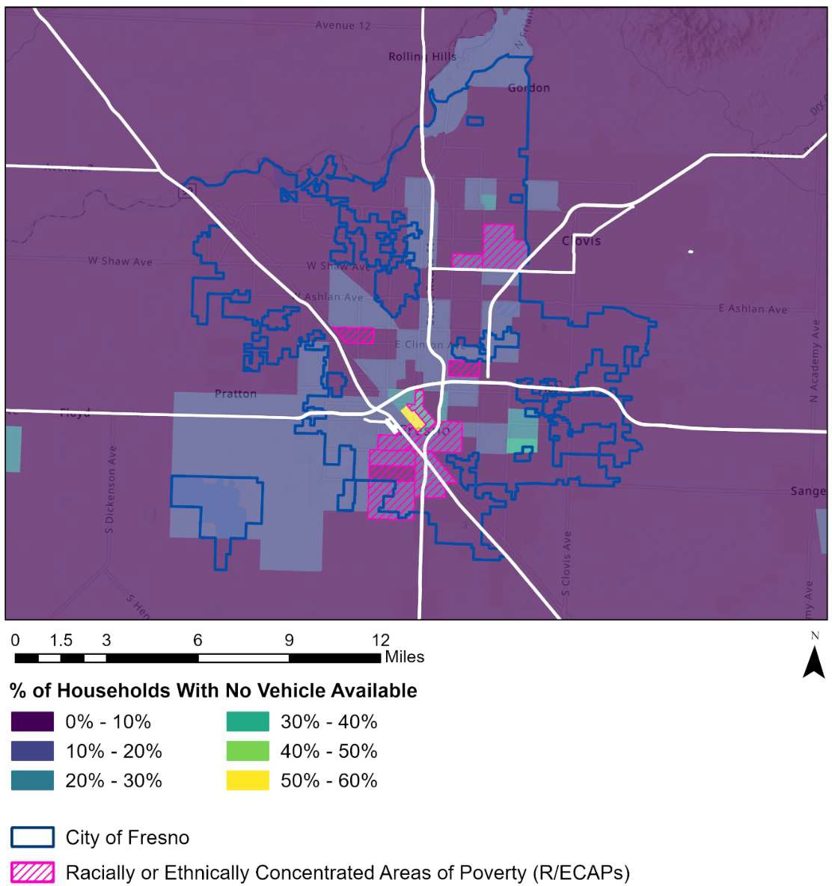

**% of Households With No Vehicle Available**

Miles

Racially of Ethnically Concentrated Areas of Poverty (R/ECAPs)

City of Fresno

*Data Source: 2019-2023 American Community Survey Five-Year Estimates*

##### Walkability

Along with access to transit, low-cost transportation, and vehicles, walkability shapes the extent to which residents are able to access employment, resources, and services. EPA’s National Walkability Index assesses walkability at the block group level based on street intersection density, proximity to transit stops, and diversity of land uses. The city of Fresno as a whole has above average levels of walkability. The most walkable areas, pictured in the deepest shade of green in Figure 30, include several tracts in downtown and north Fresno, one in central Fresno, and two in Clovis. Areas with above average walkability are clustered in central Frenso and in the area bordered by E. Shaw Ave to the north and E. Ashlan Ave to the south. Areas that are least walkable are indicated by orange in Figure 16 and include the southernmost area of the city and the area surrounding the Fresno-Clovis Regional Wastewater Treatment Facility, which includes three of the city’s R/ECAP tracts. Yellow indicates below average walkability and is located along the outer edges of the city limits.

#### FIGURE 30. NATIONAL WALKABILITY INDEX FOR CITY OF FRESNO

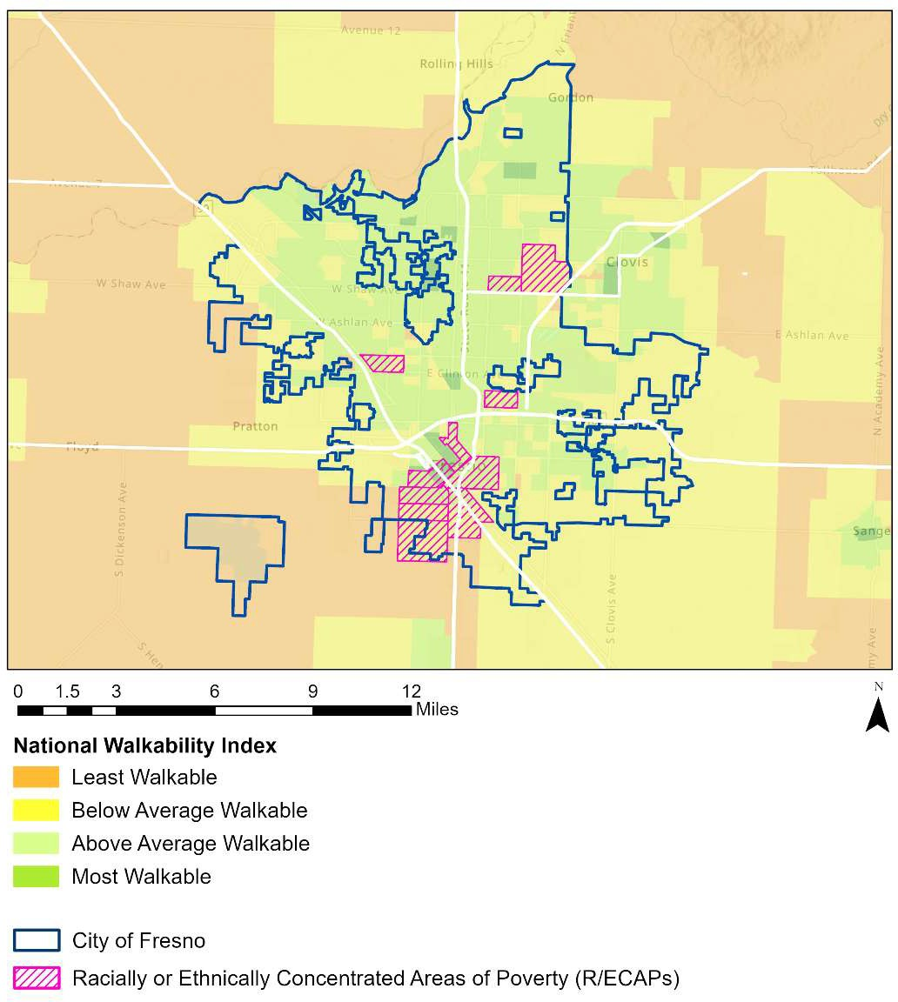

Most Walkable

Above Average Walkable

Below Average Walkable

Least Walkable

Miles

City of Fresno

Racially of Ethnically Concentrated Areas of Poverty (R/ECAPs)

**National Walkability Index**

*Data Source: National Walkability Index, https://*[*www.epa.gov/smartgrowth/national-walkability-index-*](http://www.epa.gov/smartgrowth/national-walkability-index-) *user-guide-and-methodology*

### Low-Poverty Neighborhoods

Poverty rates are highest in central Fresno, east of the Fresno-Chandler Executive Airport, and in tracts directly north of E. Shaw Ave, areas that include the city’s R/ECAPs (see Figure 31). Eleven census tracts in these areas have poverty rates above 40%. Black and Hispanic residents are overrepresented in these high-poverty census tracts relative to their share of the city’s overall population, while White and Asian residents are underrepresented.

Twelve census tracts in the city have poverty rates below 5%. Census tracts with the lowest poverty levels are clustered in north Fresno, in areas such as Fort Washington and Figgarden (see Figure 31). White residents are overrepresented in these lower- poverty census tracts, while Hispanic residents are underrepresented relative to their share of the city’s total population.

Residents and stakeholders who participated in this planning process noted that housing choices for low-income residents in the city of Fresno are often limited to higher-poverty areas by:

* a lack of supply of affordable housing in many areas of the city;
* a lack of supply of housing in general, which drives up overall housing prices;
* a lack of variety of housing types available, including tiny homes, townhomes, and smaller homes that may be more affordable;
* high rental rates and displacement of residents due to increases in rents; and
* limited development of multifamily housing and smaller, more affordable housing units

A lack of affordable housing in many areas of the city of Fresno limits lower-income residents’ housing choices to areas with more affordable housing, which often coincide with areas that have higher poverty rates. The high cost of housing restricts access to housing in many areas of the city for lower-income households, which are disproportionately Black and Hispanic or Latino.

For residents who do not have access to vehicles, housing choices are also often limited by inadequate transportation access in some areas of the city, infrequent bus service, and travel times to places of employment. In this way, residents who rely on public transportation often must live near the city’s FAX bus routes or their places of employment, or else face long commutes to jobs.

#### FIGURE 31. PERCENT OF POPULATION BELOW POVERTY LEVEL, 2019-2023

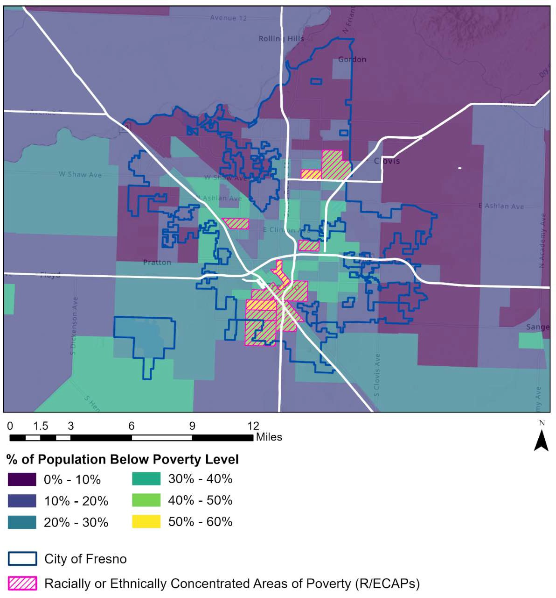

**% of Population Below Poverty Level**

Miles

City of Fresno

Racially of Ethnically Concentrated Areas of Poverty (R/ECAPs)

*Data Source: 2019-2023 American Community Survey Five-Year Estimates*

### Environmental Quality

Environmental quality and access to environmental amenities shape the opportunities available to residents. Access to parks and greenspace can provide a range of environmental, social, and health benefits, including access to nature and recreation opportunities, cleaner air and water, alternative transportation options, improvements in physical and mental health and wellbeing, and opportunities for food production and other local economic development. At the same time, environmental hazards, such as poor air quality and toxic facilities, are associated with negative health effects, including increased respiratory symptoms, hospitalization for heart or lung diseases, cancer and other serious health effects, and even premature death. Certain population groups, such as children, have a greater risk of adverse effects from exposure to pollution.

##### Access to Parks

The Trust for Public Land estimates the need for parks by census block group based on population density, density of low-income households, density of people of color, rates of poor mental health and low physical activity, urban heat islands, and pollution burden. Based on these factors, in Fresno the need for parks is greatest in parts of Mayfair, central Fresno, and south Fresno. Parks are most accessible in north Fresno, near Fort Washington’s Woodward Park.

Community members echoed concerns about park access in the city. Over half of survey respondents (58%) noted that parks and trails are not equally provided in all communities in the city, while only 14% said that they are equally provided.

#### FIGURE 32. PARK ACCESS, CITY OF FRESNO

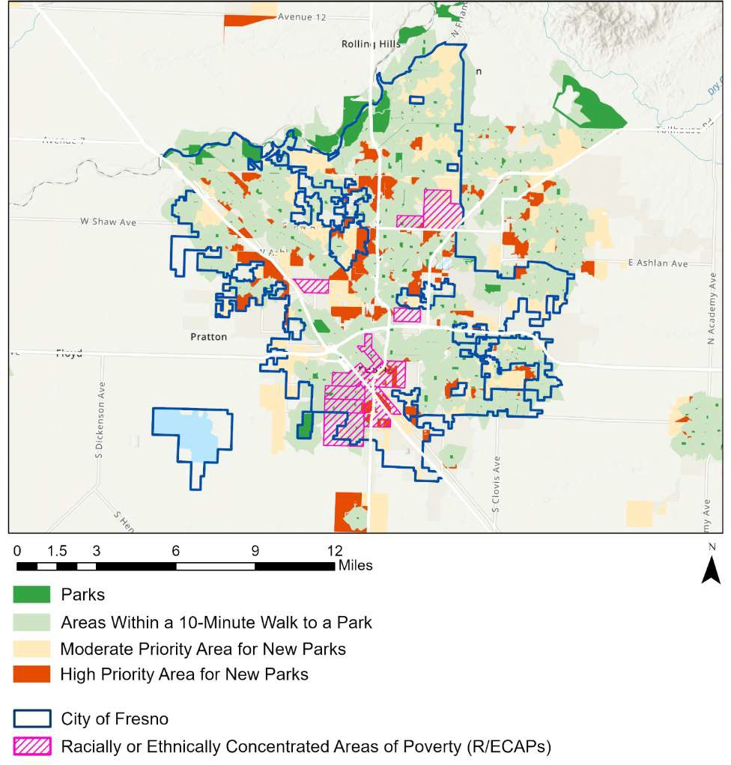

High Priority Area for New Parks

Moderate Priority Area for New Parks

Areas Within a 10-Minute Walk to a Park

Parks

Miles

City of Fresno

Racially of Ethnically Concentrated Areas of Poverty (R/ECAPs)

*Source: Trust for Public Land ParkScore, 2023*

26 Trust for Public Land. (2022). The ParkServe Database. Retrieved from: https://[www.tpl.org/ParkServe/About](http://www.tpl.org/ParkServe/About)

##### Environmental Hazards

Toxic sites may pose risks to residents living nearby and thus may constitute fair housing concerns if they disproportionately impact protected classes. The city has three Superfund sites, which the U.S. Environmental Protection Agency (EPA) defines as any land that has been contaminated by hazardous waste and identified as a candidate for cleanup because it poses a risk to human health and/or the environment. Two of the city’s Superfund sites are currently on the agency’s National Priorities List (NPL) as of 2024 data. They are the Fresno Municipal Sanitary Landfill and Industrial Waste Processing, both of which are located in south Fresno (Figure 33).

The EPA’s National Air Toxics Assessment (NATA) estimates health risks from air toxics. The most recent assessment uses data from 2020 to examine cancer risk from ambient concentrations of pollutants. The city of Fresno has low to moderate levels of cancer risk from air toxins—about 30 to 40 per million in city census tracts. Point sources of emissions are scattered throughout the city but slightly clustered in central and south Fresno, particularly in downtown and the areas surrounding Mayfair, the Fresno Yosemite International Airport, and Calwa (see Figure 34).

The Environmental Protection Agency’s Toxics Release Inventory (TRI) tracks the management of certain toxic chemicals that may pose a threat to human health and the environment. Certain industrial facilities in the U.S. must report annually how much of each chemical is recycled, combusted for energy recovery, treated for destruction, and disposed of or otherwise released on- and off-site. The EPA’s Risk-Screening Environmental Indicators (RSEI) Model analyzes TRI data on the amount of toxic chemicals released, together with risk factors such as the chemical’s fate and transport through the environment, each chemical’s relative toxicity, and the number of people potentially exposed, to calculate a numeric score designed to be compared to other RSEI scores.

27 EPA. (2024). Superfund. Retrieved from: https://[www.epa.gov/superfund/search-superfund-sites-](http://www.epa.gov/superfund/search-superfund-sites-) where-you-live

28 United States Environmental Protection Agency. National Air Toxics Assessment. (2019). Retrieved from: https://[www.epa.gov/national-air-toxics-assessment](http://www.epa.gov/national-air-toxics-assessment)

29 U.S. EPA. (n.d.) Toxic Release Inventory Program. Retrieved from: https://[www.epa.gov/toxics-release-](http://www.epa.gov/toxics-release-) inventory-tri-program/what-toxics-release-inventory. Data retrieved from: https://[www.arcgis.com/home/item.html?id=2c4a0b5f85b945f8a67125e6a93fa7fe](http://www.arcgis.com/home/item.html?id=2c4a0b5f85b945f8a67125e6a93fa7fe)

30 United States Environmental Protection Agency. (n.d.) Risk-Screening Environmental Indicators (RSEI) Model. Retrieved from: https://[www.epa.gov/rsei](http://www.epa.gov/rsei)

Toxic release inventory sites are clustered in south Fresno. In particular, Modern Custom Fabrications Inc owns several sites with potential risk scores that are several times higher than those of other nearby facilities (noted by the size of the purple dots in Figure 35), indicating significantly greater health risks for residents living near the facility. Of the nine sites with RSEI scores greater than 100,000, eight were owned by this corporation.

#### FIGURE 33. SUPERFUND SITES IN THE CITY OF FRESNO, 2024

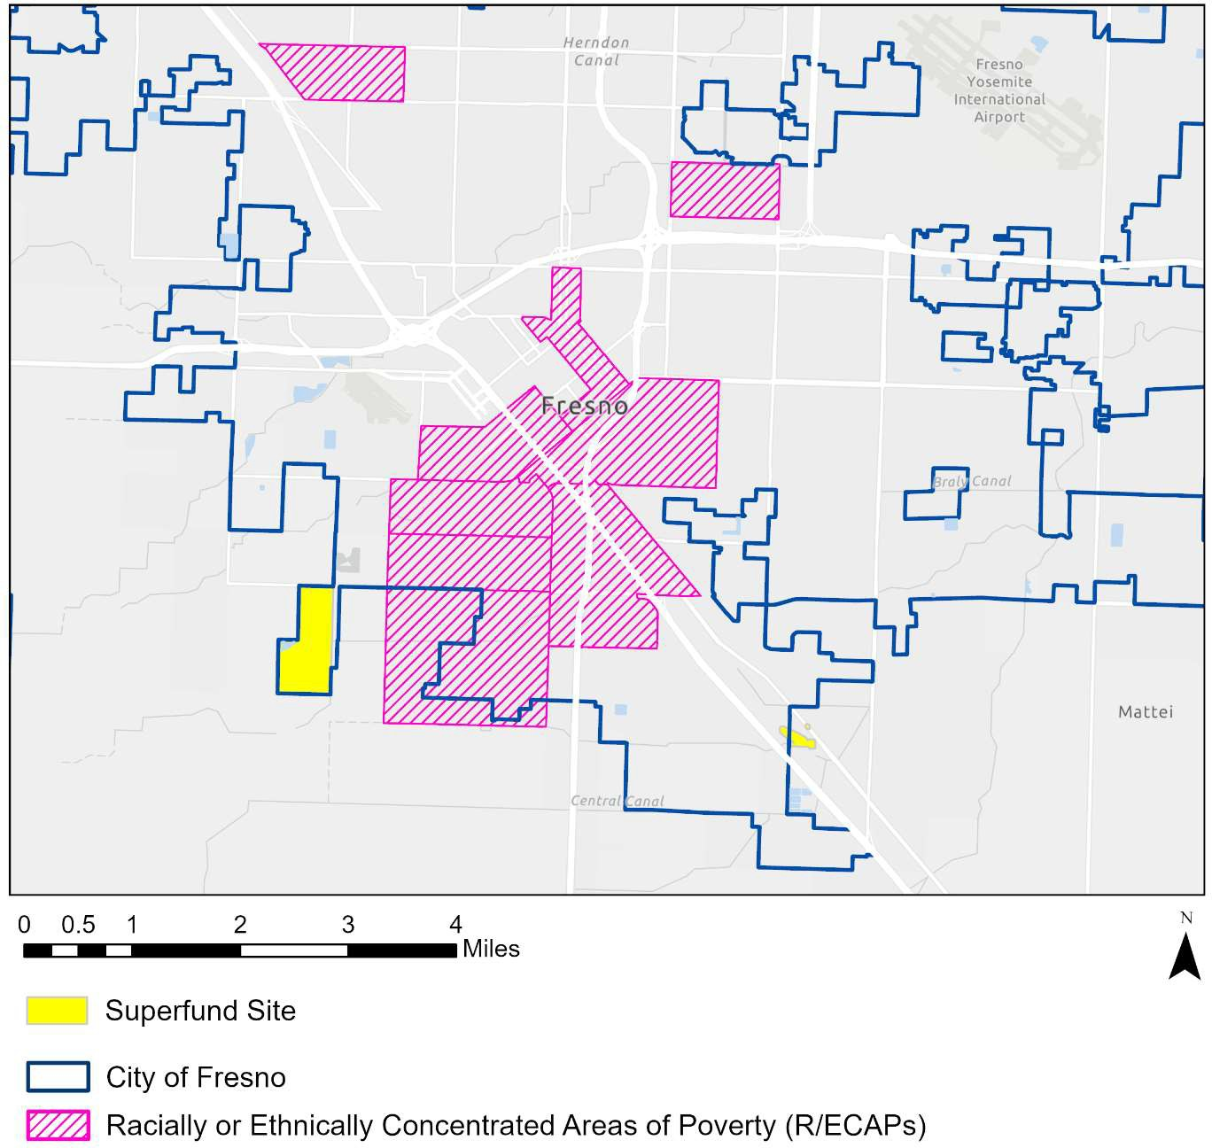

Miles

Superfund Site

City of Fresno

Racially of Ethnically Concentrated Areas of Poverty (R/ECAPs)

*Data Source: EPA. (2024). Superfund. Retrieved from: https://*[*www.epa.gov/superfund/search-superfund-*](http://www.epa.gov/superfund/search-superfund-) *sites-where-you-live*

#### FIGURE 34. NATIONAL AIR TOXICS ASSESSMENT, CITY OF FRESNO, 2020

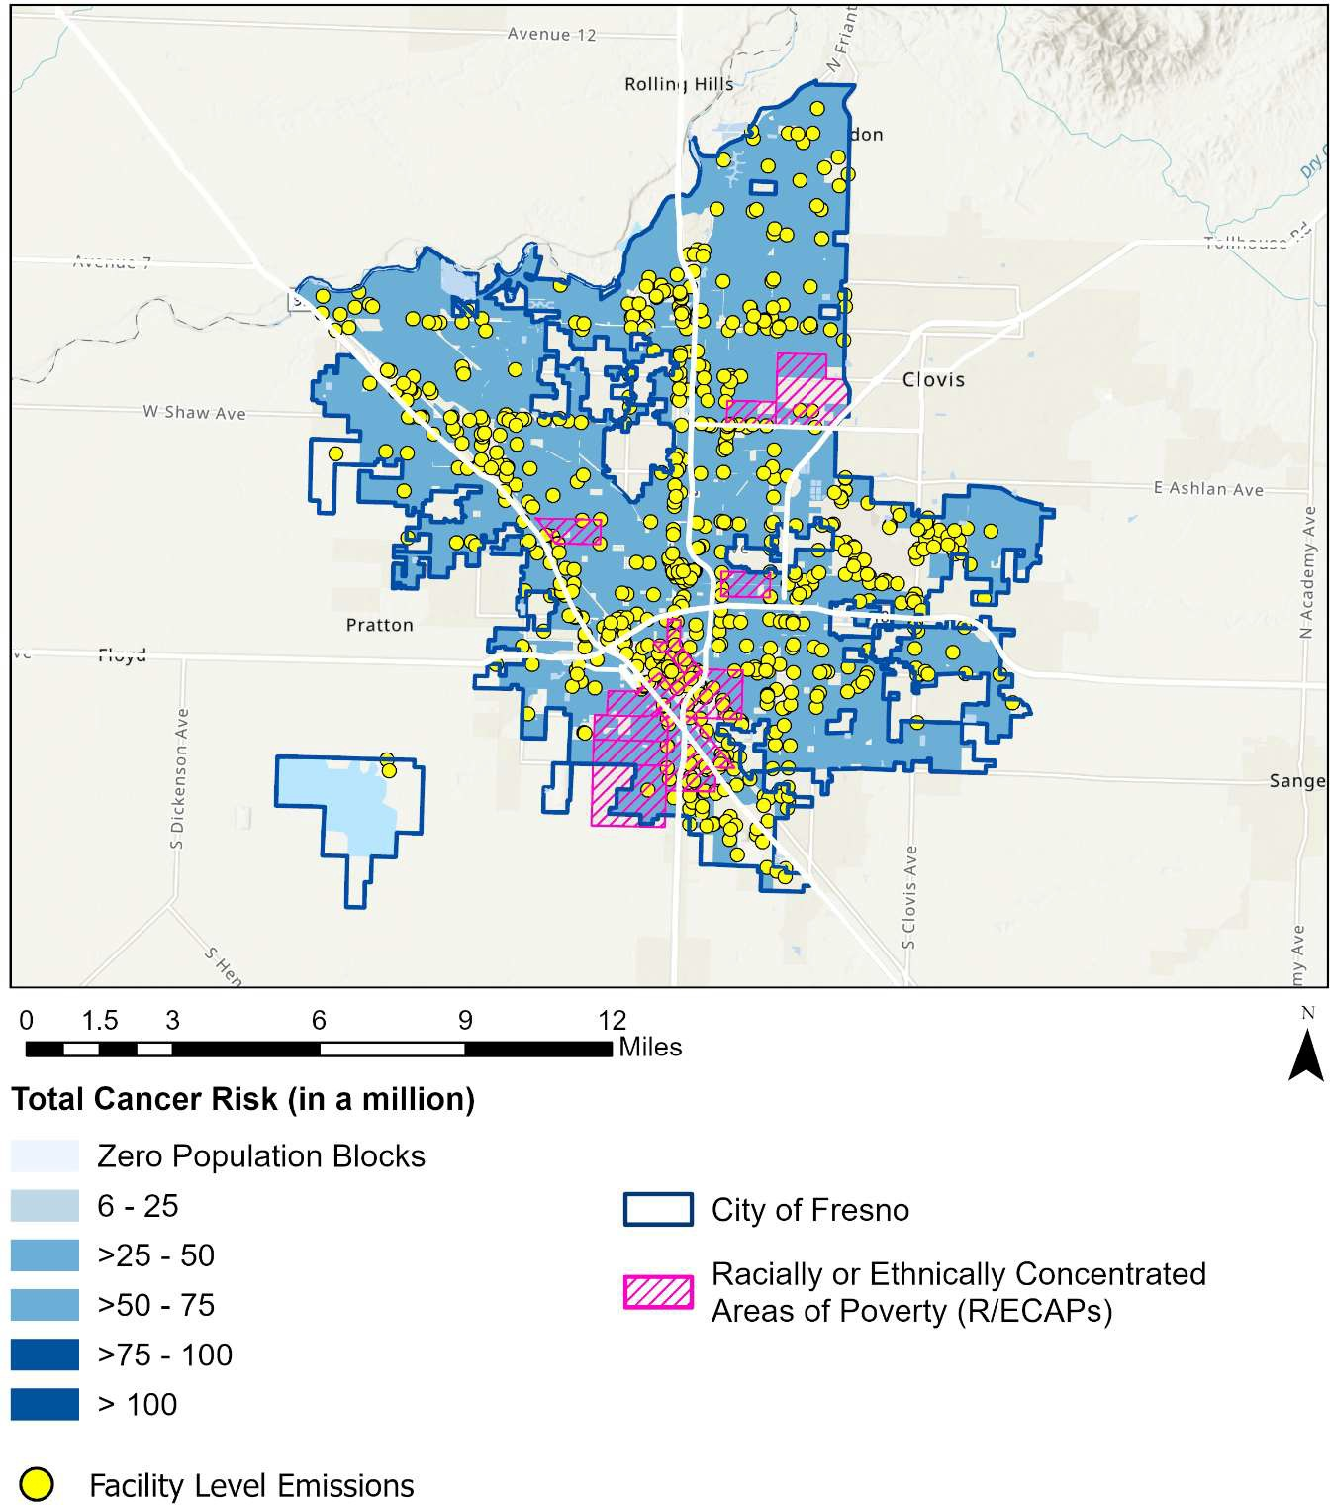

**Total Cancer Risk (in a million)**

Facility Level Emissions

Zero Population Blocks

Racially or Ethnically Concentrated Areas of Poverty (R/ECAPs)

Miles

City of Fresno

*Data Source: EPA (2020) AirToxScreen. https://*[*www.epa.gov/AirToxScreen/airtoxscreen-mapping-tool*](http://www.epa.gov/AirToxScreen/airtoxscreen-mapping-tool)

#### FIGURE 35. TOXIC RELEASE INVENTORY FACILITIES, CITY OF FRESNO, 2021

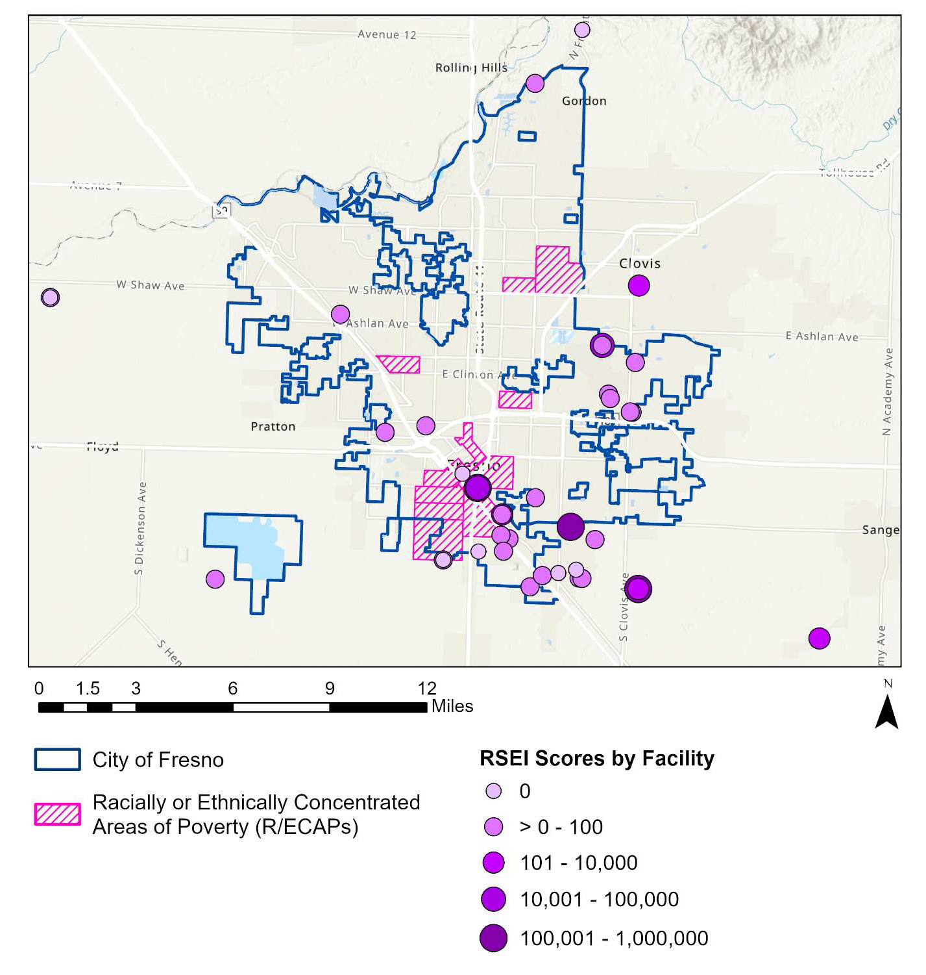

Miles

**RSEI Scores by Facility**

Racially or Ethnically Concentrated Areas of Poverty (R/ECAPs)

City of Fresno

*Data Source: Map of RSEI Scores (2021), EPA Geoservices. https://geopub.epa.gov/arcgis/rest/services/EMEF/rsei/MapServer*

### Food

Many individuals and families face challenges in accessing food that is both healthy and affordable. In neighborhoods in which the nearest grocery store is many miles away, transportation costs and lack of access to vehicles may pose particular challenges for low-income households, who may be forced to rely on smaller stores that are often unaffordable and may not offer a full range of healthy food choices. Even in areas with fresh food retailers nearby, the higher cost of healthy foods such as produce often presents a barrier to accessing healthy food.

USDA Food Research Atlas data indicates that the share of residents who have low incomes and live further than one-half mile from the nearest supermarket is highest in census tracts in south Fresno, between West Park and Calwa. In six census tracts in these areas, 75% or more residents have low incomes and live more than one-half mile from a supermarket (see Figure 36). Additionally, 75% of one census tract’s population is low-income and has low access to grocery stores (tract 54.08 adjacent to E Shaw Ave, also identified as a R/ECAP). In contrast, areas within or surrounding Mayfair, Fort Washington, and the Fresno Yosemite International Airport tend to have the lowest shares of residents with low incomes who live more than one-half mile from a supermarket. In these areas, fewer than 15% of residents are considered low-income and low-access.

Survey respondents echoed concerns surrounding food access, with 62.1% noting that grocery stores and other shopping opportunities are not equally available in all communities, the third highest of all community resources asked about in the survey, behind roads and sidewalks (76.3%) and property maintenance (67.4%).

Poverty and a lack of access to vehicles also contribute to issues of food access and insecurity in the city. An estimated 20.9% of Fresno residents were living below the federal poverty level as of the 2019-2023 American Community Survey five-year estimates, indicating that low incomes are a barrier for a substantial portion of residents in accessing fresh food. Poverty rates are highest in central Fresno and in the areas surrounding Mayfair and Old Fig Garden, where they fall above 40% in 11 census tracts. These tracts are all considered R/ECAPs as well, indicated by the pink crosshatch pattern (see Figure 36).

#### FIGURE 36. PERCENT OF POPULATION WITH LOW INCOMES AND LOW ACCESS TO GROCERY STORES, 2019

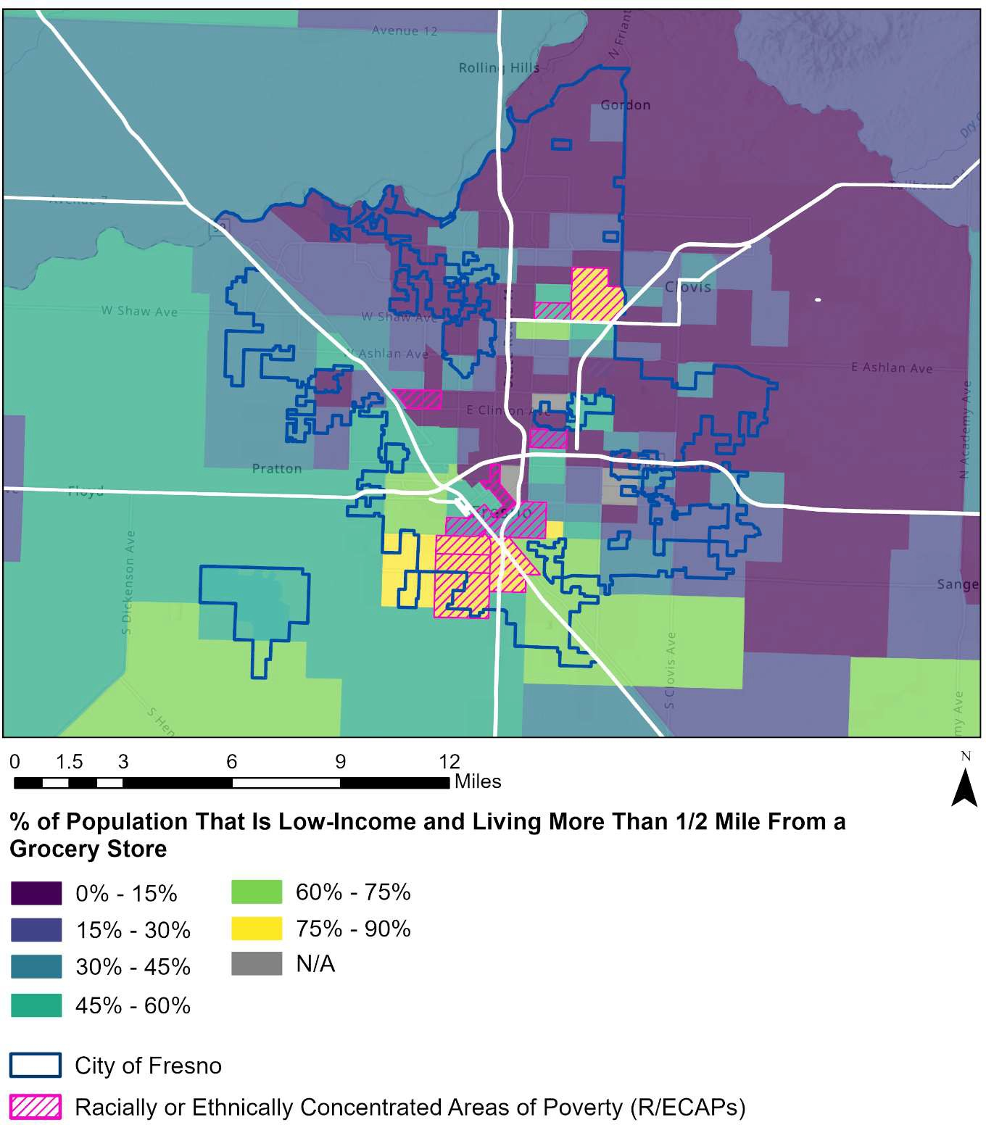

Miles

City of Fresno

Racially or Ethnically Concentrated Areas of Poverty (R/ECAPs)

**% of Population That Is Low-Income and Living More Than 1/2 Mile From a Grocery Store**

*Source: USDA Food Access Research Atlas, 2019. Food store is defined as a supermarket, supercenter, or large grocery store.*

Further, in many census tracts—particularly in parts of central Fresno—significant shares of households do not have a vehicle. Low levels of vehicle access indicate that food access may be particularly challenging for significant proportions of households in areas

of the city with limited access to bus service and low levels of walkability. In this way, the combination of uneven distribution of food outlets across the city, substantial shares of households with low incomes, and a lack of access to vehicles creates barriers to food access and security.

### Healthcare

Access to high-quality, affordable physical and mental healthcare shapes community health outcomes, including both length of life and quality of life. Sufficient availability of primary care physicians is essential for access to preventive and primary care, and for referrals to appropriate specialty care when needed. Residents of Fresno County have access to healthcare providers at a rate of one primary care physician per 1,480 residents, one dentist per 1,560 residents, and one mental health provider per 210 residents (see Table 7). These figures indicate that residents of Fresno County have lower levels of access to primary care physicians and dentists compared to the state of California and the United States, and slightly higher access to mental health providers.

#### TABLE 7. RATIO OF POPULATION TO HEALTHCARE PROVIDERS, CITY OF FRESNO, STATE OF CALIFORNIA, AND UNITED STATES, 2021-2023

|  |  |  |  |
| --- | --- | --- | --- |
|  | **Fresno County** | **California** | **United States** |
| Primary Care Physicians | 1,480:1 | 1,230:1 | 1,330:1 |
| Dentists | 1,560:1 | 1,080:1 | 1,360:1 |
| Mental Health Providers | 210:1 | 220:1 | 320:1 |

*Source: County Health Rankings, Area Health Resource File/American Medical Association, 2021-202332*

The United States Health Resources and Services Administration (HRSA) identifies geographic areas with a lack of access to primary care services, known as Medically

31 County Health Rankings. (2024). Primary Care Physicians. Retrieved from: https://[www.countyhealthrankings.org/explore-health-rankings/measures-data-sources/county-health-](http://www.countyhealthrankings.org/explore-health-rankings/measures-data-sources/county-health-) rankings-model/health-factors/clinical-care/access-to-care/primary-care-physicians, and Steinbrook, R. (2009). Easing the shortage in adult primary care—is it all about money?. New England Journal of Medicine, 360(26), 2696-2699.

32 County Health Rankings 2024 Measures. Retrieved from: https://[www.countyhealthrankings.org/health-](http://www.countyhealthrankings.org/health-) data/california/fresno?year=2024

Underserved Areas. The HRSA calculates an Index of Medical Underservice based on the number of providers per 1,000 population ratio, the percent of population at 100% of the Federal Poverty Level, the percent of population age 65 and over, and the infant mortality rate. In Figure 37 below, the central and southern areas of Fresno, including downtown, Goldleaf, and Edison, are indicated as Medically Underserved Areas.

#### FIGURE 37. MEDICALLY UNDERSERVED AREAS, CITY OF FRESNO AND SURROUNDING AREAS

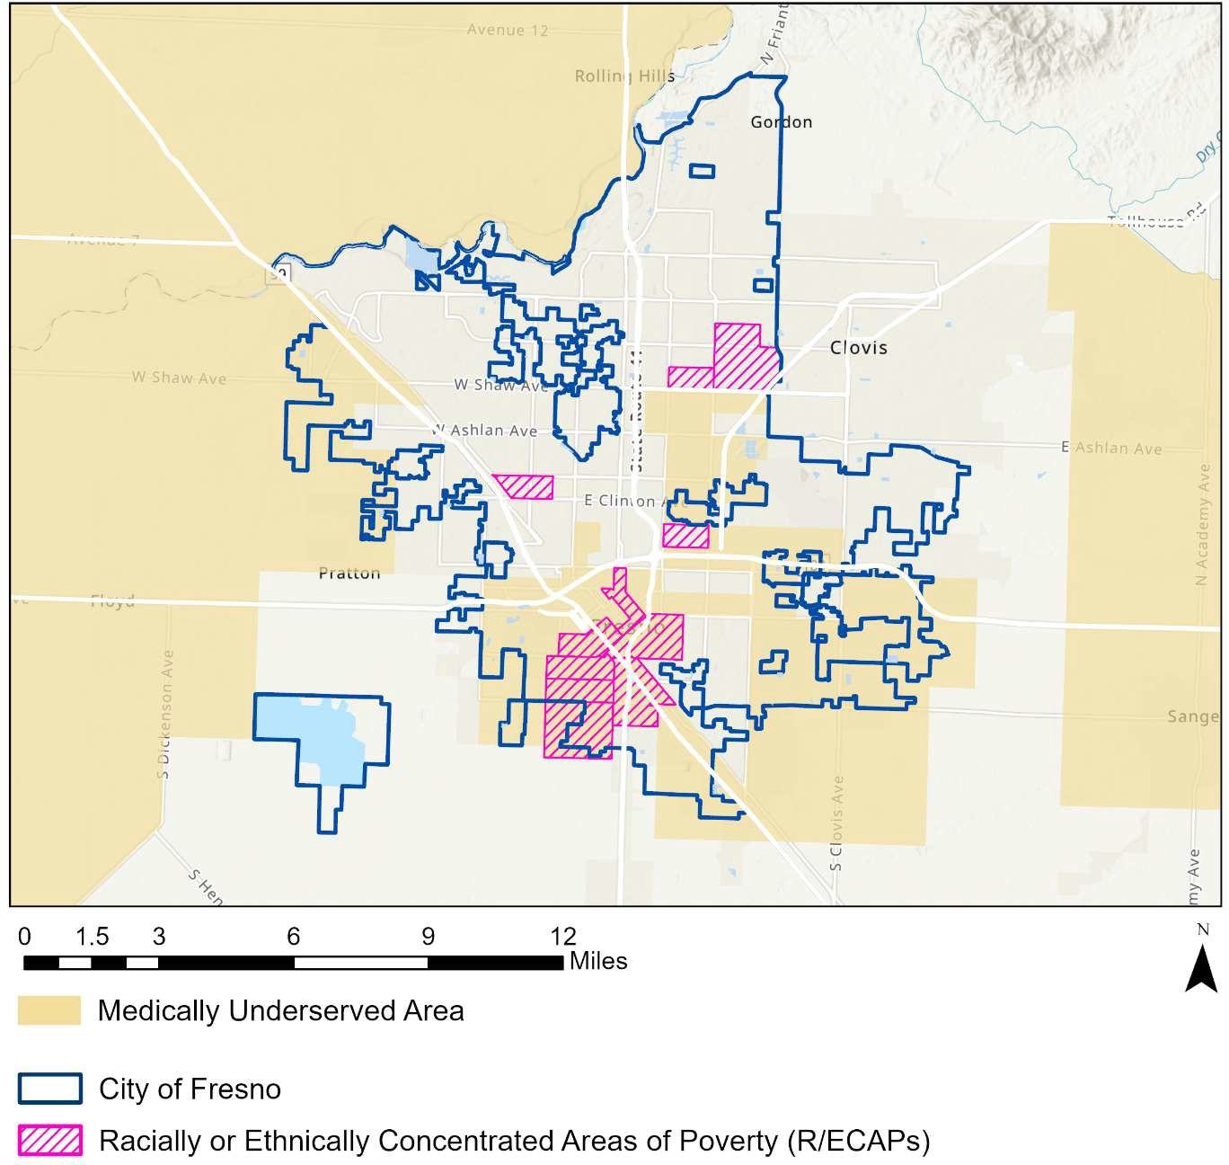

Medically Underserved Area

City of Fresno

Racially or Ethnically Concentrated Areas of Poverty (R/ECAPs)

Miles

*Source: Health Resources and Services Administration*

33 Health Services and Resources Administration. (2022). Scoring Shortage Designations. Retrieved from: https://bhw.hrsa.gov/workforce-shortage-areas/shortage-designation/scoring

In addition to access to healthcare providers, health insurance coverage is an important component of access to needed healthcare—including preventive care—and to maintaining financial security. While the majority of city residents have health insurance (93.5% according to 2019-2023 American Community Survey five-year estimates), shares of uninsured residents continue to vary by location across the city.

The proportion of residents who are uninsured is highest in central Fresno, particularly in census tracts near the downtown area along E Cesar Chavez Blvd and north of San Joaquin Memorial High School. In three census tracts in these areas, the share of uninsured residents is around 15%. Tracts with low shares of uninsured residents are clustered in north Fresno, north of Shaw Ave. In many of these tracts, fewer than 5% of residents are uninsured (see Figure 38).

#### FIGURE 38. PERCENT OF POPULATION THAT IS UNINSURED, CITY OF FRESNO, 2019-2023

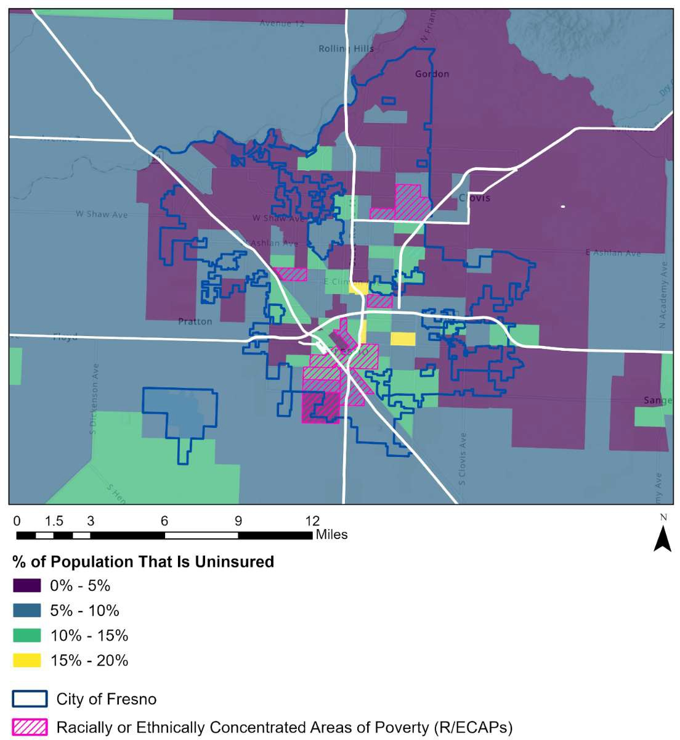

**% of Population That Is Uninsured**

Miles

City of Fresno

Racially or Ethnically Concentrated Areas of Poverty (R/ECAPs)

*Data Source: 2019-2023 American Community Survey 5-Year Estimates*

Overall, healthcare access is shaped by multiple factors, including availability of providers, health insurance coverage, income, housing affordability and stability, and access to vehicles or other transportation options. Investments in programs designed to increase access to healthcare—such as expanding access to health insurance, investing in telehealth and mobile health services, education about where to access health services, and improved cultural responsiveness—may help increase access for residents. Because of geographic disparities in health insurance coverage, efforts such as increasing enrollment in Medicaid and Marketplace health insurance plans and providing access to low-cost health services may be most effective in addressing goals of improving access to healthcare by focusing efforts in census tracts with low levels of health insurance coverage.

## HOUSING PROFILE

The availability of quality affordable housing plays a vital role in ensuring housing opportunities are fairly accessible to all residents. On the surface, high housing costs in certain areas are exclusionary based solely on income. But the disproportionate representation of several protected class groups in low- and middle-income levels can lead to unequal access to housing options and neighborhood opportunity in high-cost housing markets. Black and Hispanic residents, immigrants, people with disabilities, and seniors often experience additional fair housing barriers when affordable housing is scarce.

Beyond providing fair housing options, the social, economic, and health benefits of providing quality affordable housing are well-documented. National studies show that affordable housing encourages diverse, mixed-income communities, which result in many social benefits. Affordable housing also increases job accessibility for low- and middle- income populations and attracts a diverse labor force critical for industries that provide basic services for the community. Affordable housing is also linked to improvements in mental health, reduction of stress, and decreased cases of illnesses caused by poor- quality housing.34 Developing affordable housing is also a strategy used to prevent displacement of existing residents when housing costs increase due to economic or migratory shifts.

Conversely, a lack of affordable housing eliminates many of these benefits and increases socioeconomic segregation. High housing costs are linked to displacement of low-income households and an increased risk of homelessness.35 Often lacking the capital to relocate to better neighborhoods, displaced residents tend to move to socioeconomically disadvantaged neighborhoods where housing costs are most affordable.36

This section discusses the existing supply of housing in Fresno. It also reviews housing costs, including affordability and other housing needs by householder income.

34 Maqbool, Nabihah, et al. "The Impacts of Affordable Housing on Health: A Research Summary." *Insights from Housing Policy Research*, Center for Housing Policy, [www.rupco.org/wp-](http://www.rupco.org/wp-) content/uploads/pdfs/The-Impacts-of-Affordable-Housing-on-Health-CenterforHousingPolicy- Maqbool.etal.pdf.

35 “State of the Nation’s Housing 2015.” Joint Center for Housing Studies of Harvard University, <http://www.jchs.harvard.edu/sites/default/files/jchs-sonhr-2015-full.pdf>

36 Deirdre Oakley & Keri Burchfield (2009) Out of the Projects, Still in the Hood: The Spatial Constraints on Public-Housing Residents’ Relocation in Chicago.” Journal of Urban Affairs, 31:5, 589-614.

Homeownership rates and access to lending for home purchases and mortgage refinancing are also assessed.

### Housing Supply Summary

The Fresno, CA MSA has an estimated 392,371 housing units, of which slightly fewer than half (188,013 units, or 47.9%) are in the city of Fresno. While the city and MSA both experienced growth in housing units from 2013 through 2023, the MSA grew at a significantly faster rate (23.6%) than the city of Fresno (8.7%). Growth in occupied housing units was particularly strong (12.9% and 26.5%, respectively) as numbers of vacant units declined in both areas over the time period.

The American Community Survey’s definition of vacancy includes housing that is available for sale or rent, housing that has been rented or sold but not yet occupied, seasonal housing, and other vacant units. Using this definition, the vacancy rate in Fresno is estimated at 4.4% as of the 2019-2023 American Community Survey, down from 8.0% in 2009-2013. Vacancies in the wider metro area occur at a slightly higher rate (6.5%). These rates are lower than that of the state of California overall (7.6% as of the 2019- 2023 ACS).

Shares of for-sale homeowner units are particularly low, pointing to tight housing markets and high demand for homeownership. The share of owner units that are vacant and for sale (homeowner vacancy rate) is just 0.7% in city and 1.0% in the MSA. The share of renter units that are vacant and for rent (renter vacancy rate) is 3.0% in Fresno and 3.1% in the MSA, indicating similar availability of rental housing across the two areas. About 1.3% of units in the city and 2.1% of units in the MSA are vacant for reasons other than being available for sale or rent, being rented or sold but not yet occupied, or use as seasonal housing. These reasons include need for rehabilitation or repair, foreclosure, legal proceedings, abandonment, and other reasons. Both the city and MSA have seen declines in vacant housing units, indicating high demand for housing and increasingly tight housing markets. The following analysis examines several features of housing supply, including structure type, size, tenure, and age of housing.

#### TABLE 8. HOUSING UNITS BY OCCUPANCY STATUS

**2009-2013 2019-2023**

**TOTAL HOUSING UNITS**

**173,000**

**188,013**

**2013-2023**

**Change**

**8.7%**

Occupied Housing Units 159,163 179,684 12.9%

Vacant Housing Units

13,837

8,329

-39.8%

Vacancy Rate 8.0% 4.4%

-3.6

percentage points

*Data Source: 2009-2013 and 2019-2023 American Community Survey Five-Year Estimates, Table DP04.*

Jurisdictions with a variety of housing structure types are better able to meet the needs of all residents, including different members of protected classes. Multifamily housing, including rental apartments, are often more affordable rental options than single-family homes for low- and moderate-income households, who are disproportionately likely to be non-White households. Multifamily units may also be the preference of some elderly and disabled householders who are unable or do not desire to maintain a single-family home.

Figure 39 shows housing units by structure types in Fresno and the Fresno, CA MSA. Single-family detached homes are the predominant housing type, making up about 61.4% of housing units in the city and 69.3% of units in the MSA. In Fresno, units in small multifamily buildings of five to 19 units are the next most common (12.6%), followed by units in duplexes, triplexes, and quadruplexes (10.7%), and units in large multifamily buildings of 20 or more units (9.5%). Single-family attached units and mobile homes each comprise about 2% to 3% of units in the city, while units in other structures (RV, boat, van, etc.) comprise 0.1% of housing units.

Relative to the city, the MSA has lower shares of units in small and large multifamily structures and duplexes, triplexes, and quadruplexes, and a higher share of single-family detached units.

The high shares of single family-detached structures both the city and MSA may pose limitations on residents in obtaining housing in units of other housing types, including ‘missing middle’ housing, such as duplexes, triplexes, quadruplexes, units in small apartment buildings, or other housing types that may provide opportunities for increased affordability, variety in housing unit size, or specific amenities or opportunities for social connection. When neighborhoods contain a concentration of similar housing types, residents may find it difficult to obtain housing that meets their needs or to remain in their neighborhoods of choice as they experience life changes.

#### FIGURE 39. HOUSING UNITS BY STRUCTURE TYPE

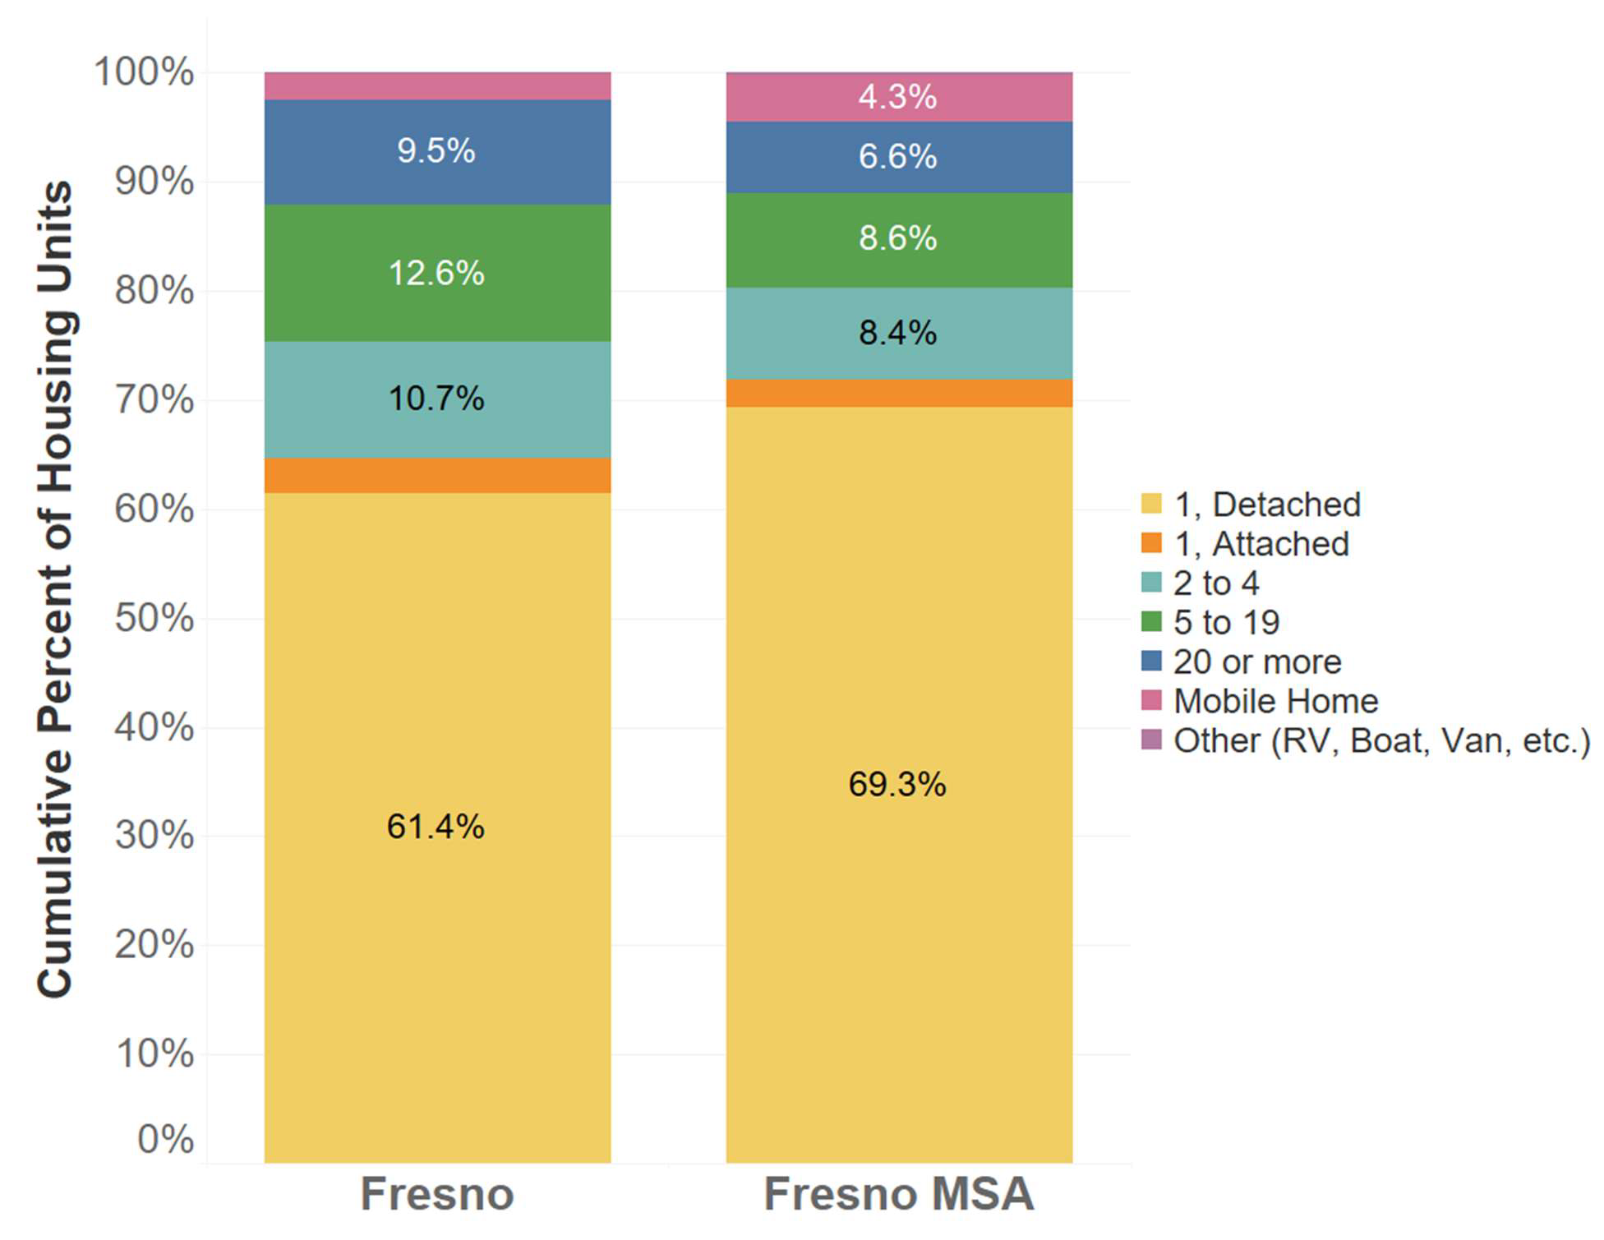

1, Detached

1, Attached

2 to 4

5 to 19

20 or more

Mobile Home

Other (RV, Boat, Va,. Etc.)

**Fresno MSA**

**Fresno**

**Cumulative Percent of Housing Units**

*Data Source: 2019-2023 American Community Survey Five-Year Estimates, Table B25024.*

Availability of housing in a variety of sizes is important to meet the needs of different demographic groups. Neighborhoods with multi-bedroom detached, single-family homes typically attract larger families, whereas dense residential developments with smaller unit sizes and fewer bedrooms often accommodate single-person households or small families. However, market forces and affordability impact housing choice and the ability to obtain housing of a suitable size. Markets that do not offer a variety of housing sizes at different price points can lead to barriers for some groups. Rising housing costs can, for example, lead to overcrowding as large households with lower incomes are unable to afford pricier, larger homes and are forced to reside in smaller units. On the other hand, people with disabilities or seniors with fixed incomes may not require large units but can be limited by higher housing costs in densely populated areas where most studio or one- bedroom units are located.

Figures 40 and 41 detail housing units by the number of bedrooms and resident tenure (renters or homeowners). In Fresno and the Fresno MSA, the vast majority (about 85%

to 86%) of owner-occupied units have three or more bedrooms. Another 12% to 13% of owner-occupied units in the city and MSA have two bedrooms. Studio and one-bedroom units are the least common owner-occupied units in both areas, comprising fewer than 2% of units.

Compared to owner-occupied units, rental units tend to have fewer bedrooms. Two- bedroom units are the most common renter-occupied housing size, comprising about 35% to 36% of units in the city and MSA. Three-bedroom units are the next most common, comprising about 26% to 30% of renter-occupied units across the two areas. Studios and one-bedroom units are significantly more common among renter-occupied units than homeowner units, making up 16.5% and 15.4% of units in the city, and 11.4% and 14.2% of units in the MSA, respectively. Units with four or more bedrooms make up about 7% to 9% of all rented units in the city and MSA.

The low shares of owner-occupied units with zero to two bedrooms across the city and MSA points to challenges for homebuyers seeking smaller housing units that may provide increased levels of affordability and have lower maintenance costs. Renter households with large families, on the contrary, may experience challenges securing housing with more than three bedrooms.

#### FIGURE 40. HOUSING UNITS BY SIZE, OWNER-OCCUPIED UNITS

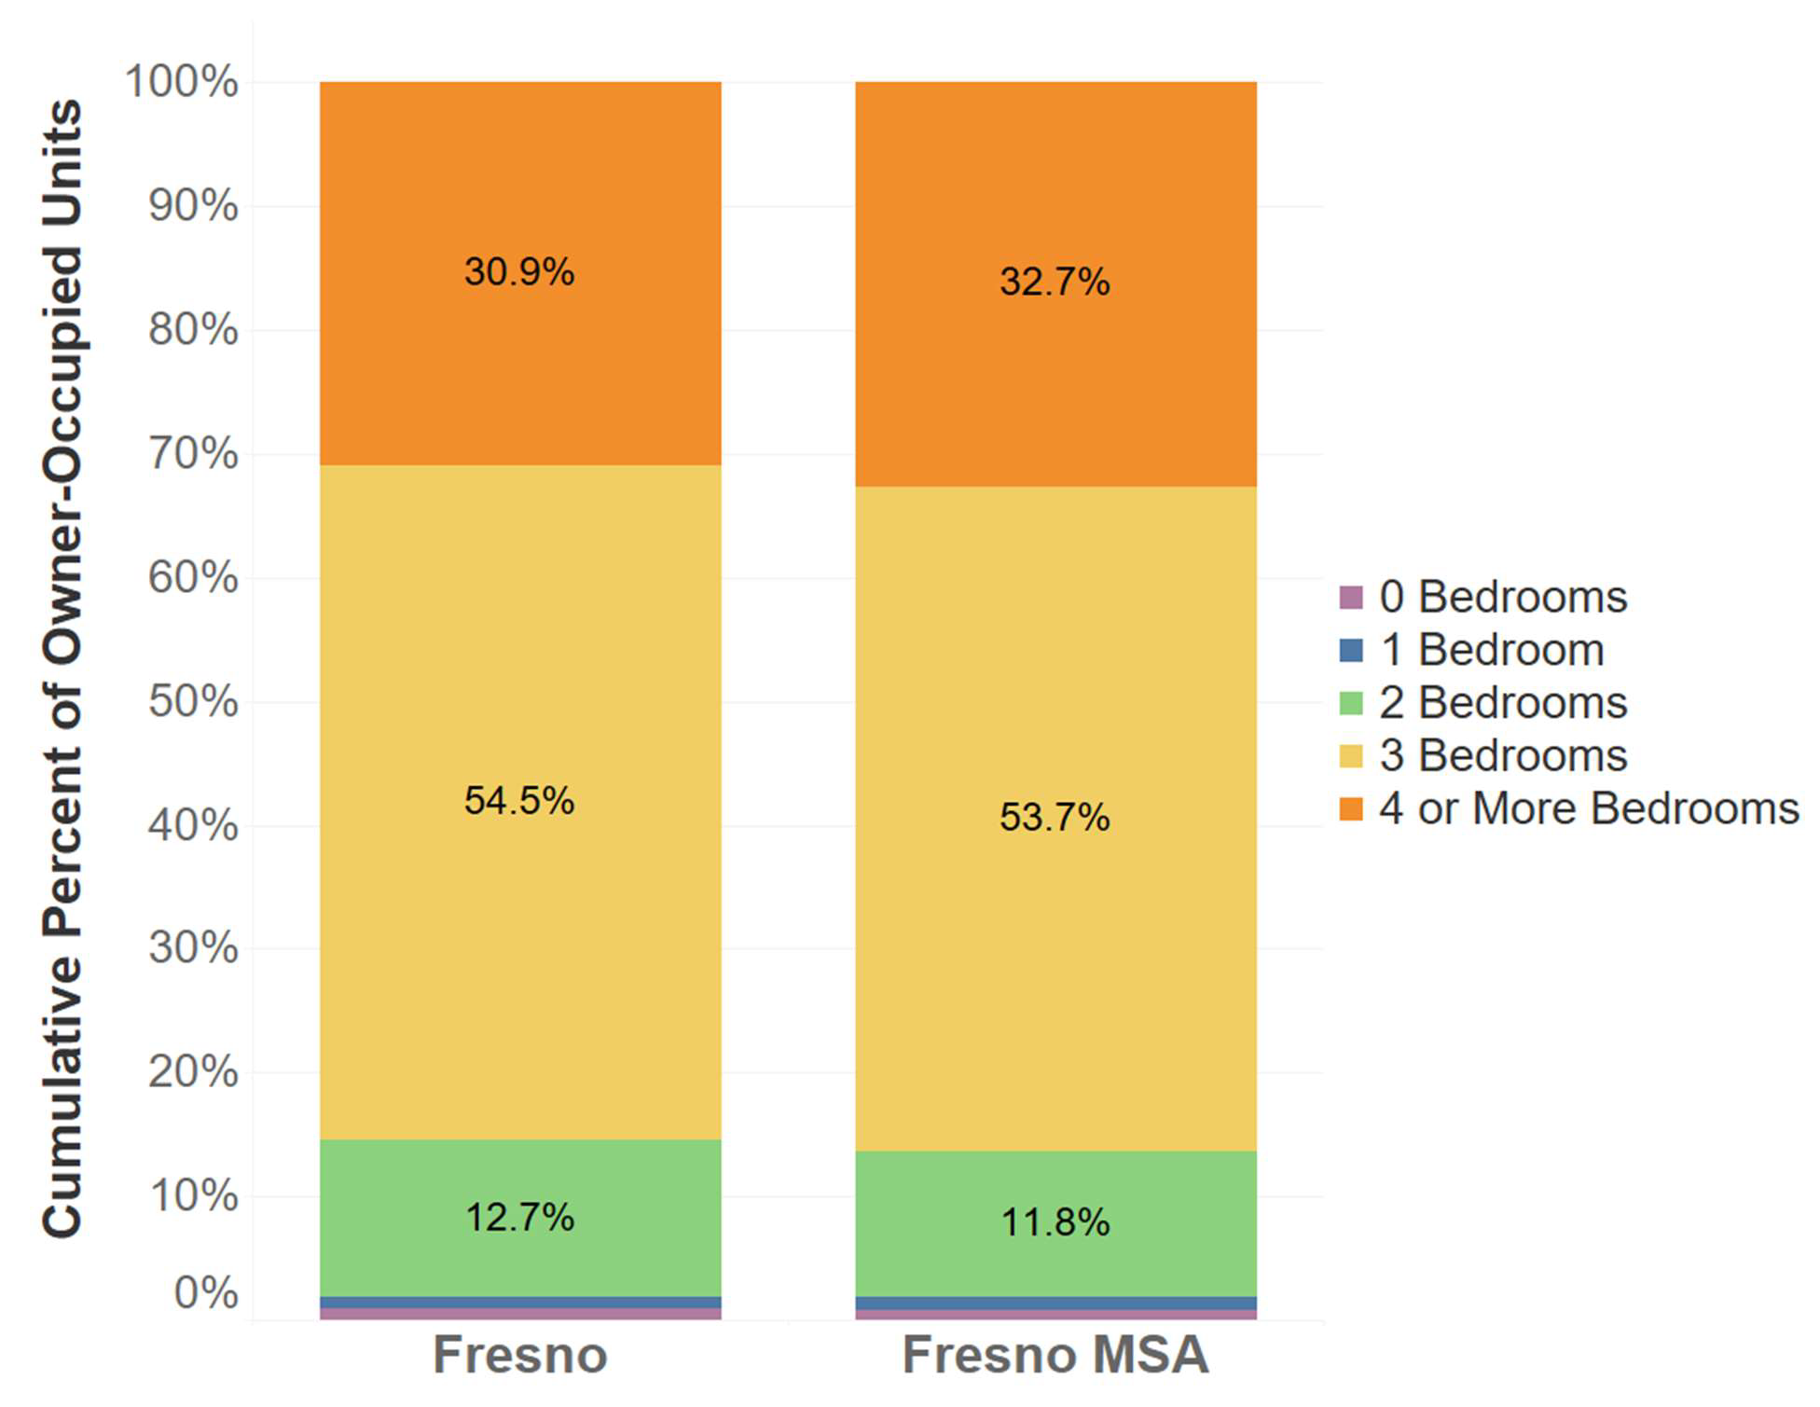

0 Bedrooms

1 Bedroom

2 Bedrooms

3 Bedrooms

4 or More Bedrooms

**Cumulative Percent of Owner-Occupied Units**

**Fresno MSA**

**Fresno**

*Data Source: 2019-2023 American Community Survey Five-Year Estimates, Table B25042.*

*NOTE: Unoccupied units are not included in this table because tenure data is not available for these units.*

#### FIGURE 41. HOUSING UNITS BY SIZE, RENTER-OCCUPIED UNITS

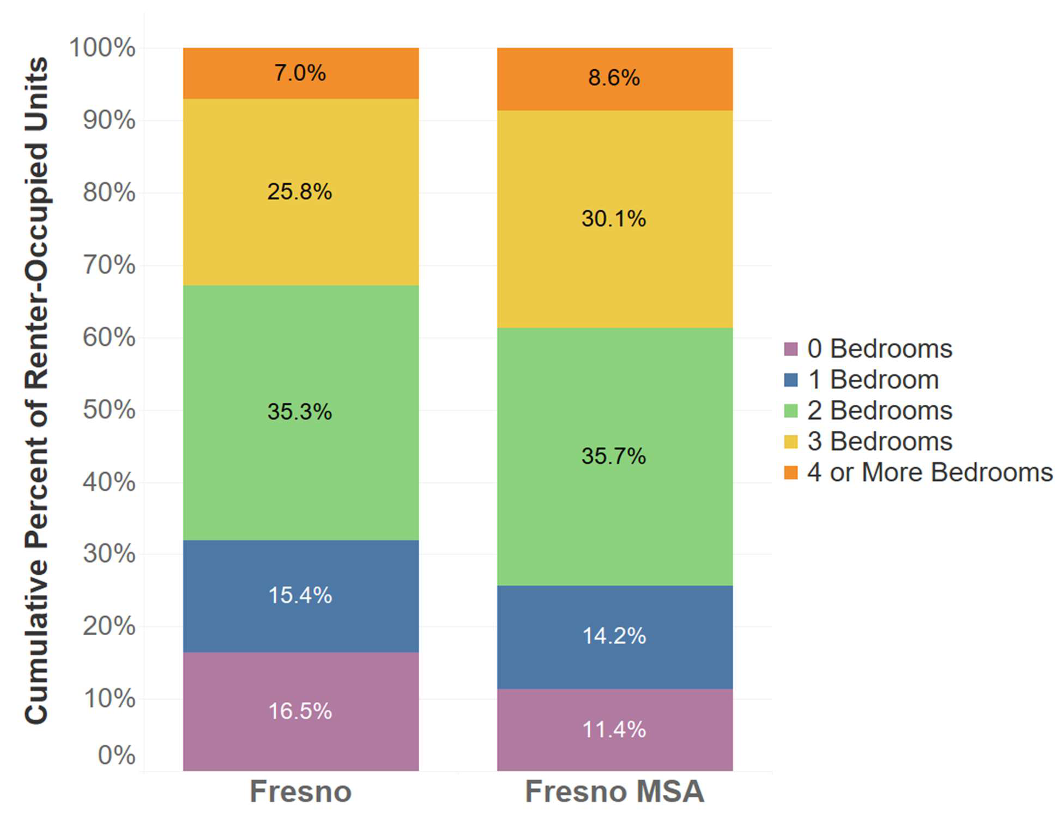

**Cumulative Percent of Renter-Occupied Units**

**Fresno MSA**

**Fresno**

0 Bedrooms

1 Bedroom

2 Bedrooms

3 Bedrooms

4 or More Bedrooms

*Data Source: 2019-2023 American Community Survey Five-Year Estimates, Table B25042.*

*NOTE: Unoccupied units are not included in this table because tenure data is not available for these units.*

An assessment of the region’s housing conditions can provide a basis for developing policies and programs to maintain and preserve the quality of the housing stock. The age of housing can have a substantial impact on housing conditions and costs. As housing ages, maintenance costs rise, which can present significant affordability issues for low- and moderate-income homeowners. Aging rental stock can lead to rental rate increases to address physical issues or deteriorating conditions if building owners defer or ignore maintenance needs. Deteriorating housing can also depress neighboring property values, discourage reinvestment, and eventually impact the quality of life in a neighborhood. Homes built prior to 1950 have a high likelihood of containing lead-based paint. However, the use of lead-based paint did not end until 1978 and may affect an even larger number of households.

Development of new market-rate and subsidized housing units can support housing affordability and reduce displacement of lower-income residents. In contrast, areas with growing populations in which few new housing units are built tend to experience housing shortages and reduced affordability. Subsidized units, such as those built with low-income housing tax credits and other federal and state subsidies, have been found to be particularly protective in reducing displacement.37

Data on age of housing in Fresno and the Fresno, CA MSA points to a large share of older housing stock and a decline in construction of new units since 2010 (see Figure 42). An estimated 50.9% of units in the city and 47.4% of units in the MSA are in structures built prior to 1980. The MSA contains a slightly greater share of newer housing, with 25.2% of units built in 2000 and later, compared to 21.9% of units in the city. Just 8.3% of units in the city (15,677 units) and 9.3% of units in the MSA (36,412 units) were built in 2010 or later. The older housing stock in the city and MSA may pose both economic and public health challenges, particularly for individuals and families living in older housing units.

37 Zuk, M. and Chapple, K. (2016). Housing Production, Filtering and Displacement: Untangling the Relationships. Berkeley Institute of Governmental Studies. Retrieved from: https://[www.urbandisplacement.org/wp](http://www.urbandisplacement.org/wp) content/uploads/2021/08/udp_research_brief_052316.pdf

#### FIGURE 42. YEAR STRUCTURE BUILT

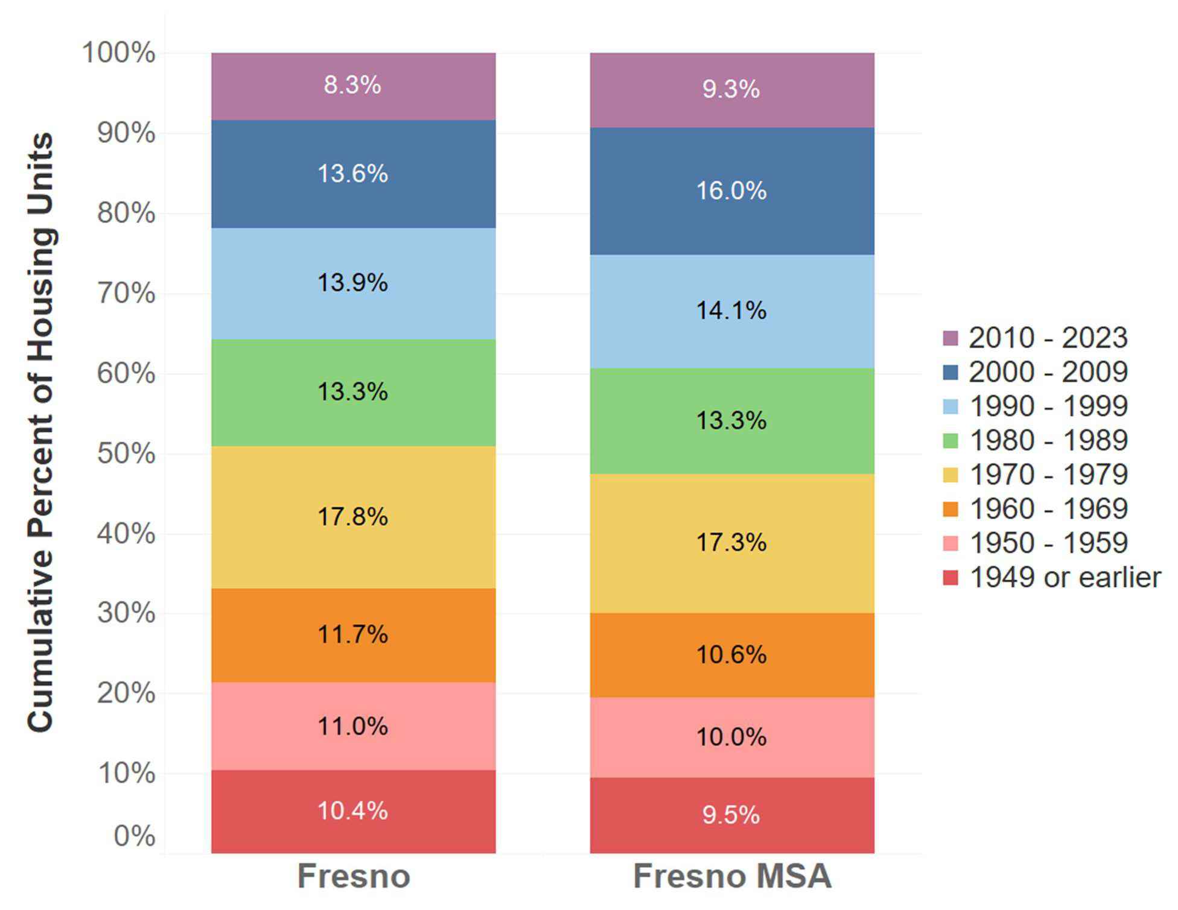

2010 – 2023

2000 – 2009

1990 – 1999

1980 – 1989

1970 – 1979

1960 – 1969

1950 - 1959

1949 or earlier

**Fresno MSA**

**Fresno**

**Cumulative Percent of Housing Units**

*Data Source: 2019-2023 American Community Survey Five-Year Estimates, Table B25034.*

### Housing Costs and Affordability

The availability of housing that is both affordable and in good condition was a common need identified by residents and stakeholders, particularly for low- and moderate-income households. The National Low Income Housing Coalition’s annual Out of Reach report examines rental housing rates relative to income levels for counties throughout the U.S. The figure below shows annual household income and hourly wages needed to afford Fair Market Rents in Fresno County.

#### FIGURE 43. REQUIRED INCOME, WAGES, AND HOURS TO AFFORD FAIR MARKET RENTS IN FRESNO COUNTY, 2024

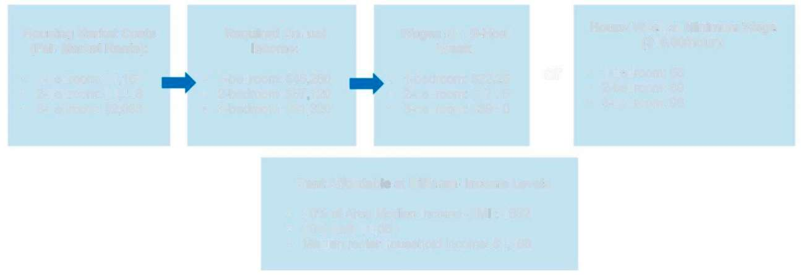

* 30% of Area Median Income (AMI): $632
* 50% AMI: $1,054
* Median renter household income: $1,166

**Rent Affordable at Different Income Levels**

* 1-bedroom: $1,157
* 2-bedroom: $1,443
* 3-bedroom: $2,033

**Housing Market Costs (Fair Market Rents):**

**Required Annual Income:**

* 1-bedroom: $46,280
* 2-bedroom: $57,720
* 3-bedroom: $81,320
* 1-bedroom: $22.25
* 2-bedroom: $27.75
* 3-bedroom: $39.10

**Wages for 40-Hour Week:**

or

* 1-bedroom: 56
* 2-bedroom: 69
* 3-bedroom: 98

**Hours/ Week at Minimum Wage ($16.00/hour):**

*Data Source: National Low Income Housing Coalition Out of Reach 2024, Accessed from https://nlihc.org/oor/state/ca*

To afford a two-bedroom rental unit—the county’s most common rental type—without being cost burdened, a renter household would need to earn an annual income of

$57,720, which translates to a 40-hour work week at an hourly wage of $27.75. It would take a 69-hour work week at the minimum wage of $16.00 to afford the same two- bedroom unit. According to the Out of Reach Report, the median renter household income in Fresno County is $46,642, which is slightly above the necessary annual income to afford a one-bedroom unit at fair market rent.

The American Community Survey also provides estimates on monthly renter and homeowner costs. As of the 2019-2023 American Community Survey five-year estimates, about 79% to 81% of renter households across the city and MSA spend less than $1,500 per month on rent, while about 14% to 15% spend $1,500 to $1,999. About 4% of households across the city and MSA spend $2,000 to $2,500 on rent, and about 2% to 3% spend $2,500 or more. More recent data from the Zumper database shows average rents in the city at $1,618 for a two-bedroom unit and $2,153 for a three-bedroom unit as of December 2024, indicating sharp increases in rental costs in recent years. Renters

earning the median renter household income may thus find it difficult to find housing in Fresno at an affordable rate for their income level.

#### FIGURE 44. CONTRACT RENT, CITY OF FRESNO AND FRESNO, CA MSA

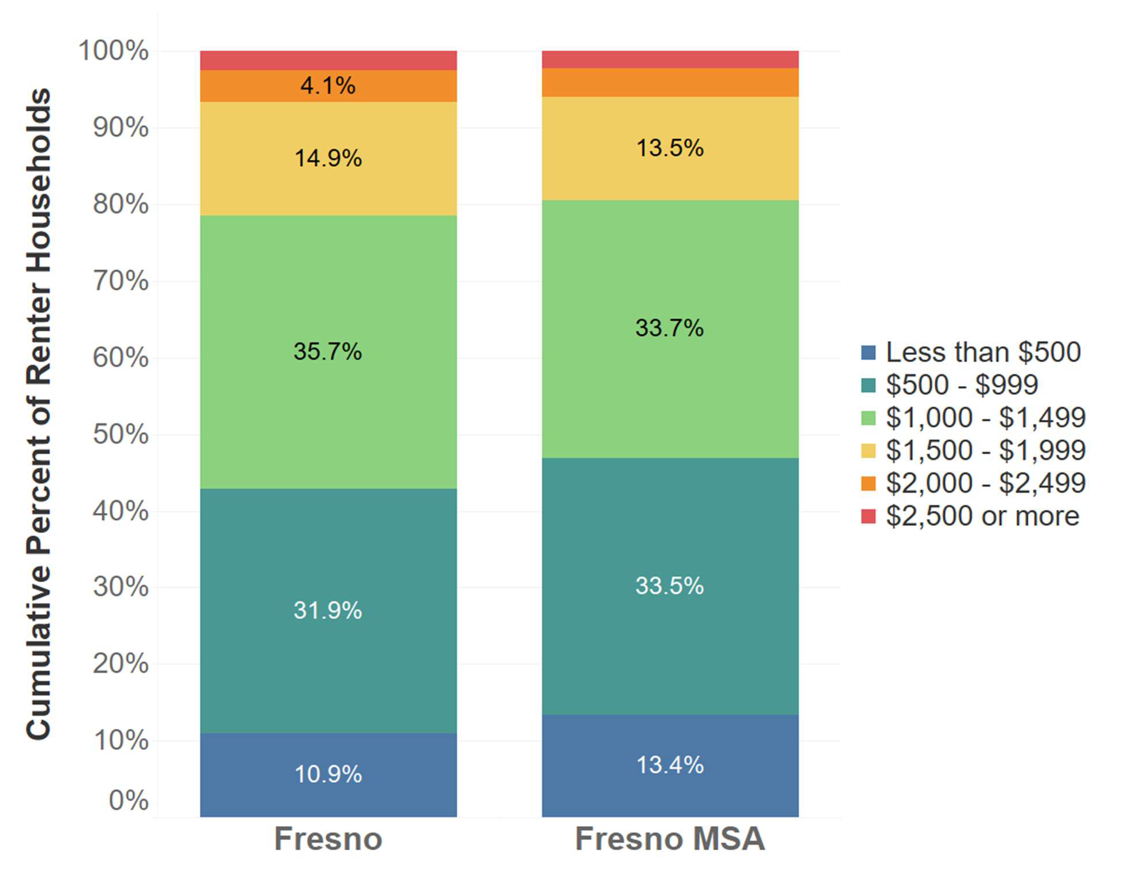

Less than $500

$500 - $999

$1,000 - $1,499

$1,500 - $1,999

$2,000 - $2,499

$2,500 or more

**Cumulative Percent of Renter Households**

**Fresno MSA**

**Fresno**

Data Source: 2019-2023 ACS 5-Year Estimates, Table B25056.

For many Fresno households, homeownership is more expensive than renting. As of the American Community Survey five-year estimates for 2019-2023, about 50% to 52% of homeowners across the city and MSA spend $1,500 or more per month on housing—a larger share than the estimated 19% to 21% of renter households spending within this same range. Owner households in the city and MSA are also significantly more likely to spend $2,500 or more per month on housing costs than renters (about 16% to 19% of homeowner households, compared to about 2% to 3% of renter households). More recent data from Zillow’s Home Value Index (ZHVI) estimates the typical home value in Fresno at $382,198 as of November 2024, a 47.7% increase over the typical home value of

$258,786 in November 2019. These values indicate steep increases in home prices in recent years and barriers to homeownership for lower-income residents. As home values

and interest rates have increased, renting is generally more accessible to low-to- moderate income families than homeownership in Fresno.

#### FIGURE 45. MONTHLY OWNER COSTS, CITY OF FRESNO AND FRESNO, CA MSA

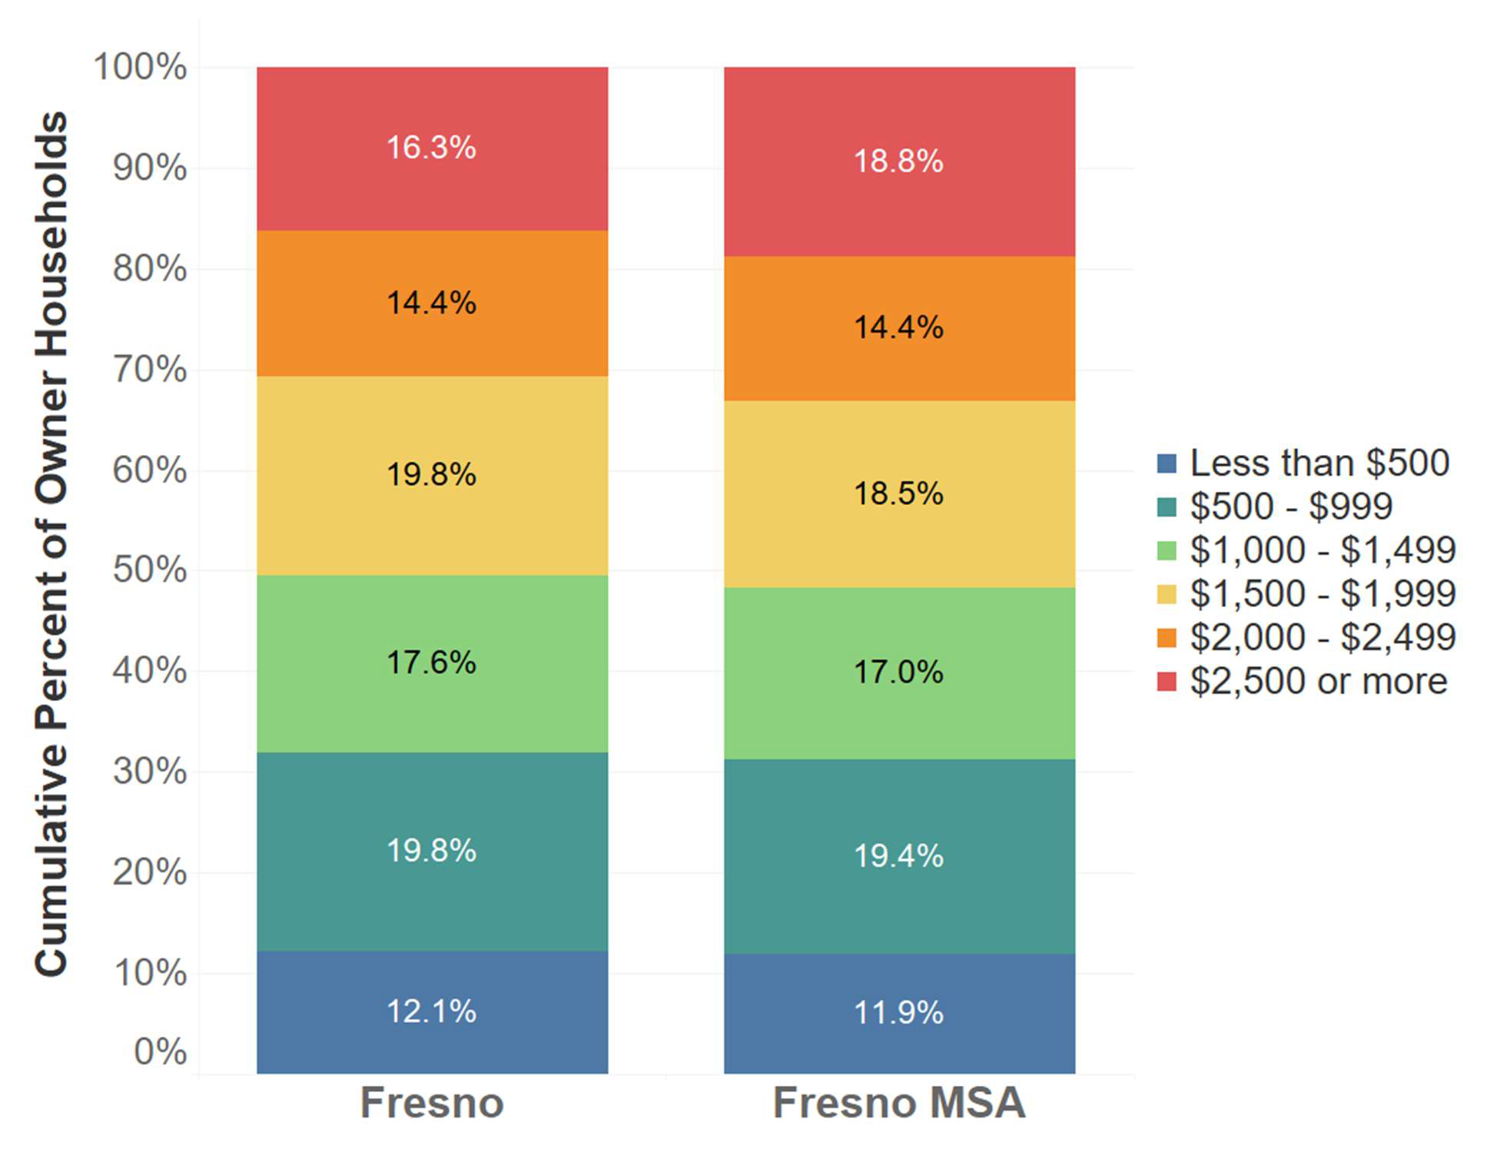

**Cumulative Percent of Owner Households**

**Fresno MSA**

**Fresno**

Less than $500

$500 - $999

$1,000 - $1,499

$1,500 - $1,999

$2,000 - $2,499

$2,500 or more

*Data Source: 2019-2023 American Community Survey Five-Year Estimates, Table B25094.*

### Housing Needs

Housing cost and condition are key components to housing choice. Housing barriers may exist in a jurisdiction when some protected class groups have greater difficulty accessing housing in good condition and that they can afford. To assess affordability and other types of housing needs, HUD defines four housing problems:

1. A household is cost burdened if monthly housing costs (including mortgage payments, property taxes, insurance, and utilities for owners and rent and utilities for renters) exceed 30% of monthly income.
2. A household is overcrowded if there are more than 1.0 people per room, not including kitchen or bathrooms.
3. A housing unit lacks complete kitchen facilities if it lacks one or more of the following: cooking facilities, a refrigerator, or a sink with piped water.
4. A housing unit lacks complete plumbing facilities if it lacks one or more of the following: hot and cold piped water, a flush toilet, or a bathtub or shower.

HUD also defines four severe housing problems, including a severe cost burden (more than 50% of monthly housing income is spent on housing costs), severe overcrowding (more than 1.5 people per room, not including kitchens or bathrooms), lack of complete kitchen facilities (as described above), and lack of complete plumbing facilities (also as described above).

To assess housing need, HUD receives a special tabulation of data from the U. S. Census Bureau’s American Community Survey that is largely not available through standard Census products. This data, known as Comprehensive Housing Affordability Strategy (CHAS) data, counts the number of households that fit certain combination of HUD- specified criteria, such as housing needs by race and ethnicity. CHAS data for Fresno is provided in the tables and figures that follow.

While an estimated 45.8% of all households in Fresno experience a housing problem as of the 2017-2021 CHAS data, significant disparities exist by household tenure (renter and owner households), disability status, and race/ethnicity. An estimated 28.4% of owner households and 61.6% of renter households in Fresno have at least one housing problem (see Table 9). The most common type of housing problem is cost burden, with 22.8% of owners and 43.0% of renters experiencing either cost burden or severe cost burden. The second most common type of housing problem is overcrowding, with 5.4% of owners and 16.6% of renters experiencing either overcrowding or severe overcrowding. Incomplete kitchen or plumbing facilities are significantly less common, with 0.3% of owners and 1.39% of renters experiencing this problem.

#### TABLE 9. HOUSEHOLDS WITH HOUSING PROBLEMS BY TYPE IN FRESNO, 2017- 2021

|  |  |  |  |  |
| --- | --- | --- | --- | --- |
| **Housing Problem** | **Housing Status** | | | |
| **Owners** | | **Renters** | |
| **#** | **%** | **#** | **%** |
| Cost Burden 18,960 22.8% 39,420 43.0% | | | | |

|  |  |  |  |  |
| --- | --- | --- | --- | --- |
| Severe Cost Burden | 8,515 | 10.2% | 20,895 | 22.8% |
| Overcrowding | 4,460 | 5.4% | 15,225 | 16.6% |
| Severe Overcrowding | 1,310 | 1.6% | 8,405 | 9.2% |
| Incomplete Kitchen or Plumbing Facilities | 225 | 0.3% | 1,765 | 1.9% |
| Total Households w/ Problems | **23,645** | **28.4%** | **56,410** | **61.6%** |
| **Total Households** | **83,175** | **100.0%** | **91,580** | **100.0%** |
| *Source: 2017-2021 CHAS, Table 3.* |  |  |  |  |

*Note: Numbers of households with cost burden include households with severe cost burden. Numbers of households with overcrowding include households with severe overcrowding.*

Tables 10 and 11 depict housing problems by disability status and by race and ethnicity, highlighting populations that are disproportionately impacted by substandard housing conditions. An estimated 55.9% of households with a member with a disability in Fresno have at least one housing problem, compared to 43.3% of households with no members with a disability (see Table 10) and 45.8% of all households.

#### TABLE 10. HOUSEHOLDS WITH HOUSING PROBLEMS BY DISABILITY STATUS IN FRESNO, 2017-2021

|  |  |  |  |  |  |  |
| --- | --- | --- | --- | --- | --- | --- |
| **Disability Type** | **Housing Problem Status** | | | | | |
| **With Housing Problems** | | **Without Housing Problems** | | **TOTAL** | |
| **#** | **%** | **#** | **%** | **#** | **%** |
| Hearing/Vision 15,130 53.2% 13,330 46.8% 28,460 100% | | | | | | |

|  |  |  |  |  |  |  |
| --- | --- | --- | --- | --- | --- | --- |
| Ambulatory | 16,660 | 54.7% | 13,775 | 45.3% | 30,435 | 100% |
| Cognitive | 14,485 | 58.3% | 10,350 | 41.7% | 24,835 | 100% |
| Self- Care/Independent | 15,470 | 57.8% | 11,300 | 42.2% | 26,770 | 100% |
| Living |  |  |  |  |  |  |

|  |  |  |  |  |  |  |
| --- | --- | --- | --- | --- | --- | --- |
| **TOTAL** | **61,745** | **55.9%** | **48,755** | **44.1%** | **110,500** | **100%** |
| No members of household with disability | 50,940 | 43.3% | 66,660 | 56.7% | 117,600 | 100% |

*Source: 2017-2021 CHAS, Table 6*

*Note: Households for which cost burden was not computed and who had none of the other housing problems are excluded from this table.*

Looking at housing problems by race and ethnicity, Native American and Black households experience housing problems at the highest rates (62.0% and 55.0% of households, respectively). Native American households are also disproportionately likely to experience severe housing problems (49.7% of Native American households). Rates of housing problems are high for renter households across races and ethnicities, ranging from 56.4% of White households to 68.2% of Native American households. Owner households experience housing problems at significantly lower rates than renters, ranging from 31.7% of Asian/ Pacific Islander households to 43.5% of Native American households. Overall, housing problems are most common among Native American, Black, Hispanic, and Asian/ Pacific Islander renter households.

#### TABLE 11. HOUSING PROBLEMS, RENTER AND OWNER HOUSEHOLDS BY RACE AND ETHNICITY, 2017-2021

|  |  |  |  |  |  |  |  |  |  |  |
| --- | --- | --- | --- | --- | --- | --- | --- | --- | --- | --- |
| **HOUSING PROBLEMS BY TENURE** | **RACE / ETHNICITY** | | | | | | | | | |
| **Hispanic** | | **White** | | **Asian/Pacific Islander** | | **Black** | | **Native American** | |
| **#** | **%** | **#** | **%** | **#** | **%** | **#** | **%** | **#** | **%** |
| **RENTER HOUSEHOLDS** | | | | | | | | | | |

Housing Problem(s) 28,575 63.9% 14,280 56.4% 6,154 62.3% 5,810 65.6% 375 68.2%

Severe Housing Problem(s)

20,105

45.0%

8,285

32.7%

4,569

46.3%

3,925

44.4%

335

60.9%

No Housing Problems 16,110 36.1% 11,050 43.6% 3,720 37.7% 3,040 34.4% 175 31.8%

**OWNER HOUSEHOLDS**

**100.0%**

**100.0% 550**

**100.0% 8,850**

**100.0% 8,850**

**100.0% 25,330**

**44,685**

**TOTAL RENTERS**

Housing Problem(s) 9,775 32.6% 8,750 23.8% 3,310 31.7% 1,115 29.7% 80 43.5%

Severe Housing Problem(s)

5,980

19.9%

4,340

11.8%

2,165

20.7%

475

12.7%

30

16.3%

No Housing Problems 20,220 67.4% 27,980 76.2% 7,145 68.3% 2,635 70.3% 104 56.5%

**ALL HOUSEHOLDS**

**100.0%**

**100.0% 184**

**100.0% 3,750**

**100.0% 10,455**

**100.0% 36,730**

**29,995**

**TOTAL OWNERS**

Housing Problem(s) 38,350 51.4% 23,030 37.1% 9,464 46.6% 6,925 55.0% 455 62.0%

Severe Housing Problem(s)

26,085

34.9%

12,625

20.3%

6,734

33.1%

4,400

34.9%

365

49.7%

No Housing Problems 36,330 48.6% 39,030 62.9% 10,865 53.4% 5,675 45.0% 279 38.0%

**TOTAL 74,680 100.0% 62,060 100.0% 20,329 100.0% 12,600 100.0% 734 100.0%**

*Source: 2017-2021 CHAS, Table 1 & 2. Note: Numbers of households with housing problems include households with severe housing problems.*

# 100

Housing problems also vary by geography in Fresno (see Figure 46). Areas with the highest shares of households with housing problems include parts of central/ downtown Fresno, southwest Fresno, and east Fresno adjacent to the Fresno Yosemite International Airport and around California State University, Fresno. In 17 census tracts in these areas, more than 60% of households experience housing problems. Areas in which low shares of households experience housing problems include parts of north Fresno around Fort Washington, Woodward Park, Old Fig Garden, the San Joaquin Country Club, and north of California State University, Fresno, as well as southeast Fresno south of the Sunnyside Country Club. In six census tracts in these areas, 20% or fewer households have one or more housing problems.

#### FIGURE 46. SHARE OF HOUSEHOLDS WITH HOUSING PROBLEMS BY CENSUS TRACT IN FRESNO, 2017-2021

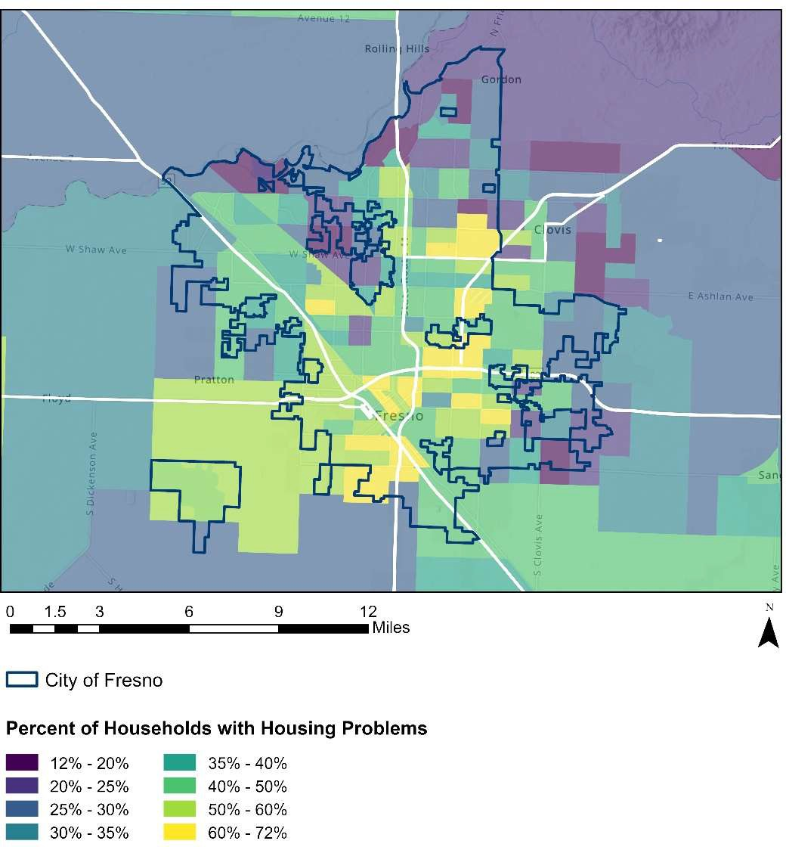

**Percent of Households with Housing Problems**

Miles

City of Fresno

*Source: 2017-2021 CHAS Data*

### Homeownership and Lending

Homeownership is vital to a community’s economic well-being. It provides the opportunity to build wealth, is generally associated with higher levels of civic engagement,38 and is correlated with positive cognitive and behavioral outcomes among children.39

Federal housing policies and discriminatory mortgage lending practices prior to the Fair Housing Act of 1968, along with continuing impediments to access, have had significant impacts on the homeownership rates of racial and ethnic minorities, particularly Black and Hispanic populations. The gap between the White and Black homeownership rate is the largest among racial and ethnic groups. In 2022, the U.S. Census Bureau reported a 25.4 percentage point gap in homeownership rate between White and Black households, representing a slight widening of the gap since 2002 (24.3 percentage points). Over the same period, the gap in the homeownership rate between White and Hispanic households narrowed from 24.7 to 21.8 percentage points.40

Homeownership trends have changed in recent years because of significant events in the housing market and labor force. The homeownership rate for Millennials (the generation born between 1981 and 1997) is eight percentage points lower than the two previous generations, controlling for age. This discrepancy can be attributed to a multitude of factors ranging from preference for urban areas, cost of education and associated debt, changes in marriage and childbearing patterns, rising housing costs, and the current supply of affordable housing.41

The map that follows shows the homeownership rate by census tract in Fresno. The homeownership rate is highest in parts of north, northwest, east, and southeast Fresno, where it tops 80% in 17 census tracts, including in Old Fig Garden, Fort Washington, and areas west of Golden State Boulevard in north and northwest Fresno, and east of the Fresno Yosemite International Airport and around Sunnyside in east and southeast Fresno. The homeownership rate is lowest in central Fresno around the city’s downtown

1. Manturuk K, Lindblad M, Quercia R. “Homeownership and civic engagement in low-income urban neighborhoods: a longitudinal analysis.” Urban Affairs Review. 2012;48(5):731–60.
2. Haurin, Donald R. et al. “The Impact of Homeownership on Child Outcomes.” Low-Income Homeownership Working Paper Series. Joint Center for Housing Studies of Harvard University. October 2001, [http://www.jchs.harvard.edu/sites/default/files/liho01-14.pdf.](http://www.jchs.harvard.edu/sites/default/files/liho01-14.pdf)
3. U.S. Census Bureau. Homeownership Rates by Race and Ethnicity of Householder: 1994 to 2017.
4. Choi, Jung et al. “Millennial Homeownership: Why Is It So Low, and How Can We Increase It?” The Urban Institute. July 2018. [www.urban.org/sites/default/files/publication/98729/millennial_homeownership_0.pdf.](http://www.urban.org/sites/default/files/publication/98729/millennial_homeownership_0.pdf)

and in parts of north Fresno, including the area north of Shaw Avenue around California State University, Fresno, where it falls below 20% in 13 census tracts (see Figure 47).

#### FIGURE 47. HOMEOWNERSHIP RATE, CITY OF FRESNO, 2019-2023

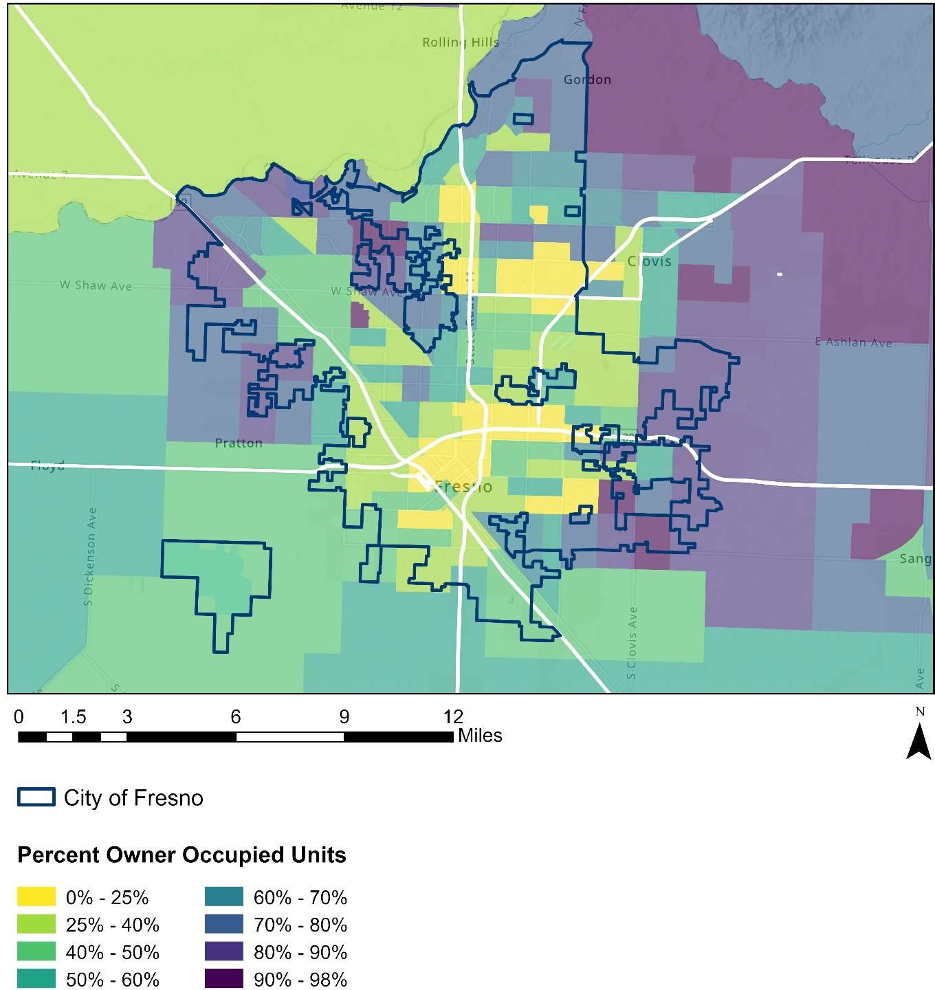

Miles

**Percent Owner Occupied Units**

City of Fresno

*Data Source: American Community Survey Five-Year Estimates, 2019-2023, Table S2502*

The table that follows shows numbers of owner and renter households, as well as homeownership rates by race and ethnicity in Fresno. Owner-occupied households make up about half (49.7%) of all households in the city. Homeownership rates are highest among White and Asian/ Pacific Islander households in the city (56.3% and 54.6%, respectively). The homeownership rate is lowest among Black households (33.8%; see Table 12).

#### TABLE 12. HOMEOWNERSHIP RATES BY RACE AND ETHNICITY

|  |  |  |  |
| --- | --- | --- | --- |
| **CITY OF FRESNO** | | | |
| **Householder Race / Ethnicity** | **Owner Households** | **Renter Households** | **Homeownership Rate** |

|  |  |  |  |
| --- | --- | --- | --- |
| White | 46,540 | 36,186 | 56.3% |
| Black | 4,447 | 8,693 | 33.8% |
| Asian / Pacific Islander | 12,127 | 10,075 | 54.6% |
| Native American | 1,008 | 1,295 | 43.8% |
| Hispanic/ Latino (of any race) | 32,776 | 45,052 | 42.1% |
| **TOTAL** | **89,235** | **90,449** | **49.7%** |

*Source: American Community Survey Five-Year Estimates, 2019-2023, Table S2502*

*NOTE: Numbers of households by race/ethnicity add up to more than the totals because racial categories may include Hispanic/ Latino households in addition to non-Hispanic/ Latino households.*

### Mortgage Lending

Prospective homebuyers need access to mortgage credit, and programs that offer homeownership should be available without discrimination. The proceeding data and analysis assesses the degree to which the housing needs of residents are being met by home loan lenders.

The Home Mortgage Disclosure Act of 1975 (HMDA) requires most mortgage lending institutions to disclose detailed information about their home lending activities annually. The objectives of the HMDA include ensuring that borrowers and loan applicants are receiving fair treatment in the home loan market.

The national 2023 HMDA data consists of information for 10 million home loan applications reported by 5,113 home lenders including banks, savings associations, credit unions, and mortgage companies. HMDA data, which is provided by the Federal Financial Institutions Examination Council (FFIEC), includes the type, purpose, and characteristics of each home mortgage application that lenders receive during the calendar year. It also includes additional data related to those applications including loan pricing information, action taken, property location (by census tract), and information about loan applicants such as sex, race, ethnicity, and income. 670 financial institutions reported HMDA data for census tracts wholly or partially in the city of Fresno in 2023.

Applicants in Fresno submitted a total of 14,458 home purchase loan applications in 2023. The following analysis looks at 4,511 applications in which the mortgage was applied for as a first lien, including conventional, FHA-insured, VA-guaranteed, and FSA / RHS- guaranteed loans for single-family homes. Within each record, some data variables are 100% reported— “Loan Type,” “Loan Amount,” and “Action Taken,” for example—but other data fields are less complete. According to the HMDA data, these records represent applications taken entirely by mail, Internet, or phone in which the applicant may have declined to identify their sex, race, and/or ethnicity. Records for applications with missing race and ethnicity data are included in a separate category entitled “No Race or Ethnicity Given.” This data does not include seller-financed loans.

Looking at first-lien applications completed in 2023, about two in five applications in the city were completed by Hispanic or Latino applicants (1,729 applications, or 38.3% of all applications). Asian or Pacific Islander applicants, White applicants, and applicants of other races or who did not provide information about their race each made up about 18% to 22% of all completed applications (820, 823, and 990 applications, respectively). Black applicants submitted 3.3% of applications (149 applications).

Table 13 shows loan approval rates for completed loan applications by race and ethnicity at various income levels in Fresno. The Median Family Income in the Fresno, CA HUD

Metro FMR Area is $79,400, according to HUD’s FY 2023 Income Limits. The income tiers below represent low-income applicants earning up to 80% AMI ($63,520), middle- income applicants earning 80% to 120% AMI ($63,520 to $95,280), and high-income applicants earning more than 120% AMI (over $95,280). In 2023, there were 118 applications for which income was not reported. These applications are included in the totals under “all applicants.” Excluded from these figures are applications that were withdrawn or closed due to incompleteness such that no decision was made regarding approval or denial.

### Mortgage Denials

HMDA data indicates that 13.0% of first-lien mortgage applications for single-family homes in the city were denied in 2023. 26.6% of all applications from low-income earners were denied. Among middle-income earners, 11.1% of applicants were denied a loan, while 10.3% of applications from high-income earners were denied.

Looking at these figures by race and ethnicity, Asian/ Pacific Islander applicants, Hispanic applicants, and applicants of other races or who didn’t provide race or ethnicity information all had relatively similar rates of denial (14.8%, 13.2%, and 12.5%, respectively). Black applicants were denied mortgages at a significantly higher rate (20.8%) than the city’s average rate of 13.0%, while White applicants were less likely to be denied than applicants of other races (9.8%). Overall, Black applicants were more than twice as likely to be denied a loan as White applicants and about 1.4 to 1.7 times as likely to be denied as applicants of other races.

##### Low-Income Applicants

26.6% of low-income mortgage loan applicants were denied a mortgage loan. Low- income applicants identifying as Black and Asian/ Pacific Islander experienced disproportionate rates of mortgage loan denial (48.3% and 38.9%). Hispanic/ Latino applicants and applicants of other races or who did not provide race/ethnicity information were denied mortgages at the lowest rates of all low-income applicants (23.0% and 23.3%, respectively).

##### Middle-Income Applicants

Middle-income applicants, earning between 80% to 120% AMI, were denied mortgages at a rate of 11.1%. At this income level, Asian/ Pacific Islander applicants and applicants of other races or who did not provide race/ethnicity information were denied at higher rates (14.8% and 15.4%, respectively), while White households were least likely to be denied (5.8%).

##### High-Income Applicants

At high incomes, 10.3% of applicants experienced a mortgage loan denial. At this income level, Black applicants experienced denials at the highest rates (16.1%), while White applicants had the lowest rates of denial (7.8%).

##### Reasons for Denial

Reasons for denial are shown in Table 14. Hispanic applicants had the largest number of denials (228), followed by applicants of other races or whose race was not provided (124), and Asian/ Pacific Islander applicants (121). The primary reason for mortgage loan denial was debt-to-income ratio (208 applicants). Other frequent reasons for loan denial included collateral (86 applicants), insufficient cash (downpayment, closing costs; 68 applicants), and unverifiable information (52 applicants).

These findings indicate disparities in access to mortgage loans in the city, particularly for Black applicants. Denials based on a high debt-to-income ratio and insufficient cash indicate that many applicants struggle with long-term financial instability, which creates barriers to accessing a mortgage. Denials based on collateral indicate that the value of a requested loan is high relative to the appraised value of a home, creating loan-to-value ratios that fall above lenders’ thresholds. The data suggests that additional resources are needed to stabilize the path to homeownership, including support for homebuyer readiness classes or other pre-application assistance, downpayment assistance programs, and wider-ranging social support for households to improve their chances of securing mortgage loans.

#### TABLE 13. LOAN DENIAL RATES BY RACE AND ETHNICITY IN FRESNO

|  |  |  |  |
| --- | --- | --- | --- |
| **White** | **Black** | **Asian / Pacific Islander** | **Other/ Race Not Available** |

|  |  |  |
| --- | --- | --- |
| **Applicant Home**  **LOW INCOME** | **APPLICANT RACE AND ETHNICITY** | |
| **Non-Hispanic/ Latino**  **Hispanic/ Latino** | **All Applicants** |
|  | |

|  |  |  |  |  |  |  |
| --- | --- | --- | --- | --- | --- | --- |
| Completed Applications | 107 | 29 | 72 | 116 | 357 | 681 |
| Denial Rate | 28.0% | 48.3% | 38.9% | 23.3% | 23.0% | 26.6% |
| **MIDDLE INCOME** |  |  |  |  |  |  |
| Completed Applications | 189 | 33 | 209 | 234 | 598 | 1,263 |
| Denial Rate | 5.8% | 9.1% | 14.8% | 15.4% | 9.9% | 11.1% |
| **HIGH INCOME** |  |  |  |  |  |  |
| Completed Applications | 527 | 87 | 537 | 566 | 808 | 2,525 |
| Denial Rate | 7.8% | 16.1% | 11.9% | 8.8% | 11.4% | 10.3% |
| ALL APPLICANTS |  |  |  |  |  |  |
| Completed Applications | 823 | 149 | 820 | 990 | 1,729 | 4,511 |
| Denial Rate | 9.8% | 20.8% | 14.8% | 12.5% | 13.2% | 13.0% |

*Data Source: FFIEC 2023 Home Mortgage Disclosure Act Data, Accessed via https://ffiec.cfpb.gov/data- browser/data/2023?category=counties&items=06019*

*NOTE: “Completed applications” includes applications that were approved but not accepted, denied, and approved with a loan originated. It does not include applications withdrawn by the applicant or closed for incompleteness.*

#### TABLE 14. PRIMARY REASON FOR LOAN DENIAL BY APPLICANT RACE AND ETHNICITY

|  |  |  |  |  |  |  |
| --- | --- | --- | --- | --- | --- | --- |
| **Denial Reason** | **White** | **Black** | **Asian/ Pacific Islander** | **Other/ Race not Available** | **Hispanic/ Latino** | **All Applicants** |

|  |  |  |  |  |  |  |
| --- | --- | --- | --- | --- | --- | --- |
| Collateral | 17 | 1 | 11 | 17 | 40 | 86 |
| Credit Application Incomplete | 5 | 2 | 8 | 18 | 14 | 47 |
| Credit History | 9 | 2 | 10 | 9 | 15 | 45 |
| Debt to Income Ratio | 21 | 15 | 54 | 36 | 82 | 208 |
| Employment History | 3 | 0 | 5 | 2 | 10 | 20 |
| Insufficient cash (down payment, closing costs) | 8 | 5 | 9 | 18 | 28 | 68 |
| Mortgage insurance denied | 0 | 0 | 0 | 0 | 0 | 0 |
| Other | 10 | 1 | 18 | 12 | 18 | 59 |
| Unverifiable Information | 8 | 5 | 6 | 12 | 21 | 52 |
| **TOTAL DENIALS** | **81** | **31** | **121** | **124** | **228** | **585** |

*Data Source: FFIEC 2023 Home Mortgage Disclosure Act Data, Accessed via https://ffiec.cfpb.gov/data- browser/data/2023?category=counties&items=06019.*

### Zoning, Affordability, and Housing Choice

Comprehensive land use planning is a critical process by which communities address a myriad of public policy issues such as housing, transportation, health, recreation, environmental protection, commercial and retail services, and land values, and address how the interconnection and complexity of these issues can ultimately impact the entire municipality. Likewise, decisions regarding land use and zoning have a direct and profound impact on affordable housing and fair housing choice, shaping a community or region’s potential diversity, growth, and opportunity for all. Zoning determines where housing can be built, the type of housing that is allowed, and the amount and density of housing that can be provided. Zoning also can directly or indirectly affect the cost of developing housing, making it harder or easier to accommodate affordable housing.

The following sections will explore (I) how California state law impacts local land use and zoning authority and decision-making and (II) how the zoning and land use codes of the City of Fresno impact housing affordability and fair housing choice within its municipal borders.

##### Intersection of Local Zoning with Federal and State Fair Housing Laws

One goal of zoning is to balance individual property rights with the power of government to promote and protect the health, safety, and general welfare of the overall community. Zoning codes regulate how a parcel of land in a community may be used and the density of development. Local governments may divide their jurisdiction into zoning districts by adopting a zoning map consistent with the comprehensive plan; define categories of permitted and special/conditional uses for those districts; and establish design or performance standards for those uses. Zoning may regulate the height, shape, and placement of structures and lot sizes or shapes. Jurisdictions also can expressly prohibit certain types of uses within zoning districts.42 In this way, local ordinances may define the type and density of housing resources available to residents, developers, and other organizations within certain areas, and as a result influence the availability and affordability of housing.

42 Local government power to regulate land use derives from the State's expressly delegated police power, first to municipal governments and then to counties, as found in the various enabling statues of the state constitution and Official Code of Georgia Annotated. *See* O.C.G.A. § 36-66-1 *et seq*. (zoning authority cities). State law grants local municipalities authority to adopt and enact local comprehensive plans, but such plans are not intended to limit or compromise the right of the governing body of any county or municipality to exercise the power of zoning. *See* O.C.G.A § 36-70-5.

While local governments have the power to enact zoning and land use regulations, that power is limited by state and federal fair housing laws (e.g., California’s Fair Employment and Housing Act (FEHA), the federal Fair Housing Act (FHA), the Americans with Disabilities Act (ADA), constitutional due process and equal protection). The FHA prohibits both private individuals and government authorities from denying a member of a protected class equal access to housing, including through the enforcement of a local zoning ordinance that disproportionately limits housing choice for protected persons. In *Texas Department of Community Affairs v. The Inclusive Communities Project*, a 2015 landmark disparate impact case under the FHA, the Supreme Court affirmed that part of the FHA’s central purpose is to eradicate discriminatory housing practices, including specifically unlawful zoning laws and other housing restrictions.

Besides intentional discrimination and disparate impact, discrimination on the basis of disability also includes: “[A] refusal to make reasonable accommodations in rules, policies, practices, or services, when such accommodations may be necessary to afford such person equal opportunity to use and enjoy a dwelling.”43 This provision has been held to apply to zoning and land use decisions by local governments.

California has adopted a parallel version of Title VIII of the Civil Rights Act of 1968, as amended by the Fair Housing Amendments Act of 1988, (the “Fair Housing Act,” “FHA” or “FHAA”), known as the Fair Employment and Housing Act (“FEHA”) (Cal. Gov. Code § 12900 - 12996). Both the FHA and FEHA prohibit discrimination in the sale, rental, and financing of dwellings, and in other housing-related transactions, based on sex (which under the FEHA also includes specifically pregnancy, childbirth, breastfeeding or medical conditions related to pregnancy, childbirth or breastfeeding), race, color, disability (physical and mental), religion, national origin, or familial status (families with children). California has a broader definition of “disability” than federal civil rights acts. In California, disability includes physical or mental impairments that “limit a major life activity” as opposed to the federal definition which requires that the disabling condition “substantially limit” one or more major life activities. The FEHA also expands on the classes of persons protected against discriminatory housing practices to also prohibit discrimination in housing based on gender, gender identity, and gender expression, sexual orientation, marital status, age, source of income, genetic information, and retaliation for protesting illegal discrimination, or “any other basis prohibited by Section 51 of the Civil Code,” which also includes as a basis of protection medical condition, citizenship, primary language, and immigration status.

43 FHA § 804(f)(3)(b)

“Source of income” is defined narrowly under the FEHA as “lawful, verifiable income paid directly to a tenant or paid to a representative of a tenant” and under the definition “a landlord is not considered a representative of a tenant.” Accordingly, source of income under the FEHA has been adjudged to not include government rent subsidies, specifically Housing Choice Vouchers under Sec. 8 of the FHA. While the FEHA does not prevent a landlord from refusing to accept tenants who rely on Section 8 vouchers, the California Court of Appeals has found that a local ordinance that specifically protects against discrimination based on a tenant’s participation in the Section 8 program is not preempted by the state law. Fresno did not have a local ordinance protecting tenants relying on Section 8. Because the number of voucher holders often far outnumbers available rental units in an area, in 2019, the state legislature passed, and the governor signed into law, a separate statewide bill that makes it unlawful for landlords to refuse a tenant because that tenant’s source of payment relies on subsidies or participation in Section 8.44

The FEHA prohibits discrimination and harassment in all aspects of housing, including sales and rentals, evictions, terms and conditions, mortgage loans and insurance, and land use and zoning. California’s fair housing law has fewer exemptions than its federal counterpart. An owner-occupied single-family home, where the owner does not rent to more than one individual (as opposed to owner-occupied buildings with no more than four units under the FHAA) and complies with FEHA's prohibition against discriminatory statements, notices, or advertisements, is one of the few exemptions under the FEHA. Exemptions also apply to housing operated by organizations and private clubs that limit occupancy to members and statements indicating a preference for same-sex roommates in shared living situations. The FEHA explicitly prohibits discriminatory “public or private land use practices, decisions and authorizations” including, but not limited to, “zoning laws, denials of permits, and other [land use] actions . . . that make housing opportunities unavailable” to protected groups. Like the FHA, it requires housing providers to make reasonable accommodation in rules and practices to permit persons with disabilities to use and enjoy a dwelling and to allow persons with disabilities to make reasonable modifications of the premises.

Under California’s Unruh Civil Rights Act, all persons are entitled to full and equal accommodations, advantages, facilities, privileges, or services in all “business establishments,” including both private and public entities. The Unruh Act has been consistently construed to apply to rental housing, and is an additional claim often averred

44 SB 329, signed Oct. 8, 2019, to amend Sections 12927 and 12955 of the Government Code, relating to discrimination.

in housing discrimination cases. The Unruh Civil Rights Act protects all persons against arbitrary and unreasonable discrimination by a business establishment.

Despite state law generally leaving zoning and land use regulations to local decision- making, the FEHA explicitly preempts any local ordinance that conflicts with the categories of housing discrimination specifically set forth in the statute. Fresno has not adopted a local nondiscrimination ordinance or expanded on the rights and obligations already guaranteed by the FEHA or Unruh Civil Rights Act.

### City of Fresno Zoning Ordinance Review

Although comprehensive plans and zoning and land use codes play an important role in regulating the health and safety of the structural environment, overly restrictive codes can negatively impact housing affordability and fair housing choice within a jurisdiction. Examples of zoning provisions that most commonly result in barriers to fair housing choice include:

* Restrictive forms of land use that exclude any specific form of housing, particularly multi-family housing, or that require large lot sizes or low-density that deter affordable housing development by limiting its economic feasibility.
* Restrictive definitions of family that impede unrelated individuals from sharing a dwelling unit.
* Placing administrative and siting constraints on group homes for persons with disabilities.
* Restrictions making it difficult for residents with disabilities to locate housing in certain neighborhoods or to modify their housing.
* Restrictions on occupancy of alternative sources of affordable housing such as accessory dwellings, mobile homes, and mixed-use structures.

Fresno’s treatment of these types of issues are explored and evaluated in the tables and narrative on the following pages.

Because zoning codes present a crucial area of analysis for a study of impediments to fair housing choice, the latest available Development Code and land use ordinances of the City were reviewed and evaluated in relation to ten common fair housing issues. Taken together, these issues give a picture of:

* 1. The degree to which exclusionary zoning provisions may impact affordable housing opportunities within those jurisdictions.
  2. The degree to which the zoning code may impact housing opportunities for persons with disabilities.

The zoning ordinance was assigned a risk score of either 1, 2, or 3 for each of the ten issues and was then given an aggregate score calculated by averaging the individual scores, with the possible scores defined as follows:

The provision poses little risk for discrimination or limitation of fair housing choice, or is an affirmative action that intentionally promotes and / or protects affordable housing and fair housing choice.

The provision is neither among the most permissive nor most restrictive; while it could complicate fair housing choice, its effect is not likely to be widespread.

The provision causes or has potential to result in systematic and widespread housing discrimination or the limitation of fair housing choice, or is an issue where the jurisdiction could take affirmative action to further affordable housing or fair housing choice but has not.

**3 – High Risk:**

**2 = Medium Risk:**

1 = Low Risk:

The following table lists the ten issues reviewed and Fresno’s scores for each issue. A complete report including citations to relevant statutes, code sections, and explanatory comments, are included as an appendix to this document.

#### TABLE 15. FRESNO ZONING CODE RISK SCORES

**Issue Risk Score**

1a. Does the jurisdiction’s definition of “household” have the effect of preventing unrelated individuals from sharing the same residence? Is the definition unreasonably restrictive?

1b. Does the definition of “household” discriminate against or treat 1

differently unrelated individuals with disabilities (or members of any other protected class)?

2a. Does the zoning code treat housing for individuals with disabilities (e.g., group homes, congregate living homes, supportive services housing, personal care homes, etc.) differently from other single family residential and multifamily residential uses? For example, is such housing only allowed in certain residential districts, must a special or conditional use permit be granted before siting such housing in certain residential districts, etc.?

2b. Does the zoning ordinance unreasonably restrict housing opportunities for individuals with disabilities who require onsite supportive services? Or is housing for individuals with disabilities allowed

in the same manner as other housing in residential districts?

1

**Issue Risk Score**

3a. Do the jurisdiction’s policies, regulations, and/or zoning ordinances provide a process for persons with disabilities to seek reasonable modifications or reasonable accommodations to zoning, land use, or other regulatory requirements?

3b. Does the jurisdiction require a public hearing to obtain public input 1

for specific exceptions to zoning and land-use rules for applicants with disabilities? If so, is the public hearing process only required for applicants seeking housing for persons with disabilities or required for all applicants?

4. Does the ordinance impose spacing or dispersion requirements on

certain protected housing types?

1

5. Does the jurisdiction restrict any inherently residential uses protected

by fair housing laws (such as residential substance abuse treatment 1

facilities) only to non-residential zones?

6. Does the jurisdiction’s zoning and land use rules constitute exclusionary zoning that precludes development of affordable or low- income housing by imposing unreasonable residential design regulations (such as high minimum lot sizes, wide street frontages, large setbacks, low floor area ratios (FARs), large minimum building square footage, or large livable floor areas, restrictions on number of bedrooms per unit,

and/or low maximum building heights)?

1

7a. Does the zoning ordinance fail to provide residential districts where multi-family housing is permitted as of right? Are multifamily dwellings

excluded from all single-family dwelling districts? 1

7b. Do multi-family districts restrict development only to low-density housing types?

8. Are unreasonable restrictions placed on the construction, rental, or occupancy of alternative types of affordable or low-income housing (for

example, accessory dwellings or mobile/manufactured homes)?

1

9a. Are the jurisdiction’s design and construction requirements (as contained in the zoning ordinance or building code) congruent with the 1

Fair Housing Act’s accessibility standards for design and construction?

9b. Is there any provision for monitoring compliance?

**1**

**Average Risk Score**

1

10. Does the zoning ordinance include an inclusionary zoning provision

or provide any incentives for the development of affordable housing or housing for protected classes?

**Risk Score**

**Issue**

The City’s average risk score (calculated by taking the average of the 10 individual issue scores) is 1.0, indicating that overall there is low risk of the development code and other land use regulations contributing to discriminatory housing treatment or impeding fair housing choice. In most cases, the Development Code and other land use code sections are reasonably permissive and allow for flexibility as to the most common fair housing issues. Remarkably, the City did not receive a “2” (medium risk) or “3” (high risk) score on any of the ten issues evaluated. While facially Fresno’s code does not put it in jeopardy of violating the minimum fair housing and AFFH standards as they relate to local government land use regulations and policies, even well-scoring jurisdictions must also work to apply their land use codes and policies in an equitable manner. Additionally, there are always incremental improvements to be made to rules and policies to more fully protect the fair housing rights and housing choice of all of the City’s residents and to better fulfill the mandate to affirmatively further fair housing.

The restriction of housing choice for certain historically/socio-economically disadvantaged groups and protected classes can happen in any number of ways and should be viewed on a continuum. The zoning analysis matrix developed for this report and the narrative below are not designed to assert whether the City’s code creates a per se violation of the FHA or HUD regulations, but are meant as a tool to highlight significant areas where zoning and land use ordinances may otherwise jeopardize the spirit and intent of fair housing protections and HUD’s AFFH standards for its entitlement communities.

The issues chosen for discussion show where zoning ordinances and policies could go further to protect fair housing choice for protected and disadvantaged classes, and yet still fulfill the zoning objective of protecting the public’s health, safety, and general welfare. Specifically, the issues highlighted by the matrix inform, first, the degree to which the zoning ordinance may be overly restrictive and exclusionary to the point of artificially limiting the affordable housing inventory and directly contributing to higher housing and rental costs. And secondly, the matrix helps inform the impact the local regulations may have on housing opportunities for persons with disabilities, a protected class under state and federal fair housing law.

### Impact of Zoning Provisions on Affordable Housing

Academic and market research have shown what also is intuitive: land use regulations can directly limit the supply of housing units within jurisdictions, thus contributing to making housing more expensive and less affordable.45 Exclusionary zoning is understood to mean zoning regulations that impose unreasonable residential design regulations that are not congruent with the actual standards necessary to protect the health and safety of current average household sizes and prevent overcrowding. Zoning policies that impose barriers to housing development by making developable land and construction costlier than they are inherently can take different forms, including high minimum lot sizes, low density allowances, wide street frontages, large setbacks, low floor area ratios, large minimum building square footage or large livable floor areas, restrictions on number of bedrooms per unit, low maximum building heights, restrictions against infill development, restrictions on the types of housing that may be constructed in certain residential zones, arbitrary or antiquated historic preservation standards, minimum off-street parking requirements, restrictions against residential conversions to multi-unit buildings, lengthy permitting processes, development impact fees, and/or restrictions on accessory dwelling units.

The Brookings Institution has found that “[o]n roughly 75% of land in most cities today, it is illegal to build anything except single-family detached houses. The origins of single- family zoning in America are not benign: Many housing codes used density as a proxy for separating people by income and race.”46 Although today it may be difficult to prove that a zoning ordinance’s preference for single family zoning is facially (or intentionally) discriminatory in direct violation of fair housing laws, such land use regulations still may have the effect of artificially limiting the supply of housing units in a given area and disproportionately reducing housing choice for moderate to low-income families, minorities, persons with disabilities on fixed incomes, families with children, and other protected classes by making the development of affordable housing cost prohibitive.

45 See Gyourko, Joseph, Albert Saiz, and Anita A. Summers, A New Measure of the Local Regulatory Environment for Housing Markets: The Wharton Residential Land Use Regulatory Index (2007), available at real.wharton.upenn.edu; Randal O’Toole, The Planning Penalty: How Smart Growth Makes Housing Unaffordable (2006), available at independent.org/pdf/policy_reports/2006-04-03-housing.pdf; Edward L. Glaeser and Joseph Gyourko, The Impact of Zoning on Housing Affordability (2002), available at law.yale.edu/system/files/documents/pdf/hier1948.pdf; The White House’s Housing Development Toolkit, 2016, available at whitehouse.gov/sites/whitehouse.gov/files/images/Housing_Development_Toolkit%20f.2.pdf.

46 Baca, Alex, “Gentle” Density Can Save Our Neighborhoods, Dec. 4, 2019, available at https://[www.brookings.edu/research/gentle-density-can-save-our-neighborhoods.](http://www.brookings.edu/research/gentle-density-can-save-our-neighborhoods)

Legitimate public objectives, such as maintaining the residential character of established neighborhoods, environmental protection, or public health, must be balanced with housing needs and availability.

When Fresno drafted and adopted its current General Plan in 2014, it recommended large-scale rezones to allow for both more housing units and greater diversity of housing types, infill development, and use of vacant land for residential uses. The City adopted a new Development Code and updated Zoning Map in 2015 and 2016, respectively, to be more consistent with the policy goals of the General Plan related to housing and to codify those rezonings. In 2024, the City adopted the Fresno Multi-Jurisdictional 2023-2031 Housing Element, which provides further recommendations to increase fair access to housing, including rezoning to provide a variety of housing types in high-resource areas and encouraging missing middle and multi-unit housing types in currently single-family dominated neighborhoods.

With the General Plan’s Housing Element Amendment and rezonings implemented through the new Development Code and Zoning Map, Fresno shifted from a preference for single-family detached housing to residential and mixed-use zones that allow more density and housing type diversity. The Development Code and Zoning Map, however, still maintain single family detached only zoning districts (RE, RS-1, RS-2, and RS-3)— with no duplexes, townhomes, triplexes, row homes, garden homes, zero lot line dwellings, or the like (Accessory/Secondary dwelling units are permitted, however, in all single-family districts. See description below regarding Issue 8 of the matrix). In the RS- 4 district, single-family attached dwellings are a conditional use. In the RS-5 district, single family attached dwellings and cottage housing are permitted by right uses; duplexes and multi-unit dwellings require conditional use permit approval. For each district, the City has established a density limit, minimum lot size, minimum setbacks, maximum lot coverage, maximum height of 35 feet, and other development controls. The Development Code and Zoning Map divide single-family zoning into 6 districts with a range of densities (up to 12 units/acre, without density bonus) and minimum lot sizes ranging from 5 acres in the RE district; 36,000 sq. ft. in the RS-1 district; 20,000 sq. ft. in the RS-2 district; 9,000 sq. ft. in the RS-3 district; 5,000 sq. ft. in the RS-4; and 4,000 sq. ft. in the RS-5 district. To promote more density and infill development the RS-3, RS-4, and RS-5 districts also have maximum lot size requirements.

In the RM-1 multifamily district, single family detached, single family attached, duplexes, and cottage housing (as well as multifamily) are permitted uses under the same RS-5 lot and design standards. Single family attached and duplexes also are permitted in the RM- 2 district, and duplexes are permitted by right in the RM-3 district.

Cottage housing developments, also known as “pocket neighborhoods,” are a group of four to 12 single-family homes, between 600 and 1,200 square feet, that are arranged in

common relation to one another, usually surrounding a shared landscaped area. Cottage housing, permitted in the RS-5 and RM-1 districts, can be built at a density of up to 1.33% of the number of units permitted in the underlying district. The cottage housing option allows more diversity in housing options and infill development opportunities while protecting the character of single-family neighborhoods.

Any development standards place some degree of artificial pressure on the cost of housing and limit housing diversity, density, and socioeconomic integration within many desirable neighborhoods. Some of Fresno’s low and very-low density single-family districts have more barriers to affordable housing development; however, with the range of densities and housing types permitted in the medium and high density districts, opportunity for density bonuses (see Issue 10) and infill development, and vacant or underdeveloped land available (see Housing Element), Fresno’s zoning code should not unreasonably exclude development of affordable single-family units within the city. Because of the amendments to the Housing Element and Development Code/Map, Fresno received a “1/low risk” score on Issue 6 of the matrix related to exclusionary zoning.

However, exclusionary zoning can happen on a continuum, and there is more the City can do to use zoning and land use policies to further remove artificial barriers to development of and access to affordable housing across all residential zones. While Fresno’s development ordinance is not highly restrictive, there are opportunities for greater flexibility to encourage more affordable housing development in the single-family districts. Allowing more housing units in the single-family districts can bring down average housing prices as it spreads the cost of land across more homes and creates more supply in the housing market. This can be accomplished in a variety of ways; for instance, by permitting or incentivizing conversion of large single-family dwellings or replacement of detached dwellings on large lots to attached dwellings, two-family, three-family, or low- density multifamily dwellings compatible in physical scale with single-family dwellings. Other tools include lowering the minimum lot size requirements and relaxing other development controls such as minimum lot widths, minimum setbacks, and maximum height allowances. Or to assuage concerns about changing the established physical character of a neighborhood, general requirements about height, yard space, and architectural elements can remain unchanged in those zones, making attached and small multifamily housing types less daunting for neighbors. Other alternatives to large lot sizes may include cluster developments, density blending, zero lot line developments (rowhouses, garden homes, patio homes, and townhomes), and transfer of development rights in appropriate locations. The City could follow the example of cities such as Minneapolis, which has up-zoned every residential zoning district to eliminate single- family detached only zones. Allowing duplexes and triplexes on what had been single- family lots theoretically can double or triple housing capacity in many neighborhoods.

Relaxing exclusionary land use standards city-wide may not be a silver bullet to solving the housing shortage and affordability crisis many jurisdictions around the state and country face, but over time can make allowance for incremental improvements and alleviate the local government’s own complicity in the problem.

In addition to the rezonings to an RM multifamily category, the General Plan update called for some commercial- and office-zoned lands suitable for residential development to be rezoned to a new Mixed-Use or Downtown category that allows for both residential and commercial/office uses. Three Downtown Districts were created for the urban core in 2016: DTC (Downtown Core), DTG (Downtown General), and DTN (Downtown Neighborhood). The new Downtown standards allow for the development of fully residential projects and establish unlimited residential densities and intensity (floor-to- area ratio) at building heights up to 15 stories. In the city’s core, the City provides reduced application fees and priority processing for single and multifamily projects. The Mixed- Use regulations were implemented to promote pedestrian-oriented infill development, intensification, and reuse of land with ground-floor neighborhood retail uses and upper- level multifamily housing and a mix of small lot single-family attached houses and townhomes.

The Development Code and Zoning Map make possible reasonable development of by- right multifamily units at varying density allowances in the multifamily Medium-High Density RM-1, Urban Density RM-2, High Density RM-3 districts; Mixed Use NMX, CMX, and RMX districts; Commercial CMS and CR districts; and Downtown DTN, DTG, and DTC zoning districts. The RM, Mixed Use, Commercial, and Downtown districts also permit a mix of other housing types including single family attached and duplexes. The Development Code and General Plan provide for a range of densities for multifamily in the RM districts (up to 45 units/acre, without density bonus, in the RM-3 district); mixed- use buildings or standalone residential in the Commercial districts (up to 16 units/acre); and mixed-use buildings in the Mixed Use districts (up to 45 units/acre, without density bonus, in the RMX district) and in the Downtown districts with no density limits. The development regulations for the RM districts include minimum densities for multifamily as well. Fresno received a “1/low risk” score on Issue 7 of the matrix related to permitted by right multifamily development.47

47 While multifamily dwellings are a permitted use in the RM, Mixed Use, and Downtown districts, a determination of whether a sufficient portion of the zoning map permits multifamily development to meet demand was not made. Besides development controls and permit procedures, availability of land affects the feasibility of developing multifamily housing. The housing element of the General Plan describes the availability of vacant and underdeveloped land that may be designated for multifamily dwellings. Other considerations like housing market conditions, existing land-use patterns, the provision of public services

As for Issue 8 regarding alternative types of affordable housing, the City scored a “1/low risk” because it permits both manufactured housing and accessory dwelling units. State law mandates that accessory dwelling units be permitted by right wherever single-family dwellings are permitted, subject to local design and development conditions. ADUs have the potential to reduce barriers to housing options for some families as a form of infill- development that can be affordable and offer important housing choice within existing high-opportunity neighborhoods. Under Fresno’s Development Code, “Second Dwelling Units” (i.e. accessory dwelling units), “Backyard Cottages” (i.e. “tiny homes”), and “Accessory Living Quarters” (dependent units) are permitted by right in all the single- family and multifamily districts where they meet zoning and design requirements. The maximum floor areas are 1,250 sq. ft. for a second dwelling unit, 440 sq. ft. for a backyard cottage, and 500 sq. ft. for an accessory living quarter.

In 2019, the California legislature passed a bill that limits fees and restrictions on building new accessory dwelling units. For example, ADUs created by converting garages would not be required to have replacement parking.48 Another ADU bill eliminates minimum lot size requirements for adding an ADU, requires proposed ADUs to be ministerially approved or denied within 60 days, and allows ADUs to be added inside existing apartment buildings (typically via conversion of parking garages).49

In Fresno, a manufactured/factory-built house is considered a single-family detached dwelling unit and is treated as such. Manufactured homes in compliance with state and local regulations may be used for residential purposes if built on a permanent foundation. Mobile home parks are permitted in the RM-MH district, with a minimum density of 12 u/a and a maximum density of 16 u/a.

##### Inclusionary Zoning and Density Bonuses

Inclusionary zoning (IZ) can be an important tool for affirmatively furthering fair housing choice. Voluntary and mandatory IZ can both help boost the number of affordable units and act as a desegregation tool to help support neighborhood diversity and keep high- opportunity areas affordable for a greater socioeconomic swath of the population. Because the private developer subsidizes the affordable units (in exchange for greater density and other development concessions), the main difficulty in implementing

and infrastructure, demand for “luxury” units, and other planning goals also have an impact on the quantity of multifamily and affordable housing.

48 SB 13, effective October 9, 2019, to amend, repeal, and add Section 65852.2 of the Government Code, and to add and repeal Section 17980.12 of the Health and Safety Code, relating to land use

49 AB 68, effective October 9, 2019, to amend Sec. 65852.2 and 65852.22 of the Government Code.

inclusionary zoning is finding how much below market rentals/sales developers will tolerate before making new housing construction economically infeasible and actually having a negative effect on housing unit production. As for Issue 10 regarding inclusionary zoning efforts, Fresno’s Development Code does include voluntary inclusionary zoning incentives for the development of affordable housing and housing for older persons, tracking the State’s mandate for local governments to implement the state density bonus law.

The bonuses under the local ordinance apply to general residential projects of five or more units and senior housing projects of more than 35 units. Developments that meet the thresholds for density bonuses also may qualify for other incentives and concessions such as modification of development standards, reduced off-street parking requirements; or others proposed by the developer or the City that result in identifiable cost reductions.

Under the current local ordinance, the developer may receive a density bonus of (a) 20% if 5% of the total units of a housing development are affordable to very low income households; (b) 20% if 10% of the total units of a housing development are affordable to lower income households; (c) 20% if a housing development qualifies as a Senior Citizen Housing Development; (d) 5% if 10% of the total dwelling units in a condominium project are affordable to persons and families of moderate income; (e) 25% for conversion of apartments to condos if at least 33% of the total units of the proposed condominium project are affordable to persons of low or moderate income or if 15% of the total units of the condominium project are affordable to lower income households; or (f) additional density bonus or concessions for a development that includes a state childcare facility or a donation of land that could accommodate at least 40 units. For rental units, the City and property owner must enter into an enforceable recorded covenant which governs such things as number of units; target units; household income group; certification procedures; building schedule; term of affordability; remedies for breach; etc.

Fresno’s Development Code also includes a Transit Oriented Development-TOD Height and Density Bonus that may be used in combination with an Affordable Housing Density Bonus. For projects that qualify for both the TOD bonus and Affordable Housing bonus, the bonus height may exceed the base district height by 25% and the bonus density may exceed that of the base district by 100%.

California’s density bonus law has been amended many times since it was first adopted in 1976 to clarify the legislation in response to legal and implementation challenges and to add new provisions and standards. For instance, the term of affordability has gone up from 30 to 55 years for low and very low-income units under state law. Other changes to the state law that are not yet reflected in Fresno’s local ordinance include an update to the reduced parking requirements as a development incentive; density bonus option for commercial developments that include affordable dwelling units; other housing categories

that are eligible for a density bonus like low-income student housing, transitional housing for foster youth, housing for veterans, and housing for persons experiencing homelessness; and rules clarifying the application and processing requirements, among others. The state regulations regarding density bonuses use a sliding scale so that the greater the percentage of affordable units, the higher the density bonus. The newest amendments, which took effect January 1, 2020, significantly increase the potential density bonus and concessions to which a developer may be entitled. For 100% affordable housing projects, the development can receive an 80% density bonus over the base density, four regulatory concessions, and are not subject to any minimum parking requirements. If the project is within one-half mile of a major transit stop, the City may not apply any density limit to the project and it will also receive a height increase of up to three additional stories, or 33 feet. Limits on 100% affordable projects will only come from other local development standards like maximum height limits, setbacks, lot coverage, etc. (which also may be subject to allowable concessions).

Fresno’s ordinance was last updated effective 2016. However, as the state law is amended from time to time, the updated requirements are incorporated by reference into the local ordinance regarding inclusionary zoning bonuses. “The provisions of this section shall be governed by the requirements of Government Code Section 65915. Where conflict may occur between the provisions of this section and State law, the State law shall govern.” Fresno should update its density bonus ordinances to codify changes to the state law that have occurred since its last update, including the new bonus for 100% affordable projects.

The City could go even further than the state bonus law in ensuring the long-term affordability of not just rental units but owner-occupied units as well. For-sale units are only required to be affordable to the initial occupants of the units, who must be very low income, lower income or moderate income, as applicable. At resale, the local government must enforce an equity-sharing agreement (involving sale of the home at fair market value and sharing of the profits with the city). To avoid losing affordable owner-occupied units with the first resale, Fresno could adopt requirements for deed restrictions or other measures to protect long-term affordability for an owner-occupied project to be eligible for a density bonus.

Fresno could also consider adopting mandatory inclusionary zoning requiring that developers wanting to build in the city’s strongest housing markets or core neighborhoods provide some amount of affordable units, as mandatory vs. voluntary inclusionary

programs have shown much more success in actually producing new affordable units.50 A 2006 survey of mandatory and voluntary inclusionary programs in California found that of the 170 then-known programs in the state, 24 of these programs had been able to produce 10% or more of their new units as inclusionary housing. Of these 24 productive programs, 22 were mandatory, and two were voluntary (voluntary programs were found to have relied on growth management policies to produce the affordable housing).51

Although no one specific zoning change can solve affordable or fair housing needs alone, taken together these zoning tools could allow for an increased supply of a variety of housing types distributed more equitably across the city, helping put downward pressure on rental and sale prices and providing low- and moderate-income families access to all the congruent benefits of housing choice, including access to better jobs, schools, public transportation, healthcare, cultural amenities, and public facilities.

## PUBLICLY SUPPORTED HOUSING

Publicly supported housing encompasses several strategies and programs developed since the 1930s by the federal government to ameliorate housing hardships that exist in neighborhoods throughout the country. The introduction and mass implementation of slum clearance to construct public housing projects during the mid-1900s signified the beginning of publicly supported housing programs. Government-owned and managed public housing was an attempt to alleviate problems found in low-income neighborhoods such as overcrowding, substandard housing, and unsanitary conditions. Once thought of as a solution, the intense concentration of poverty in public housing projects often exacerbated negative conditions that would have lasting and profound impact on their communities.

Improving on public housing’s model of high-density, fixed-site dwellings for very low- income households, publicly supported housing programs have since evolved into a more multi-faceted approach overseen by local housing agencies. The Housing and Community Development Act of 1974 created Section 8 rental assistance programs. Section 8, also referred to as the Housing Choice Voucher (HCV) program, provides two

50 See Brian R. Lerman, Mandatory Inclusionary Zoning—The Answer to the Affordable Housing Problem, 33 B.C. ENVTL. AFF. L. REV. 383, 387–88 (2006); Pinedo, Victor J., Embracing the Excluded: Using Mandatory Inclusionary Zoning to Affirmatively Further Fair Housing in St. Louis, Cornell Journal of Law and Public Policy: Vol. 26 : Iss. 2, Article 5 (2016).

51 Nonprofit Housing Association of Northern California, Affordable by Choice: Trends in California Inclusionary Housing Programs, 2006, available at <http://inclusionaryhousing.org/wp-> content/uploads/2016/08/NPH-IHinCA2006.pdf

types of housing vouchers to subsidize rent for low-income households: project-based and tenant-based. Project-based vouchers can be applied to fixed housing units in scattered site locations while tenant-based vouchers allow recipients the opportunity to find and help pay for available rental housing on the private market.

The Tax Reform Act of 1986 created the Low-Income Housing Tax Credit (LIHTC) program to incentivize development of affordable, rental-housing development. Funds are distributed to state housing finance agencies that award tax credits to qualified projects to subsidize development costs. Other HUD Programs including Section 811 and Section 202 also provide funding to develop multifamily rental housing specifically for disabled and elderly populations.

The now-defunct HOPE VI program was introduced in the early 1990s to revitalize and rebuild dilapidated public housing projects and create mixed-income communities. Although HOPE VI achieved some important successes, the Choice Neighborhoods Initiative program was developed to improve on the lessons learned from HOPE VI. The scope of Choice Neighborhoods spans beyond housing and addresses employment access, education quality, public safety, health, and recreation.

Current publicly supported housing programs signify a general shift in ideology toward more comprehensive community investment and de-concentration of poverty. However, studies have shown a tendency for subsidized low-income housing developments and residents utilizing housing vouchers to continue to cluster in disadvantaged, low-income neighborhoods. Programmatic rules and the point allocation systems for LIHTC are thought to play a role in this clustering and recent years have seen many states revising their allocation formulas to discourage this pattern in new developments. The reasons for clustering of HCVs is more complicated since factors in decision-making vary greatly by individual household. However, there are indications that proximity to social networks, difficulties searching for housing, and perceived or actual discrimination contribute to clustering. This section will review the current supply and occupancy characteristics of

52 Department of Housing and Urban Development. *Evidence Matters: Transforming Knowledge into Housing and Community Development Policy*. 2011. [www.huduser.gov/portal/periodicals/em/EM-](http://www.huduser.gov/portal/periodicals/em/EM-) newsletter_FNL_web.pdf.

53 Dawkins, Casey J. *Exploring the Spatial Distribution of Low-Income Housing Tax Credit Properties*. US Department of Housing and Urban Development, [www.huduser.gov/publications/pdf/dawkins_exploringliht_assistedhousingrcr04.pdf.](http://www.huduser.gov/publications/pdf/dawkins_exploringliht_assistedhousingrcr04.pdf)

54 Galvez, Martha M. *What Do We Know About Housing Choice Voucher Program Location Outcomes? A Review of Recent Literature*. What Works Collaborative, 2010. [www.urban.org/sites/default/files/publication/29176/412218-What-Do-We-Know-About-Housing-Choice-](http://www.urban.org/sites/default/files/publication/29176/412218-What-Do-We-Know-About-Housing-Choice-) Voucher-Program-Location-Outcomes-.PDF.

publicly supported housing types and its geographic distribution within the study area.

### Supply and Occupancy

The Housing Authority of the City of Fresno and the Housing Authority of Fresno County (combined known as “Fresno Housing”), is responsible for the administration of publicly supported housing in the city and county to house families, the elderly, and people with disabilities. According to HUD’s 2023 A Picture of Subsidized Housing (APSH) data, there are approximately 14,091 publicly supported housing units associated with the city’s Housing Authority (see Table 16). These units include public housing, Project-Based Section 8, Housing Choice Vouchers, and “other multifamily”, which includes units designated for seniors and/or persons with disabilities through the Section 202 and Section 811 programs. There are also approximately 7,508 LIHTC units in the city, 7,029 of which are designated for low-income households earning 60% AMI or less. Together, publicly supported housing in Fresno makes up 7.4% of the city’s housing units. The Housing Authority of the City of Fresno and the Housing Authority of Fresno County 2025 Draft Annual Plans provide the most recent record of the Fresno housing inventory. These plans state that there are 923 public housing units and 13,719 Housing Choice Vouchers in use, totaling 14,642 publicly supported housing units.

#### TABLE 16. UNITS BY PUBLIC HOUSING AUTHORITY

**Housing Authority**

**Public Housing Units**

**Housing Choice Vouchers**

Housing Authority of the City of Fresno

451 7,874

Housing Authority of Fresno County

472

5,845

*Data Source: 2025 Annual PHA Plans*

#### TABLE 17. HOUSING UNITS BY PROGRAM CATEGORY FOR CITY OF FRESNO

|  |  |  |  |
| --- | --- | --- | --- |
| **City of Fresno**  **Housing Units** | | | |
|  | **# of units** | **% of total housing** | **Occupancy Rate** |

|  |  |  |  |
| --- | --- | --- | --- |
| Public Housing | 575 | 0.3% | 95% |
| HCV Program | 11,149 | 5.9% | 89% |
| Project-Based Section 8 | 2,202 | 1.1% | 93% |
| LIHTC Program | 7,508 | 3.9% | N/A |
| Other Multifamily | 165 | 0.08% | 100% |

|  |  |  |  |
| --- | --- | --- | --- |
| **City of Fresno**  **Housing Units** | | | |
|  | **# of units** | **% of total housing** | **Occupancy Rate** |
| **TOTAL HOUSING UNITS** | **188,013** | **100%** | **95.5%** |

*Data Source: 2019-2023 5-Year American Community Survey; 2023 A Picture of Subsidized Housing; HUD User LIHTC Database.*

Subsidized housing units are also available through the state’s Low Income Housing Tax Credit (LIHTC) program. The LIHTC program provides housing units to renters earning no more than 60% AMI, and the city of Fresno has approximately 7,029 LIHTC units identified as low-income units. All together, these publicly supported housing programs account for slightly more than one tenth (11.4%) of all housing units in Fresno.

To qualify for housing assistance, applicants must meet HUD established income limits that are determined annually. Extremely low-income households earning less than 30% of area median income (AMI) or the federal poverty level, along with very low-income households earning less than 50% of AMI automatically qualify for assistance, while low- income households earning less than 80% of AMI may qualify if they meet other eligibility criteria.

Table 18 shows the racial and ethnic composition of publicly supported housing units, as well as estimates for the numbers of low-to-moderate income households in the city’s service area. Data provided in the table compares the population shares of several racial and ethnic groups in publicly supported housing to their shares of the general population.

As depicted below, the majority of residents of publicly supported housing in the city of Fresno are Hispanic (46.4%), similar to the Hispanic share of the city’s overall population (42.7%) but slightly lower than the share of low-income households that are Hispanic (50.7%). While Black residents make up the second highest share among publicly supported housing residents (30%), they only comprise 7.2% of the city’s total population and 8.9% of the city’s low-income population, indicating overrepresentation of this racial group among publicly supported housing.

Comparatively, Asian and White residents are underrepresented in publicly supported housing. White households make up 35.5% of all households in Fresno and 27.1% of all low-income households but comprise only 15.1% of publicly supported housing residents. Asian and/or Pacific Islander households make up 11.6% of all Fresno households, 10.4% of low-income households, but only 6.8% of publicly supported households.

#### TABLE 18. PUBLICLY SUPPORTED HOUSING RESIDENTS AND LOW-INCOME RENTERS BY RACE / ETHNICITY

|  |  |  |  |  |  |  |  |  |
| --- | --- | --- | --- | --- | --- | --- | --- | --- |
| **Housing Type** | **RACE / ETHNICITY** | | | | | | | |
| **White** | | **Black** | | **Hispanic** | | **Asian / Pacific Islander** | |
|  | **#** | **%** | **#** | **%** | **#** | **%** | **#** | **%** |

|  |  |  |  |  |  |  |  |  |
| --- | --- | --- | --- | --- | --- | --- | --- | --- |
| Public Housing | 44 | 8% | 120 | 22% | 337 | 62% | 38 | 7% |
| Project-Based Section 8 | 414 | 20% | 393 | 19% | 951 | 46% | 207 | 10% |
| HCV Program | 1,437 | 14% | 3,388 | 33% | 4,723 | 46% | 616 | 6% |

|  |  |  |  |  |  |  |  |  |
| --- | --- | --- | --- | --- | --- | --- | --- | --- |
| Other Multifamily | 71 | 43% | 17 | 10% | 42 | 26% | 27 | 16% |
| **TOTAL OF PUBLICLY SUPPORTED RESIDENTS** | **1,966** | **15.1%** | **3,917** | **30.0%** | **6054** | **46.4%** | **888** | **6.8%** |
| 0-30% AMI Households | 7,050 | 24.2% | 3,765 | 12.9% | 14,470 | 49.6% | 3,059 | 10.5% |

|  |  |  |  |  |  |  |  |  |
| --- | --- | --- | --- | --- | --- | --- | --- | --- |
| 0-50% AMI Households | 13,025 | 25.3% | 5,510 | 10.7% | 26,160 | 50.9% | 5,284 | 10.3% |

|  |  |  |  |  |  |  |  |  |
| --- | --- | --- | --- | --- | --- | --- | --- | --- |
| 0-80% AMI Households | 21,690 | 27.1% | 7,130 | 8.9% | 40,615 | 50.7% | 8,369 | 10.4% |
| **TOTAL HOUSEHOLDS** | **62,070** | **35.5%** | **12,590** | **7.2%** | **74,675** | **42.7%** | **20,315** | **11.6%** |

*Source: 2024 CHAS Tables 1 and 9 based on 2017-2021 ACS 5-Year Estimates, 2023 APSH*

*Note: Numbers of publicly supported housing residents represent individuals, while numbers of low-income households represent households.*

# 128

### Geography of Supported Housing

The figures below depict the geographies of publicly supported housing within the city of Fresno by examining locations of publicly supported housing and HCV holders. Figure 48 below indicates that some clustering of Project-Based Section 8 developments within the downtown Fresno area. Public housing units are more evenly distributed throughout the city, but are absent in the northwest side of Fresno, including Highway City.

Voucher usage generally falls between 0% to 20% of households by city census tract, though there are five tracts in the city where 25% or more households use a voucher. These tracts are concentrated in central Fresno, with tract 34.01, which falls directly to the west of Mayfair along Route 41, indicating 41% of households using a voucher.

#### FIGURE 48. PUBLIC HOUSING IN THE CITY OF FRESNO

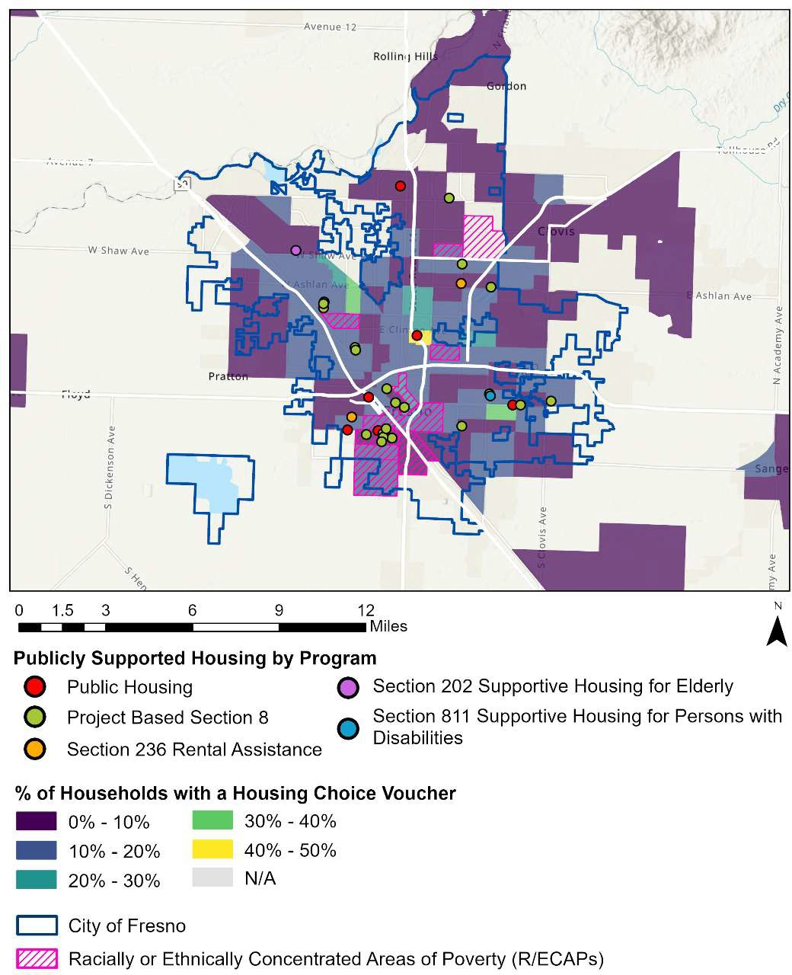

Section 202 Supportive Housing for Elderly

Section 811 Supportive Housing for Persons with Disabilities

Section 236 Rental Assistance

Project Based Section 8

Public Housing

**Publicly Supported Housing by Program**

Miles

**% of Households with a Housing Choice Voucher**

Racially or Ethnically Concentrated Areas of Poverty (R/ECAPs)

City of Fresno

*Source: 2023 A Picture of Subsidized Housing (APSH)*

## HOUSING FOR PEOPLE WITH DISABILITIES

According to the American Community Survey, 13% of the nation’s non-institutionalized population reported having a disability between 2019 and 2023. Research has found that the U.S. generally has an inadequate supply of housing that meets the needs of people with disabilities and allows for independent living. The U.S. Department of Housing and Urban Development estimates that approximately one third of the nation’s housing stock can be modified to accommodate people with disabilities, but less than 1% is currently accessible by wheelchair users.55

Identifying and quantifying existing accessible housing for all disabilities is a difficult task because of varying needs associated with each disability type. People with hearing difficulty require modifications to auditory notifications like fire alarms and telecommunication systems while visually impaired individuals require tactile components in design and elimination of trip hazards. Housing for people that have difficulty with cognitive functions, self-care, and independent living often require assisted living facilities, services, and staff to be accessible.

Modifications and assisted living arrangements tend to pose significant costs for the disabled population, which already experiences higher poverty rates compared to populations with no disability. Studies have found that 55% of renter households that have a member with a disability have housing cost burdens, compared with 45% of those with no disabilities.56

In Fresno, over 80,000 people have one or more disabilities, making up nearly 15% of the population. The most common disability types are cognitive, independent living, and ambulatory difficulties, each impacting tens of thousands of residents. As shown below in Table 19, the percentage of the population with a disability more than triples for senior residents. This presents a significant fair housing concern when considered in combination with Fresno’s rapidly increasing senior population, as discussed in the

55 Chan, S., Bosher, L., Ellen, I., Karfunkel , B., & Liao, H. . L. (2015). Accessibility of America’s Housing Stock: Analysis of the 2011 American Housing Survey. U.S. Department of Housing and Urban Development: Office of Policy Development and Research.

56 America's Rental Housing 2017. (2017). Joint Center for Housing Studies of Harvard University.

Demographic Profile, which has corresponded with a slightly increased disability rate (12.3% to 14.8%) since the 2012-2017 American Community Survey.

#### TABLE 19. DISABILITY BY TYPE IN FRESNO

|  |  |  |  |  |
| --- | --- | --- | --- | --- |
| **Disability Type** | **Fresno** | | **Fresno, CA MSA** | |
| **#** | **%** | **#** | **%** |
| Hearing Difficulty | 17,348 | 3.2% | 40,898 | 3.5% |

|  |  |  |  |  |
| --- | --- | --- | --- | --- |
| Vision Difficulty | 18,019 | 3.3% | 33,249 | 2.9% |
| Cognitive Difficulty | 40,251 | 8.0% | 71,640 | 6.6% |
| Ambulatory Difficulty | 32,468 | 6.5% | 71,158 | 6.6% |
| Self-Care Difficulty | 17,205 | 3.4% | 34,908 | 3.2% |
| Independent Living Difficulty | 27,492 | 7.0% | 54,573 | 6.5% |

*Source: 2019-2023 5-Year American Community Survey, Table S1810.*

*NOTE: All % represent a share of the total population within the jurisdiction or region.*

#### TABLE 20. DISABILITY BY AGE GROUP IN FRESNO

|  |  |  |  |  |  |
| --- | --- | --- | --- | --- | --- |
| **Age of People with** |  | **Fresno** | | **Fresno, CA MSA** | |
| **Disabilities** | **#** | | **%** | **#** | **%** |
| Under Age 18 with Disabilities | 8,131 | 5.4% | | 15,730 | 4.8% |

|  |  |  |  |  |
| --- | --- | --- | --- | --- |
| Age 18 to 64 with Disabilities | 42,125 | 13.1% | 79,250 | 11.7% |
| Age 65+ with Disabilities | 26,340 | 41.1% | 58,843 | 39.7% |

*Source: 2019-2023 5-Year American Community Survey, Table DP02.*

*NOTE: All % represent the share of the population within the specified age group with a disability.*

### Accessible Housing Supply and Affordability

Any new multifamily housing with five or more units constructed after 1988 using federal subsidies must include a minimum of 5% of units accessible to persons with mobility impairments and an additional 2% of units accessible to persons with vision / hearing impairments (or one unit of each type, whichever is greater). Additionally, HUD provides support for accessible housing through its Section 202 Supportive Housing for the Elderly and Section 811 Supportive Housing for Persons with Disabilities programs.

A search for affordable elderly and special needs housing using HUD’s Resource Locator tool was conducted to identify affordable rental properties in Fresno which may be able to serve people with disabilities. The search returned 26 results, as shown below, only

one of which has units set aside under Section 811 for disabled residents. This coincides with APSH data for Fresno, which lists only 19 available Section 811 units. Notably, this property contains only studio and one-bedroom units.

#### TABLE 21. HUD RESOURCE LOCATOR AFFORDABLE ACCESSIBLE UNITS IN FRESNO

|  |  |  |  |  |  |  |
| --- | --- | --- | --- | --- | --- | --- |
| **Name** | **Studio units** | **1-bed units** | **2-bed units** | **3-bed units** | **4+ bed units** | **Section 811** |
| Glen Agnes | 0 | 149 | 0 | 0 | 0 | N |

|  |  |  |  |  |  |  |
| --- | --- | --- | --- | --- | --- | --- |
| Garland Gardens | 0 | 0 | 45 | 6 | 0 | N |
| Delno Terrace | 30 | 30 | 0 | 0 | 0 | N |
| Chestnut Apartments | 0 | 24 | 44 | 22 | 0 | N |
| Sunnyside Glen Apts | 0 | 74 | 0 | 0 | 0 | N |
| Mono Hilltop Manor | 0 | 59 | 0 | 0 | 0 | N |
| Pleasant View Apts | 0 | 10 | 25 | 15 | 10 | N |
| Pleasant Village | 0 | 14 | 56 | 16 | 4 | N |
| Viking Village Fresno Rad | 0 | 0 | 20 | 19 | 0 | N |
| The Californian | 175 | 42 | 0 | 0 | 0 | N |
| Masten Towers | 106 | 98 | 0 | 0 | 0 | N |
| Martin Luther King Sq | 0 | 1 | 21 | 25 | 10 | N |
| Bigby Villa | 0 | 0 | 53 | 65 | 59 | N |
| Silvercrest Fresno | 59 | 98 | 1 | 0 | 0 | N |
| Westgate Gardens | 0 | 35 | 30 | 25 | 10 | N |
| Sierra Gateway Sr Res | 0 | 79 | 0 | 0 | 0 | N |
| Arbor Court | 0 | 16 | 3 | 0 | 0 | N |
| **Hotel Fresno Apartments** | **15** | **5** | **0** | **0** | **0** | **Y** |
| Fresno Edison II | 0 | 7 | 15 | 20 | 4 | N |
| Kearney-Cooley Plaza | 0 | 61 | 44 | 29 | 5 | N |
| Millbrook Park Apts | 0 | 25 | 25 | 25 | 0 | N |

|  |  |  |  |  |  |  |
| --- | --- | --- | --- | --- | --- | --- |
| Inyo Terrace And Cedar |  |  |  |  |  | N |
| Courts | 0 | 33 | 79 | 35 | 44 |  |
| Sierra Gateway Senior Residence II | 0 | 67 | 0 | 0 | 0 | N |
| Sunnyside Villas Apartments | 0 | 7 | 46 | 12 | 0 | N |
| Lula Haynes Plaza | 0 | 44 | 2 | 0 | 0 | N |
| El Cazador Apts | 0 | 28 | 29 | 7 | 0 | N |
| **TOTAL UNITS** | **385** | **1006** | **538** | **321** | **146** |  |

Based on a 2025 standard Supplemental Security Income (SSI) payment of $967 per month (equating to an affordable rent of $290 or less), it is highly likely that people with disabilities who are unable to work and rely on SSI as their sole source of income face substantial cost burdens and difficulty locating affordable housing. Publicly supported housing is often a key source of accessible and affordable housing for people with disabilities.

As mentioned above, Fresno currently has only 19 subsidized units set aside for disabled residents under Section 811. The table below displays the approximate number of disabled residents housed in a subsidized unit based off of APSH data, which reports both the number of utilized units and the percentage of residents with a disability by each unit type. This data shows that about 3,300 residents with disabilities within Fresno currently live in a subsidized unit; however, as discussed above, over 80,000 Fresno residents have one or more disabilities. This indicates that there is likely a significant shortage of disability accessible housing that is both affordable and available to residents with disabilities within Fresno.

#### TABLE 22. PERCENT OF RESIDENTS WITH A DISABILITY BY HOUSING PROGRAM CATEGORY IN FRESNO

|  |  |  |
| --- | --- | --- |
| **Fresno**  **Housing Type** | | |
|  | **%** | **Approx #** |

|  |  |  |
| --- | --- | --- |
| Public Housing | 10.0% | 54 |
| HCV Program | 26.0% | 2,669 |
| Project-Based Section 8 | 28.0% | 579 |
| Section 202 | N/A | N/A |
| Section 811 | 100.0% | 18 |
| *Source: 2023 APSH.* |  |  |

*NOTE: The definition of “disability” used by the Census Bureau in tables above may not be comparable to reporting requirements under HUD programs.*

### Zoning and Accessibility

Fair housing laws do not preempt local zoning laws but do apply to municipalities and local government units and prohibit them from making zoning or land use decisions or implementing land use policies that exclude or otherwise discriminate against protected persons. This includes a local government’s affirmative obligation to provide reasonable accommodations to land use or zoning policies when such accommodations may be necessary to allow persons with disabilities to have an equal opportunity to use and enjoy housing. It also includes the affirmative obligation not to segregate housing for protected classes into lower-opportunity, less desirable areas of the jurisdiction. Even where a specific zoning decision does not violate a fair housing law, HUD entitlement communities accept an obligation to set and implement standards and policies that protect and advance fair housing choice for all. The Development Code’s potential effects on accessibility are assessed in this section. Several elements of the analysis that follows refer back to the scored zoning code review presented in Chapter 6.

##### Definition of “Family” and Group Housing for People with Disabilities

Often one of the most scrutinized provisions of a municipality’s zoning code is its definition of “family.” Local governments use this provision to limit the number of unrelated persons who may live together in a single dwelling as a means of preserving the stable, traditional, and residential character of their neighborhoods. Unreasonably restrictive definitions may have the unintended consequence (or intended consequence, depending on the motivations behind the drafting of the jurisdiction’s definition) of limiting housing for nontraditional families and for persons with disabilities who reside together in congregate living situations.

Fresno’s municipal and development codes do not specifically define family but rely instead on a definition of “household” and housing occupancy standards to regulate how many unrelated persons may reside together in a dwelling unit. Rather than an arbitrary number of persons, a household is described as one or a group of persons, whether related or unrelated, living together who share the dwelling’s common areas, living expenses, food costs, and utilities, and maintain a single mortgage, lease, or rental agreement. The definition of household is not facially discriminatory against any protected class. Accordingly, Fresno received a “1/low risk” score on Issue 1 because a definition of “family” or “household” is not used or applied in a manner that would treat differently or limit the housing choices of unrelated individuals with disabilities (or members of any other protected class) living together.

Regarding housing for persons with disabilities, including those recovering from alcohol or drug abuse, the City received a “1/low risk” score on Issue 2 and on Issue 5 of the matrix. Because the City’s development code permits any number of unrelated persons to dwell together who fit the definition of a “household,” limited only by the housing/ building safety codes, housing for persons with disabilities who also meet the qualities of a “household” should be permitted in the same manner regardless of the number of unrelated persons residing there57. For other types of housing serving the needs of persons with disabilities, the development code has specific definitions and siting guidelines for “group residential" facilities, “residential care” facilities, and “transitional” and “supportive housing.”

Fresno’s Development Code regarding these use types generally follows California’s directives under the state Health and Safety Code (which preempts local zoning rules) to protect housing for persons with disabilities from exclusionary zoning criteria. State law (HSC §§1500 et seq.) requires that licensed community care facilities serving six or fewer persons be: (1) treated as a residential use, (2) allowed by right in all residential zones, and (3) treated the same with respect to regulations, fees, taxes, and permit processes as other residential uses in the same zone, whether or not the facility actually functions as equivalent to the local jurisdiction’s definition of “family” or “single housekeeping unit.” Occupancy of these facilities or dwellings is limited only by building code requirements. This protection applies to community care facilities for persons with disabilities, to residential care facilities for the elderly (§§ 1569.84 et seq.), to alcoholism or drug abuse

57 See City of Santa Barbara v. Adamson, 27 Cal.3d 123 (1980) (holding that a group that bears “the generic character of a family unit as a relatively permanent household” is as “entitled to occupy a single family dwelling as its biologically related neighbors”).

recovery or treatment facilities (§§ 11834.22 et seq.), and to congregate care facilities (§§ 1267.16. et seq.).

Accordingly, under the Development Code, “residential care facilities-limited” (those serving 6 or fewer clients) are allowed by right in all zones that allow residential uses subject to the same development standards and permit processing standards as other residential uses in those zones. “Residential care facilities-general” (providing care for more than 6 persons) are permitted by right in the RM-2 and RM-3 districts and conditionally permitted in the residential single-family districts (RS-1 to RS-5), the RM-1 district, Downtown districts, and in the CMS district. Residential care facilities for seniors (including retirement communities and life care communities) are permitted by right in the RM-2, RM-3, MXD, and Downtown districts, and are a conditional use in the RM-1 and CMS districts. Transitional and supportive housing expressly constitute a residential use and are subject only to those restrictions that apply to other residential uses of the same type in the same district.

As with other types of housing for persons with disabilities, housing that serves the needs of persons recovering from alcohol or drug addiction should be permitted as other single- family residential types as long as the home also meets the criteria of a “household.” State law requires that residential substance abuse treatment facilities for six or fewer residents recovering from alcohol or drug addiction be treated as a “family” and permitted in single family residential zones. The development code makes space for facilities that serve these populations but do not otherwise meet the criteria for its definition of a “household.” The Development Code’s definition of residential care facility expressly includes housing for people in recovery from alcohol or drug addictions. The development code also includes “clean and sober” living facilities under the use category “group residential.” A group residential facility that houses 6 or fewer is classified as a small group residence; a group residential facility for 7 or more residents is classified as a large group residence, and the Development Code’s Permitted Use Table regulates which residential zones the two types may be sited. Small group residential facilities are permitted by right in all single- family districts, multifamily districts, the Downtown districts, Mixed Use district, and CMS and CR commercial districts. Large group residential facilities are not permitted in the single-family districts but are a conditional use in the multifamily (MR), Downtown, Mixed Use, and CMS / CR districts.

Also, residential reentry facilities are a conditional use in the RM districts, CG commercial district, and the Downtown districts. Domestic violence shelters for 6 or fewer residents are permitted in all single-family districts, multifamily districts, and mixed-use districts (excluding the manufactured housing RM-MH district). Shelters for 7 or more domestic violence victims also are permitted in the residential multifamily and mixed-use districts. The development code also makes space for emergency shelters serving persons

experiencing homelessness in the RMX mixed use district and the CG commercial district, but no other residential districts.

The Department of Justice has taken the position in a past case against the City of San Jacinto, California that it is unlawful for a municipality to impose numerical occupancy limits on group housing for unrelated persons with disabilities that is more restrictive than numerical occupancy limits for related families or other unrelated persons58. Because Fresno does not impose a cap on the number of nondisabled, unrelated persons who may occupy a single family residence and be presumed to be living as a single household (other than limits imposed by the housing/building safety codes), the municipality cannot impose a cap or arbitrary limit as an additional zoning requirement on housing for persons with disabilities because of their disability. The state’s rule that licensed group homes and residential treatment facilities of up to 6 residents must be permitted in single family zoning districts does not mean that facilities with more than 6 residents must necessarily be excluded or subject to restrictions not imposed on housing for an equal or greater number of unrelated persons without disabilities. Just as Fresno has chosen the housing/building code as the proper model for regulating occupancy limits rather than an arbitrary number under a “family” or “household” definition, the housing/building code is the proper vehicle for regulating the number of residents in a group home or supportive housing, not the zoning ordinance. The City should be careful in its application of the terms “group residential” facilities, “residential care” facilities, “transitional” and “supportive housing” etc., because persons with disabilities have the same Fair Housing Act protections whether or not their housing is considered to meet a jurisdictions’ use category definitions.

As for Issue #4 of the matrix, the Development Code does not regulate concentrations of housing for persons with disabilities or put a quota on the number that may be sited within a certain distance from similar uses. Applications for residential care facilities may be subject to the administrative zone clearance or development permit process, as are other types of residential uses, and will be regulated by the zoning district in which it is located. The City received a “1/low risk” score on this issue.

##### Reasonable Accommodations

Adopting a reasonable accommodation ordinance is one specific way to address land use regulations’ impact on housing for persons with disabilities. Federal and state fair housing laws require that municipalities provide individuals with disabilities or developers of

58 United States v. City of San Jacinto, Civil Action No. 5:12-cv-01966 (C.D. Cal., consent decree June 16, 2014).

housing for people with disabilities flexibility in the application of land use and zoning and building regulations, practices, and procedures or even waive certain requirements, when it is reasonable and necessary to eliminate barriers to housing opportunities, or “to afford persons with a disability the equal opportunity to use and enjoy a dwelling.” Examples of a reasonable accommodation request may be simple such as a modification of the setback or lot coverage requirements to allow an external mobility ramp; modifying existing indoor space for accessible design features; parking changes; allowing more unrelated residents in a group home than the definition of “family” would typically permit; or more complicated like allowing a care home in a particular neighborhood or within a restricted distance to another facility without subjecting the applicant to the costly, time- consuming, and unpredictable special use permit or variance process.

The FHA does not set forth a specific process that must be used to request, review, and decide a reasonable accommodation, and accordingly many local jurisdictions across the country apply their respective zoning code’s variance or special use permit procedure to evaluate and process requests for reasonable accommodation. Variance and special permit procedures are imperfect models for processing reasonable accommodation requests because: (1) they generally require a showing of special circumstances or conditions applying to the land rather than to the individual’s special circumstances or condition due to a disability that affects his or her ability to use and enjoy the dwelling and

(2) they subject the applicant to the public hearing process where there is the potential that community opposition based on stereotypical assumptions about people with disabilities and unfounded speculations about the impact on neighborhoods or threats to safety may impact the outcome.

California recognized these issues as barriers to housing for persons with disabilities and in 2011, the State Attorney General recommended that cities and counties implement standardized fair housing reasonable accommodation procedures to comply with their affirmative duty to fair housing and to meet the requirements of the Housing Element of the General Plan, which mandates that local governments “remove constraints to, and provide reasonable accommodations for housing designed for, intended for occupancy by, or with supportive services for, persons with disabilities.”

Fresno adopted a Reasonable Accommodation Ordinance, effective 2016, which may allow an applicant with a disability a modification or exception to the rules, standards and practices for the siting, development, and use of housing or housing-related facilities for equal opportunity to the use and enjoyment of the housing of their choice. The applicant may use a form available from the City or make an oral request to the Director of Planning. Importantly, public notice is not required for consideration of a reasonable accommodation request and private or personal information regarding the nature of an

individual's disability will be kept confidential except as needed to make or review the decision.

Land use and zoning procedures are typically based on public disclosure and input; however, in the case of a reasonable accommodation request, the evaluation and decision-making process should include safeguards to protect confidential information regarding a person’s disabilities.

## FAIR HOUSING ACTIVITIES

### Fair Housing Resources

California’s fair housing protections contained within the Fair Employment and Housing Act (“FEHA”) meet or exceed federal standards contained within Title VIII of the Civil Rights Act of 1968, as amended by the Fair Housing Amendments Act of 1988, (the “Fair Housing Act” or “FHA” or “FHAA”). Accordingly, HUD has certified the FEHA as “substantially equivalent” to the substantive rights, procedures, remedies, and judicial review processes of the FHA, which makes California eligible for annual funding through the Fair Housing Assistance Program (FHAP) for fair housing enforcement activities and programs. The California Department of Fair Employment and Housing, created by the state legislature and certified by HUD as a participating agency, partners with HUD to enforce federal and state fair housing laws.

Under its Fair Housing Initiatives Program (FHIP), HUD also awards grant money to local fair housing advocacy organizations who assist persons believed to have been harmed by discriminatory housing practices; to help people identify government agencies that handle complaints of housing discrimination; to conduct preliminary investigation of claims; to carry out testing and enforcement activities to prevent or eliminate discriminatory housing practices; and to educate the public and housing providers about equal opportunity in housing and compliance with the fair housing laws.

In 2021, HUD awarded the Fair Housing Council of Central California, which has a multicounty service area including Fresno, a multiyear Private Enforcement Initiatives (PEI) grant of $425,000 to use towards testing and enforcement activities to prevent or eliminate discriminatory housing practices in the California Central Valley region. The Fair Housing council will use its grant to continue the enforcement work of its previous multi- year grant including to increase the number of enforcement actions and referrals made by complainants; discover and remedy discrimination in public and private real estate markets; detect and remedy subtle and sophisticated forms of housing discrimination; reduce the incidence of steering and other practices perpetuating segregation; and increase the number of complaints filed by new immigrants, undocumented persons, and persons with disabilities.

### Fair Housing Complaints

An individual in Fresno who believes he or she has been the victim of an illegal housing practice under the FHA or FEHA may seek assistance from the California Department of Fair Employment and Housing (DFEH) or file a complaint with the appropriate HUD Regional Office of Fair Housing and Equal Opportunity (FHEO) within one year of when the discriminatory practice occurred. Typically, once certified, HUD will refer complaints of housing discrimination that it receives to the state or local FHAP agency for investigation, conciliation, and enforcement activities. HUD policy favors having fair housing professionals based locally where the alleged discrimination occurred because it has found that a state or local agency’s closer proximity to the site of the alleged discrimination provides greater familiarity with local housing stock and trends and may lead to greater efficiency in case processing. Because the DFEH is a certified FHAP agency, most complaints filed with the HUD FHEO office will be referred back to the DFEH for investigation and enforcement.

The California FEHA provides an alternative procedure to the administrative complaint process. Persons who believe they have experienced housing discrimination may file a pre-complaint inquiry with the DFEH. The Department accepts cases based on possible violations of the FEHA, the Unruh Civil Rights Act, the Ralph Civil Rights Act, the Disabled Persons Act, and the federal FHA under a work-sharing agreement with HUD. If the investigator determines that the complaint meets the criteria for federal dual-filing status, the complaint will be assigned a federal identification number as well. Complaints originally filed with DFEH that are dual-filed with HUD are investigated by DFEH. During the investigation phase, DFEH has the authority to issue subpoenas and take depositions. If the investigation does not show a violation of the law, DFEH will close the case. Before DFEH issues a finding, it may facilitate voluntary dispute resolution through conciliation or mediation. After DFEH issues a merit finding, the opposing parties are required to participate in mandatory dispute resolution. A no-fault resolution can be negotiated at any time during the process. If dispute resolution fails, the DFEH may elect to file a complaint to be heard before the Fair Employment and Housing Commission (FEHC) or in civil court on behalf of the aggrieved complainant.

If HUD’s FHEO receives and retains a complaint, it will notify the alleged discriminator (respondent) and begin an investigation. During the investigation period, the agency will attempt through mediation to reach conciliation between the parties. If no conciliation agreement can be reached, the FHEO must prepare a final “Determination” report finding either that there is “reasonable cause” to believe that a discriminatory act has occurred or that there is no reasonable cause. If the agency finds “reasonable cause,” HUD must issue a “Charge of Discrimination.” If the investigator determines that there is no “reasonable cause,” the case is dismissed. If a charge is issued, a hearing/trial will be

scheduled before an administrative law judge (ALJ). The ALJ may award the aggrieved party injunctive relief, actual damages, and impose civil penalties; but unlike federal district court, the ALJ may not impose punitive damages. Administrative proceedings are generally more expedited than the federal court trial process. The advantages of seeking redress through the administrative complaint process are that the DFEH/FHEO takes on the duty, time, and cost of investigating the matter for the complainant and conciliation may result in a binding settlement. However, the complainant also gives up control of the investigation and ultimate findings.

Unlike an employment discrimination case, it is not necessary for an aggrieved party to exhaust all administrative remedies before filing a housing discrimination lawsuit in court. Persons wishing to file a lawsuit directly in court may bypass the administrative process with the Department as they do not need a “right-to-sue” letter from the DFEH. Aggrieved persons retain the right to bring their own civil action within the statute of limitations (generally two years) under either the federal FHA or the FEHA. The respondent in an administrative action also may elect to have the administrative proceeding terminated and the case instead adjudicated in federal court. The Department of Justice (DOJ) will prosecute the case on behalf of the aggrieved party. Additionally, the DOJ may bring suit on behalf of individuals based on referrals from HUD in the case of a “pattern or practice” of discriminatory actions, a case of particular importance to the public interest, or when there has been a breach of a conciliation agreement. An aggrieved party may intervene in any action filed by the DOJ.

Though the FHA and FEHA are not identical, they are congruent, and accordingly California courts have historically been guided by both state and federal law in deciding claims of housing discrimination. “FEHA in the housing area is thus intended to conform to the general requirements of federal law in the area and may provide greater protection against discrimination.” Brown v. Smith, 55 Cal. App. 4th 767, 780 (1997).

If an individual has evidence that his/her rights under the FHA or California FEHA have been violated in a final land use or zoning decision, the aggrieved person may file a complaint with the state DFEH or with HUD, or file a lawsuit directly in state or federal court within the statute of limitations period. HUD refers matters involving the legality of state or local zoning or other land use law or ordinance to the DOJ for further enforcement.

Housing discrimination claims may be brought against local governments and zoning authorities and against private housing providers to protect the housing rights and interests of aggrieved individuals and families impacted by discrimination, local civil rights advocacy groups on behalf of protected classes, and the DFEH or DOJ to protect the public interest.

##### Complaints Filed with HUD

Region IX of the Office of Fair Housing and Equal Opportunity (FHEO) receives complaints by households regarding alleged violations of the Fair Housing Act for cities and counties throughout California (as well as Arizona, American Samoa, Guam, Hawaii, and Nevada). The mission of the FHEO is to eliminate housing discrimination, promote economic opportunity, and achieve diverse, inclusive communities. To achieve this mission, the FHEO receives and investigates complaints of housing discrimination, and leads in the administration, development, and public education of federal fair housing laws and policies.

The San Francisco Regional Office of the FHEO maintains data reflecting the number of complaints of housing discrimination received by HUD, the status of all such complaints, and the basis/bases of all such complaints. The office responded to a request for data regarding complaints received affecting housing units in the City of Fresno for the period January 1, 2019, through December 31, 2023.

The complete data table provided by HUD is included as an appendix to this report with the HUD case file number, violation city, filing date, closure date, basis of complaint, issues cited, closure reason, and monetary relief provided. During this time, HUD received a total of 69 formal complaints of alleged housing discrimination occurring within Fresno. All of the cases have been closed. The number of complaints filed does not necessarily reflect the true number of acts of unlawful discrimination that may have occurred during the recent five-year period as, on the one hand, some incidents go unreported and, on the other hand, cases may result in a “no cause” determination if HUD’s investigation reveals a lack of evidence of unlawful conduct. In 49.3% of the cases reported (34 of 69 cases), HUD made a “no cause” determination.

27 of the cases were successfully settled through HUD’s conciliation and settlement process. In the cases resolved by settlement/ conciliation, the respondents did not necessarily admit liability, but may have settled to avoid further expense, time, and the uncertainty of litigation. Monetary or equitable damages awarded to the complainant were reported by HUD in 16 of the 27 successfully settled cases, with compensation and victims fund amounts ranging from $500 to $20,000.

#### TABLE 23. COMPLAINTS BY CLOSURE REASON

|  |  |  |  |  |  |  |
| --- | --- | --- | --- | --- | --- | --- |
| **Closure Reason** | **2019** | **2020** | **2021** | **2022** | **2023** | **Total** |
| Complainant failed to cooperate | 0 | 0 | 1 | 0 | 0 | 1 |

|  |  |  |  |  |  |  |
| --- | --- | --- | --- | --- | --- | --- |
| Complaint withdrawn by Complainant after resolution | 0 | 0 | 0 | 1 | 0 | 1 |
| Complaint withdrawn by Complainant without resolution | 3 | 0 | 0 | 0 | 2 | 5 |
| Conciliation / settlement successful | 9 | 3 | 10 | 4 | 1 | 27 |
| “No Cause” determination | 8 | 6 | 9 | 6 | 5 | 34 |
| Unable to locate Complainant | 0 | 0 | 1 | 0 | 0 | 1 |
| Total | 20 | 9 | 21 | 11 | 8 | 69 |

*Source: HUD Region IX Office of Fair Housing and Equal Opportunity*

More than one basis of discrimination may be cited in a single complaint. Disability was the most often cited basis of discrimination, occurring in almost two-thirds (63.8%) of filed cases. Race was the second most often cited basis of discrimination, cited as a factor in about one-fourth (24.6%) of filed cases. Of the 69 cases received and processed by HUD for housing in Fresno, disability was cited as the basis of discrimination in 44 cases, followed by race in 17 cases; retaliation in eight cases; color in five cases; sex in five cases; national origin in four cases; familial status in one case; and religion in one case.

Complainants also may cite more than one discriminatory act or practice, recorded as the discriminatory issue. Discriminatory refusal to rent was cited in 33 cases; discriminatory terms, conditions, privileges, or services and facilities was cited in 31 cases; failure to make reasonable accommodation was cited in 24 cases; discriminatory acts under Section 818 (coercion, etc.) was cited in 11 cases; discriminatory advertising, statements, and notices was cited in six cases; discrimination in terms/conditions/privileges relating to rental was cited in five cases; discriminatory refusal to rent and negotiate for rental and false denial or representation of availability were each cited in three cases; failure to permit reasonable modification and other discriminatory acts were each cited in two cases; and discriminatory financing (includes real estate transactions), discriminatory

advertisement- rental, and restriction of choices relative to a rental were each cited in one case.

#### TABLE 24. HUD COMPLAINT FILINGS BY BASIS, 2018-2022

|  |  |  |  |  |  |  |
| --- | --- | --- | --- | --- | --- | --- |
| **Basis** | **2019** | **2020** | **2021** | **2022** | **2023** | **Total** |
| Color | 1 | 1 | 2 | 0 | 1 | 5 |

|  |  |  |  |  |  |  |
| --- | --- | --- | --- | --- | --- | --- |
| Disability | 15 | 6 | 13 | 7 | 3 | 44 |
| Familial Status | 0 | 0 | 0 | 1 | 0 | 1 |
| National Origin | 3 | 0 | 0 | 1 | 0 | 4 |
| Race | 3 | 2 | 8 | 1 | 3 | 17 |
| Religion | 0 | 0 | 0 | 1 | 0 | 1 |
| Retaliation | 4 | 0 | 3 | 1 | 0 | 8 |
| Sex | 1 | 1 | 0 | 1 | 2 | 5 |
| Total | 20 | 9 | 21 | 11 | 8 | 69 |

*Source: HUD Region IX Office of Fair Housing and Equal Opportunity*

##### Complaints Filed with the California Civil Rights Department

The California Civil Rights Department’s (CCRD) statutory mandate is to protect the people of California from unlawful discrimination in employment, housing, businesses, and state-funded programs, and from bias-motivated violence and human trafficking. To accomplish this mission, the Department receives, investigates, conciliates, mediates, and prosecutes complaints of alleged violations of the Fair Employment and Housing Act (FEHA), Unruh Civil Rights Act, Disabled Persons Act, Ralph Civil Rights Act, Trafficking Victims Protection Act, and statutes prohibiting discrimination in state-funded activities and programs.

The state’s fair housing law includes additional classes of persons protected from housing discrimination that are not necessarily protected by the federal FHA: gender identity and gender expression, sexual orientation, marital status, age, source of income, genetic information, retaliation for protesting illegal discrimination, or “any other basis prohibited by Section 51 of the Civil Code,” which also includes as a basis of protection medical condition, citizenship, primary language, and immigration status. A complainant alleging he or she has experienced housing discrimination based on one of these additional protected classes, would not find relief by filing a complaint with HUD but instead would need to file the complaint with the state’s DFEH under state law protections.

A request was submitted to the CCRD for data reflecting the number of housing discrimination related complaints received by the Department regarding housing units in Fresno for the previous five-year period (January 1, 2019, through December 31, 2023). The CCRD reported that it had received and processed three formal complaints of housing discrimination originating within the jurisdiction of the City of Fresno. Of those, the DFEH dismissed two cases (66.6%) after a “no cause” finding, and one case was conciliated/settled successfully.

Disability was the most often cited basis of discrimination (cited in all three cases), followed by ‘other’ (cited in one case). The state’s data response also includes the alleged “harms” (equivalent to the discriminatory “issues” under HUD’s data system) experienced by the complainants: denied reasonable accommodation was cited in all three cases; denied equal terms and conditions was cited in one case; subjected to discriminatory statements/advertisement was cited in one case, and ‘other’ was cited in one case.

#### TABLE 25. CCRD COMPLAINT FILINGS, 2019-2023

|  |  |  |  |  |
| --- | --- | --- | --- | --- |
| **Filing Year** | **Status** | **Basis** | **Issue Alleged** | **Disposition** |
| 2022 | Closed | Disability (physical, intellectual/develop mental, mental health/psychiatric); Other | Denied equal terms and conditions; Denied reasonable accommodation for a disability or medical condition; Other | No Cause Determination |

2023 Closed

Disability (physical, intellectual/develop mental, mental health/psychiatric)

Denied reasonable accommodation for a disability or medical condition; Subjected to discriminatory statements/advertisement

Conciliation/ Settlement Successful

2023

Closed

Disability (physical, intellectual/develop mental, mental health/psychiatric)

Denied reasonable accommodation for a disability or medical condition

No Cause Determination

*Source: California Civil Rights Department*

##### Complaints Filed with the Fair Housing Council of Central California

The planning team also contacted the Fair Housing Council of Central California regarding complaint filings based in the city of Fresno from 2019 through 2023; no response was received.

### Fair Housing Enforcement through Civil Litigation

Under the FHA and the California Fair Employment and Housing Act, in addition to or as an alternative to filing an administrative complaint, an aggrieved person retains the right to file a civil action in an appropriate U.S. district court or state superior court (with proper jurisdiction and venue) not later than two years after the occurrence or the termination of an alleged discriminatory housing practice, thus maintaining control of the case and the potential to collect punitive damages. Victims do not have to first exhaust their administrative remedies before filing a lawsuit nor be issued a “right to sue” letter from the administrative enforcement agency (unlike employment discrimination cases). If an administrative action already has commenced, the parties still may elect to move the case to court for adjudication as long as the parties have not already entered into a conciliation agreement to resolve the alleged discriminatory housing practices or, following a charge of discrimination, an administrative hearing has not already commenced. If an administrative action is filed, the two-year statute of limitations is paused while CCRD or FHEO/HUD evaluates the complaint

Additionally, the DOJ may bring suit on behalf of aggrieved individuals based on referrals from HUD, or on its own initiative, in the case of a “pattern or practice” of discriminatory actions, a case of particular importance to the public interest, or when there has been a breach of a conciliation agreement. An aggrieved party may intervene in any action filed by the DOJ.

Where the court finds liability, it may award preventative and affirmative relief (permanent or temporary injunction, restraining order, or other order); actual/compensatory damages (for loss of housing, emotional damage, and other harms); a civil penalty (up to $50,000 for a first violation and up to $100,000 for a second or subsequent violation in federal court or up to $10,000 for a first violation and up to $50,000 for a third or subsequent violation in state court); attorney fees and costs; and punitive damages. Court approved settlement amounts or jury awards often are much larger than victim compensation awards or settlement amounts secured through the administrative process.

Fair housing lawsuits may be filed against local governments and zoning authorities and against private housing providers, landlords, mortgage lenders, developers, or real estate brokers. Because the FEHA has been determined to be substantially similar to the FHA, court opinions interpreting the FHA are instructive in interpreting the state law. “FEHA in the housing area is thus intended to conform to the general requirements of federal law in the area and may provide greater protection against discrimination.” *Brown v. Smith*, 55 Cal. App. 4th 767, 780 (1997).

Four notable lawsuits which were initiated or litigated during the recent five-year period (January 1, 2020, through December 31, 2024), are discussed below for their impact on

the fair housing rights of protected class persons at the local level. The first two cases involve allegations of unlawful housing discrimination occurring in Fresno. Two other California cases are highlighted because they serve as cautionary cases for potential litigation in Fresno due to similar facts or local land use or housing policies at issue.

* **Manson v. Fresno Housing Authority, Civil Action No. 1:23-cv-00679 (E.D. Cal.) (complaint filed May 3, 2023).**

Three veterans, each with mobility disabilities who are or were residents of the Renaissance at Parc Grove in Fresno —a 40-unit LIHTC development funded by the state and HUD and restricted to low-income and disabled veterans—filed this lawsuit against the property owner Parc Grove Commons and property manager Fresno Housing Authority alleging defendants violated their rights as disabled persons requesting reasonable accommodations under the federal Fair Housing Act and Section 504 of the Rehabilitation Act and under various state civil rights laws including the Fair Employment and Housing Act. The complaint alleged the building’s elevator malfunctioned over 150 times over several years, resulting in residents being physically injured, trapped inside the elevator, and effectively denied access to and from second floor units for those residents who could not use the stairs due to their mobility disabilities. Plaintiffs alleged they had made multiple reasonable accommodation requests for accessible, safe routes to and from their apartment units including reliable operation of the elevator but that defendants had effectively denied those requests by failing to repair and maintain a safe, working elevator or other accessible routes.

Plaintiffs filed a Motion for Summary Judgement (MSJ) on their claims on November 12, 2024, and defendants responded in opposition, disputing some of the relevant facts and denying the allegations of civil rights violations, negligence, and failure of industry standards. The district court set a hearing date for arguments on the MSJ for February 10, 2025.

* McGee v. Poverello House, Civil Action No. 1:18-cv-00768 (E.D. Cal.) (complaint filed June 5, 2018; order dismissing case Aug. 13, 2021).

A brief description of the alleged facts and legal issues of this case was included in Fresno’s *2020 Analysis of Impediments,* but this case is described again for further discussion as it now has been more thoroughly litigated and adjudicated.

Plaintiffs first filed in Fresno County Superior Court, but the case was later moved to federal court. At the time of complaint, plaintiffs were homeless women who sought assistance and shelter at defendants’ facilities—Poverello House and Naomi’s House, two nonprofit organizations on a shared campus that provide meals, social services, and

temporary shelter in downtown Fresno to persons experiencing homelessness. Naomi’s House specifically accommodates homeless single women on a first-come, first-served lottery basis. Plaintiffs’ complaint and statements of undisputed facts alleged that defendants violated their rights when defendants allowed another client (“D.N.”) who was born a male but identifies as a female to use the same facilities as plaintiffs, including shared shower and toilet facilities, and who allegedly subjected plaintiffs to sexual harassment. Plaintiffs asserted claims for violation of the FHA and FEHA, which prohibit housing discrimination and threats or intimidation on the basis of sex, and state law negligence and privacy claims, arguing that defendants had a duty to protect them from D.N.’s alleged sexual harassment.

Defendants are partially funded by HUD with the stipulation that they agree to follow all of HUD’s guidelines and regulations, including HUD’s Equal Access Rule pertaining to the placement of “sleeping and bathing accommodations of transgender clients according to the client’s personal gender identification.”

In analyzing Defendants’ Motion for Summary Judgment, filed on April 8, 2020, the court found as a threshold matter, that in the context of these specific facts: (i) Defendants’ shelter did not qualify as a “dwelling” subject to the fair housing laws and moreover, (ii) the plaintiffs failed to prove that the alleged harassment was “sufficiently severe or pervasive” as to deprive them of their right to enjoy the services offered by defendants. Both conclusions are dispositive of the FHA and FEHA claims.

The court recognized that though defendants made good-faith efforts to comply with federal law requiring them to accommodate D.N.’s gender identity, there may be a genuine issue of disputed fact as to whether defendants took sufficient steps to respect plaintiffs’ privacy interests. However, ultimately the court found plaintiffs failed to prove that defendants owed a duty to protect them from emotional harm by a third party client.

In an opinion dated August 12, 2021, the trial court granted Defendants’ Motion for Summary Judgment and dismissed the case.

This case underscores how emergency shelters may not always qualify as “dwellings” under the FHA and highlights the legal challenges in balancing gender identity protections with privacy concerns.

* **Martinez v. City of Clovis, Case No. 19CECG03855 (Fresno Cnty Sup. Ct., file date Oct. 23, 2019); 90 Cal.App.5th 193 (Docket No. F082914, April 7,**

**2023).**

This case involves the City of Clovis’s (City) General Plan Housing Element and related zoning ordinances and whether they comply with the State’s Housing Element Law or

contribute to discrimination, segregation, and a lack of affordable housing. The case has statewide importance and implications because the housing elements of all cities and counties in California must include compliant zoning that accommodates the jurisdiction’s regional housing needs allocation for housing units at all income levels. Moreover, this case addresses a local jurisdiction’s mandatory duty to affirmatively further fair housing under a new statutory provision which became effective January 1, 2019 (CA GOVERNMENT CODE § 8899.50).

In October 2019, pro bono attorneys with Central California Legal Services and the Public Interest Law Project filed suit against the City of Clovis in Fresno County on behalf of two low-income Housing Choice Voucher holders, claiming that the city violated the State’s Housing Element Law for the 2015-2023 planning period and discriminated against lower- income people and people of color by intentionally failing to designate sufficient land for development of affordable housing that accommodates all income groups, including the City’s share of its regional housing assessment targets. Under the California Housing Element Law, local jurisdictions are expected to meet the state’s affordable housing goals in part, by rezoning adequate parcels of land to accommodate higher density developments that can feasibly meet the housing needs of low-income residents.

The City denied liability though it conceded that the state’s Housing and Community Development (HCD) department decertified the City’s Housing Element of its General Plan in 2018 because of a shortfall of parcels zoned to accommodate lower income housing. It claimed to have taken remedial action (e.g., rezoning to permit multifamily housing in the public facility district and creating a new Regional Housing Needs Assessment overlay zone allowing multifamily homes in some parts of the city) to bring Clovis back into compliance with the state’s housing law. Indeed, in March 2019, HCD re-certified the City’s Housing Element.

After considering the briefs and arguments of both parties, the Fresno County Superior Court issued a judgment partially for Plaintiffs on June 1, 2021, finding the City’s Housing Element was not in substantial compliance with state law and accordingly ordering the City to plan and zone for an additional 4,425 low-income homes within 120 days. The lower court dismissed the Plaintiffs’ discrimination claims. The City appealed to the California Fifth District Court of Appeal and Plaintiffs cross-appealed.

In a published opinion, *Martinez v. Clovis* (Apr. 7, 2023) 90 Cal.App.5th 193, the Fifth District considered the lower court’s findings as to: (1) whether the City had complied with California’s Housing Element Law; (2) whether the City's planning and zoning decisions had a disparate impact based on race and for lower-income families under the FHA and FEHA; and (3) whether the City had met its duty to affirmatively further fair housing under new state legislation. For the questions of Housing Element Law compliance, the appellate court affirmed the lower court’s writ of mandate—though it reversed some of

the lower court’s statutory interpretation addressing sites over 10 acres and nonvacant sites—finding the trial judgment’s terms are necessary to remedy the failure of the City’s zoning overlay to comply with the Housing Element Law’s density requirements. The Fifth District reversed and remanded for further adjudication the lower court’s dismissal of Plaintiffs’ fair housing discrimination claims, noting the lower court had applied the wrong legal standards and establishing that on remand the trial court must allow for discrimination to be proven by sufficient evidence of a disparate impact on developments intended for occupancy by lower income families, even where there is no denial of a particular development. In a matter of first impression, the appellate court also addressed the recently enacted duty to affirmatively further fair housing and found as a matter of law that Clovis violated this duty when it adopted an inadequate zoning overlay that failed to comply with density requirements imposed by the Housing Element Law. The appellate court’s order required Clovis to rezone land to accommodate multifamily homes (as a proxy for low-income housing) at a density that meets its share of the RHNA, but the trial court’s and appellate court’s orders do not mandate that the City itself build or finance construction of the affordable units.

In February 2024, the years long litigation ended with a settlement agreement accepted by the Clovis City Council. Under the settlement, the City agreed to:

* establish a local housing trust fund and contribute at least $1.8 million to support affordable housing developments;
* dedicate city-owned sites to the development of affordable housing;
* rezone small infill parcels throughout the city to accommodate approximately 1,300 multi-family dwelling units;
* adopt an ordinance to require that up to 10% of units in mid-to-large-scale new housing development projects be affordable to low-income families; and
* create a development impact fee-deferral program, deferring the payment of significant portions of city development impact fees for qualifying affordable housing projects.

This case is instructive for the City of Fresno and other jurisdictions who have similarly had their Housing Element plans deemed out of compliance by the HCD or returned for revisions to meet compliance standards. Moreover, the *Clovis* opinion demonstrates that even where a jurisdiction’s Housing Element is HCD approved, it can still be challenged in court and a court will not uphold that Housing Element if it finds that the plan does not comply with the Housing Element Law. As the Court of Appeal emphasized, unlawful zoning discrimination can be found not just in a municipality’s denial of specific development and rezoning applications but also where

exclusionary zoning regulations and land use policies artificially constrain the local housing supply, especially the feasibility of developing sufficient affordable housing. The *Clovis* opinion confirms the legislature’s intent that local jurisdictions have a statutory obligation to affirmatively further fair housing in California, which means being responsible for proactively taking measures to remove regulatory barriers to affordable housing development and reduce segregation.

In a letter dated October 7, 2024, the HCD reminded Fresno that a compliant Housing Element was due on December 31, 2023. HCD reviewed the City of Fresno’s revised draft Housing Element for the 2023-2031 planning period and outlined specific areas requiring revisions necessary to substantially comply with State Housing Element Law. Failure to adopt a compliant housing element within one year of the statutory deadline may result in the housing element being deemed out of substantial compliance until all necessary rezonings are completed. Given that the housing element was due on December 31, 2023, and no longer satisfied statutory requirements, there was a window of time that Fresno was without a compliant housing element, opening it up to possible litigation and legal penalties by the state Attorney General or housing advocacy organizations, loss of local zoning and permitting authority, “Builder’s Remedy” developments59 that would not otherwise be approved, and loss of state funding for affordable housing, transportation, and infrastructure projects. According to HCD’s compliance report tracking tool, it

59 Until recent legislative reform effective January 1, 2025, if a jurisdiction failed to adopt an HCD certified compliant housing element within the required timeframe, developers could bypass certain discretionary development reviews and local zoning limitations (such as height, density, or land use restrictions) as long as the proposed project met affordability thresholds: 20% of units reserved as affordable for low- income households or 100% of units affordable to moderate-income households. This workaround known as the “Builder’s Remedy” has been upheld by the courts and used to force cities resistant to higher- density development to approve projects that they otherwise would have blocked. For example, Builder’s Remedy projects have been successfully developed in Santa Monica, Redondo Beach, and Palo Alto.

Assembly Bill 1893, passed in 2024 and effective January 1, 2025, made modifications to and puts new guardrails around the Builder’s Remedy under the Housing Accountability Act (GOVERNMENT CODE § 65589.5 *et seq*.) such as site restrictions that exclude parcels adjacent to heavy industrial uses; maximum density limits determined by a formula that considers project location and site specific analysis; density minimums; and allowance for jurisdictions to impose certain objective local standards that would facilitate the Builder's Remedy project’s proposed density. The new Builder’s Remedy law lowers the affordability set-aside requirements for mixed-income projects from 20% low-income to 13% low-income, 10% very low-income, 7% extremely low-income, or 100% affordable to moderate-income households. For project sites less than one acre and consisting of 10 units or fewer, there is no affordability requirement.

received Fresno’s adopted and revised Housing Element on December 16, 2024, reviewed it on January 21, 2025, and found Fresno to finally be in compliance.60

* **United States v. City of Hesperia, Civil Action No. 5:19-cv-02298 (C.D. Cal.) (case filed 12/2/2019; Consent Order entered 12/27/22).**

The United States DOJ brought this action against the City of Hesperia, San Bernardino County, and the San Bernardino County Sheriff’s Department based on an investigation and charge of discrimination by HUD, which found that due to the City’s “crime free ordinance” African American renters were four times more likely and Latino renters were 29% more likely than non-Hispanic White renters to be evicted and that evictions disproportionately occurred in majority-minority parts of the city. The complaint alleged the defendants engaged in a pattern or practice of discrimination based on race and national origin through the adoption and enforcement of a so-called “crime-free” rental housing program with the intent, effect, and impact of forcing African American and Hispanic or Latino residents out of the city. One City Councilmember stated the intent of enacting the ordinance was to address a “demographical problem”—i.e. the city’s increasing Black and Hispanic/Latino population—and the lawsuit alleged the Sheriff’s Department targeted Black and Hispanic/Latino renters for enforcement of the ordinance. The DOJ alleged that the Sheriff’s Department notified landlords to evict entire families including children for conduct involving one tenant or even non-tenants, evict victims of domestic violence, and evict based on mere allegations without evidence of criminal liability or conviction.

Defendants denied liability but under a settlement and Consent Order the DOJ called a “landmark agreement,” Hesperia repealed its “crime-free” ordinance, modified the related rental housing business license ordinance, and reduced fees associated with rental housing business licenses. The Sheriff’s Department agreed to stop enforcement of the “crime-free” program. The Defendants also agreed to a settlement fund of $670,000 to compensate individuals harmed by the program; the payment of $100,000 in civil penalties; $95,000 for affirmative marketing to promote fair housing in Hesperia; $65,000 to partnerships with community-based organizations; notifications to city and county employees, property managers, landlords, and rental property owners of the changes to the ordinances and fee schedule; submission of certain policies, procedures, and

60 *HCD Housing Element Review and Compliance Report*, last reviewed Jan. 30, 2025, *available at* https://[www.hcd.ca.gov/planning-and-community-development/housing-element-review-and-compliance-](http://www.hcd.ca.gov/planning-and-community-development/housing-element-review-and-compliance-) report.

ordinances for the DOJ’s review and approval; adoption of non-discrimination policies and complaint procedures; designation of civil rights coordinators; anti-discrimination training; a fair housing needs assessment; and reporting to the court and the DOJ during the Consent Order’s five-year term.

Although the *Hesperia* case does not involve the City of Fresno, it should serve as cautionary and persuasive precedent for Fresno to examine its nuisance ordinance and how it is being applied (MUNICIPAL CODE OF THE CITY OF FRESNO, MANAGEMENT OF REAL

PROPERTY ORDINANCE Sec. 10-701 *et seq*.). Following the federal enforcement action against the City of Hesperia, the California legislature passed AB 1418 (CAL. GOVERNMENT CODE § 53165.1), effective January 1, 2024, prohibiting local governments from having or enacting policies, ordinances, or programs that: require landlords to use criminal background checks; make alleged criminal behavior without a felony conviction a basis to evict a tenant; require landlords to evict an entire household when a household member is convicted of a felony; define nuisance behavior to include police contact, police service calls, or anything else outside the scope of the existing state definition of a nuisance; or require landlords to include lease provisions that provide a basis for eviction beyond those in existing state law. The bill’s sponsor and supporters argued that while “there is no evidence that ‘crime-free’ rental ordinances reduce crime,” there is, however, “evidence that the programs are implemented for discriminatory purposes” with a disproportionate impact on Black and Latine communities and tenants with disabilities, exacerbating their housing insecurity and vulnerability to evictions.

Fresno’s MANAGEMENT OF REAL PROPERTY ORDINANCE does not explicitly mandate or encourage landlords to evict tenants solely based on their contact with law enforcement or alleged criminal activity. But it may be problematic as applied. The ordinance defines nuisance broadly (perhaps outside the scope of the state’s definition) and holds all occupants—whether the person engaged in the alleged prohibited conduct or not—to be a “responsible party” subject to legal action, administrative citations, and penalties from

$1,000 up to $50,000 plus costs. Frequent police service calls to the real property or adjacent property may qualify as a nuisance under the city’s ordinance subjecting all occupants of the subject property to a nuisance enforcement action, which may violate AB 1418’s prohibition on defining as a nuisance emergency service calls. The ordinance also may violate AB 1418 by penalizing tenants for their association with another tenant or household member who has had contact with law enforcement or a criminal conviction. Fresno’s ordinance could violate the FHA as applied if Black, Hispanic, or other protected classes are targeted for enforcement or disproportionately impacted.

## PAST FAIR HOUSING GOALS AND RELATED ACTIVITIES

Fresno’s 2020-2024 Analysis of Impediments identified public and private sector impediments to fair housing. The AI offered several recommendations for addressing the impediments, which are summarized below:

##### Impediment #1: Lack of Safety Net Programs for Renters Increases Housing Instability Among Protected Classes

* Evictions affect low-income and severely rent burdened residents at high rates.
* Limited English Proficiency and immigration status create additional barriers to quality housing

*Recommendations provided in the 2020-2024 AI*

* Create an Emergency Rent and Relocation Demonstration Program
* Capture and monitor eviction data within the jurisdiction in order to develop future policy solutions for managing evictions in target areas.
* Address substandard housing and other fair housing issues through the City’s Immigrant Affairs Committee

*Actions Taken Since 2020-2024 AI*

* The City worked to improve housing stability for Fresno residents through the establishment of the Emergency Rental Assistance Program in PY 2020.
* The City worked toward increasing rental housing stability by partnering with the Fresno Interdenominational Refugee Ministries (FIRM) to provide Fair Housing education and resources to people and families most vulnerable to housing instability.
* Continued partnership with the Fresno Housing Authority provides residents with voucher assistance, landlord incentives, and fair housing education.

##### Impediment #2: Insufficient Employment Supports Leave Residents of Color with Lower Incomes and Limited Housing Choices

* Educational and employment barriers limit economic opportunities
* Low levels of kindergarten readiness; insufficient access to programs and services through early childhood; and insufficient access to quality healthcare for mothers and families of color

*Recommendations provided in the 2020-2024 AI*

* Continue working with partners on funding and implementation of the economic development, human capital, and neighborhood development strategies contained in the Fresno Regional DRIVE Plan.
* Continue providing CDBG or other funding for youth education enrichment activities to encourage reading proficiency, high school completion, career and/or college preparation, and other education components, including full-day programs to support parents in maintaining employment in low-and moderate-income census tracts.

*Actions Taken Since 2020-2024 AI*

* The City funded the Business Visibility Initiative through the Chinatown Fresno Foundation, which helped microenterprises by developing job growth and an overall improved quality of life in the Chinatown area.
* The City funded youth educational and enrichment activities through the Boys and Girls Club of Fresno County.

##### Impediment #3: Continued Need for Neighborhood Infrastructure Development and Expanded Access to Opportunity in Areas of Concentrated Poverty

* Continued need for neighborhood reinvestment in low- and moderate-income census tracts
* Areas of the city are underserved with regard to access to services, grocery, and other neighborhood-oriented retail
* Equity issues are not routinely and consistently considered in planning and policymaking
* Need to further engage communities in south and west Fresno in planning decisions

*Recommendations provided in the 2020-2024 AI*

* Consider implementing mechanisms to increase and make consistent funding for parks and other infrastructure improvements in low-and moderate-income census tracts.
* Continue City promotion of Low and Moderate Income (LMI) Tracts as Opportunity Zones for the purpose of attracting businesses.
* Expand community engagement efforts focused on community needs and priorities in south and west Fresno, including working with residents and community groups to shape the City’s approach to community engagement. As detailed in the Greater Fresno Regional DRIVE plan, implement targeted outreach to engage with end users to identify areas for investment.

*Actions Taken Since 2020-2024 AI*

* Areas targeted for infrastructure improvements through CDBG funds included:
  + Ericson Elementary Neighborhood Street Reconstruction
  + Yosemite Middle School Complete Streets
  + Roberts & 10th Neighborhood Street
  + Highway City Neighborhood Street Reconstruction
  + Webster Community Canal Barricade
  + West Fresno Elementary & MLK Neighborhood Street Improvements
  + Burroughs Elementary Neighborhood Street Reconstruction
  + Ericson Elementary Neighborhood Street Reconstruction

##### Impediment #4: Housing Options for Some Protected Classes Are Limited by Poor Housing Conditions

* Landlords in some neighborhoods fail to adequately maintain and improve rental properties
* Low-income households, including the elderly and people with disabilities, have difficulty making needed home repairs

*Recommendations provided in the 2020-2024 AI*

* Continue to monitor the effectiveness of the City’s new Rental Housing Improvement Program and revise program standards and procedures as may be needed to keep the program working successfully, to maintain enforcement, and to ensure rental properties are enrolling as required.
* Consider a rental rehabilitation program that would provide incentives to landlords to maintain their rental properties.

*Actions Taken Since 2020-2024 AI*

* The City continued to support housing rehabilitation and repair efforts through several programs, including:
  + City of Fresno Senior Paint and Exterior Repair Programs
  + Self-Help Home Repair and Rehabilitation Program
  + Habitat for Humanity Housing Rehabilitation/Repair Program
  + Fresno EOC Roof Program

##### Impediment #5: Racial Disparities Exist in Access to Homeownership

* Lower shares of African American and Latino households apply for home mortgage loans than White households
* People of color, most notably African Americans, are more likely to be denied home mortgage loans than White applicants

*Recommendations provided in the 2020-2024 AI*

* Ensure that opportunities to participate in City of Fresno homebuyer opportunities, including those operated by Community Housing Development Organizations (CHDOs) and funded through CDBG and HOME money, are affirmatively marketed to people of color, immigrants, and people with limited English proficiency.
* In recent years, the FHCCC held meetings to review Community Re-Investment Act (CRA) obligations. Continuing this conversation, convene a working group of local bankers to identify collaborative steps the City, lenders, and other local housing agencies could take to both increase the completion rate of loan applications and reduce the denial rates.

*Actions Taken Since 2020-2024 AI*

* The City and its community partners continuously work to develop programs and practices that reduce barriers to homeownership for protected classes. Reducing administrative barriers to new affordable housing construction and broadening the educational opportunities surrounding affordable housing were key objectives over each program year.

##### Impediment #6: Publicly Supported Housing Options Are Concentrated Outside of Areas of Opportunity

* Affordable housing, including publicly supported housing, is limited, particularly in desirable areas where neighborhoods offer enhanced access to some types of opportunity
* Housing Choice Voucher use is limited in NE and NW Fresno, including many neighborhoods that offer enhanced access to some types of opportunity
* Education is needed about recent statewide legislation requiring rental housing managers / owners to accept Housing Choice Vouchers

*Recommendations provided in the 2020-2024 AI*

* Develop and implement an equity assessment tool to use in review of development and policy decisions to promote a broad view of any proposed multifamily, mixed- income, or affordable housing throughout the city, including in north Fresno.
* Work with partners such as local fair housing agencies, media outlets, and the Fresno Housing Authority to publicize new state requirements regarding accepting Section 8 vouchers to landlords and property managers

*Actions Taken Since 2020-2024 AI*

* The City’s 2020-2024 Consolidated Plan included a goal to improve access to affordable housing in high opportunity areas. The Fresno Housing Authority has also developed several new affordable housing projects.
* In PY 2022, the Fresno Housing Authority constructed the Monarch at Chinatown. In PY 2023, the Fresno Housing Authority constructed the Arthur at Blackstone and converted the Days Inn Motel into Promesa Commons. Additionally, the Brand Haven Senior Housing Project was developed. In total, 285 affordable housing units were constructed, of which 33 were HOME funded.

##### Impediment #7: Many Communications and Marketing Efforts Regarding Fair Housing Are Not Effectively Targeted to Protected Classes and Non-English Speakers

* Limited English proficiency among large segments of Fresno’s population limits opportunities for two-way engagement with the City

*Recommendations provided in the 2020-2024 AI*

* The City should begin building the infrastructure for a stronger, more sustainable relationship-based community engagement approach.
* Provide cultural competency training to all Fresno HCD staff beginning with those in public-facing roles, but expanding to back-office and management as well.

*Actions Taken Since 2020-2024 AI*

* Supported by CDBG funding, the City’s Fair Housing provider Fresno Interdenominational Refugee Ministries (FIRM) has conducted targeted outreach to LEP populations and provided housing counseling services in Hmong, Ukrainian, Pashto, Farsi, Dari, and English. The organization has also provided information about fair housing rights and low-income housing programs on its own ethnic radio show and TV show, reaching thousands of LEP listeners.
* In PY 2022, the Resources for Independence Central Valley (RICV) Fair Housing Outreach Program connected with residents to provide the community with education in several languages about Fair Housing rights, responsibilities, and regulations through trainings and materials made available through social media, direct mail, the RICV newsletter, and email blasts.

##### Impediment #8: NIMBYism and Prejudice Reduces Housing Choice for Protected Classes

* Not In My Backyard (NIMBY) attitudes limit multifamily and affordable housing development in North Fresno
* Stakeholder input indicated that prejudiced attitudes by some community members impacts housing choice

*Recommendations provided in the 2020-2024 AI*

* Develop an adaptable slide deck and presentation on the subject of the value of affordable housing, including qualitative and quantitative arguments.
* Consider conducting a tour of successful affordable housing properties in Fresno for local leaders and other interested parties to build public support for additional affordable housing development.
* A broad-based and trusted local convening institution should be enlisted to create and offer a periodic diversity, equity, and inclusion training aimed at local community leaders and other interested parties.

*Actions Taken Since 2020-2024 AI*

* The City’s 2020-2024 Consolidated Plan included a goal to improve access to affordable housing for low‐income and special needs households by partnering with interested developers to increase development of low-income and affordable housing in high opportunity areas.

##### Impediment #9: Continued Need for Fair Housing Education and Enforcement

* Public input and data on housing discrimination complaint calls and filings indicate that more fair housing education is needed for landlords and lenders
* Public input and data on housing discrimination complaint calls and filings indicate that more fair housing education is needed for the general public

*Recommendations provided in the 2020-2024 AI*

* Through a contracted fair housing agency, provide education and outreach to landlords, property owners, property managers, and lenders.
* Through a contracted fair housing agency, annually design and coordinate delivery of a fair housing education program that reaches the public with information about fair housing rights and responsibilities, how to recognize discrimination, and how and where to file a complaint.

*Actions Taken Since 2020-2024 AI*

* The City continues to partner with Fair Housing advocacy and services groups to provide multilingual Fair Housing educational opportunities.
* In PY 2021, the City increased its CDBG allocation for fair housing outreach by 70% and annually allocates funds towards fair housing outreach and housing counseling

## IDENTIFICATION OF IMPEDIMENTS

Described below are the fair housing impediments identified in this Analysis of Impediments, along with associated contributing factors. Contributing factors are issues leading to an impediment that are likely to limit or deny fair housing choice or access to opportunity. Recommended activities to address the contributing factors are contained within a table in this section. There are limitations in what the City of Fresno, as a local government entity, can do to correct the named impediments. In some cases, and particularly when a private-sector actor (such as a developer or landlord or mortgage lender) is involved, the City’s role may be primarily in the realm of advocacy and convening, yet in other cases (such as zoning code amendments or investment decisions regarding public funds), the City of Fresno is able to take significant and direct action.

### Impediment #1: Housing affordability and quality issues reduce housing choice

A lack of housing options affordable to low- and moderate-income households was one of the issues most frequently cited by residents and stakeholders in Fresno. Respondents to the housing and community development survey identified ‘not enough affordable housing for families,’ ‘not enough affordable housing for individuals,’ and ‘displacement of residents due to rising housing costs’ as the top barriers to fair housing in the city. This shortage has become increasingly dire over the past five years, as home values in the city have increased by almost 50% while wages have remained comparatively stagnant. Declining vacancy rates and rising rents are also indicative of an increasingly tight housing market. An estimated 10.2% of owner households and 22.8% of renter households in Fresno are severely cost-burdened, spending more than 50% of income on housing.

Data on age of housing in Fresno and the MSA points to a decline in construction of new units since 2010, indicating a need for strategies to increase development of new affordable housing units. Just 8.3% of units (15,677 units) in the city were built in 2010 or later, as of American Community Survey five-year estimates for 2019-2023. As single- family detached structures make up the majority (about 61.4%) of housing units in Fresno, there is a particular need for development of affordable multifamily and ‘missing middle’ housing units. Lack of diversity in housing types decreases the availability of housing affordable for low- to moderate-income households who are unable to afford single-family homes. Apartments and smaller, more affordable units are also essential for many seniors and residents with disabilities.

In addition to the need to increase the supply of affordable housing, the city’s large share of older housing stock indicates a high level of need for rehabilitation and repair programs.

An estimated 50.9% of units in the city are in structures built prior to 1980, and this older housing stock may pose both economic and public health challenges, particularly for individuals and families living in older housing units.

Survey respondents indicated that Not-In-My-Backyard (NIMBY) attitudes play a role in creating barriers to housing access, with 58.8% noting that community opposition to affordable housing presents a barrier to fair housing in the city. NIMBYism was identified as an impediment to fair housing in Fresno’s 2020-2024 Analysis of Impediments to Fair Housing Choice, and the City has made efforts to address this issue through strategies such as adding a goal to its Consolidated Plan to partner with interested developers to increase development of low-income and affordable housing in high opportunity areas. However, this challenge remains and is directly tied to impediments related to homelessness and a lack of access to housing for protected classes. Continuing to implement and fund strategies to increase housing affordability will be vital to supporting residents in accessing housing in the city.

### Impediment #2: Housing problems and limited access to homeownership disproportionately impact protected classes

Analysis of homeownership data shows that the homeownership rate in Fresno is highest among White and Asian/ Pacific Islander households (56.3% and 54.6%, respectively) and lowest among Black households (33.8%). 2023 Home Mortgage Disclosure Act (HMDA) data for the city of Fresno shows that Black applicants were denied mortgages at a significantly higher rate (20.8%) than the city’s average rate of 13.0%, while White applicants were less likely to be denied than applicants of other races (9.8%). Overall, Black applicants were more than twice as likely to be denied a mortgage loan as White applicants and about 1.4 to 1.7 times as likely to be denied as applicants of other races.

Analysis of housing needs (including cost burden, overcrowding, and lacking complete kitchen/plumbing facilities) indicates that housing problems are most common among Native American, Black, Hispanic, and Asian/ Pacific Islander renter households (about 62% to 68% of whom have a housing problem), and among households with a member with a disability (55.9% of whom have a housing problem). White homeowners experience housing problems at the lowest rate (23.8%).

These findings, along with input from residents and stakeholders who participated in this planning process, suggest that additional resources are needed to stabilize the path to homeownership, including support for homebuyer readiness classes or other pre- application assistance, downpayment assistance programs, and wider-ranging social support for households to improve their chances of securing mortgage loans. Additional

housing supports, such as emergency rental assistance, rental housing repair and rehabilitation, and development of affordable rental housing, are needed to reduce cost burdens and other housing problems for low-income renter households and households with disabilities. Residents and stakeholders also emphasized a need for additional outreach and marketing to connect residents with available housing and homeownership resources.

### Impediment #3: Protected classes are disproportionately impacted by barriers to employment, education, and housing choice

Disparities in labor market engagement, educational attainment, and housing choice exist by geography, race, and ethnicity in Fresno:

* **Educational attainment** is lowest in central and south Fresno, including census tracts in and around Mayfair, the Fresno Yosemite Airport, and downtown. Native American, Hispanic or Latino, and residents of some other race alone are the least likely to have higher levels of education (10.1%, 14.2%, and 13.2% have a bachelor’s degree or higher, respectively).
* Census tracts with **low labor force participation rates** and **high unemployment rates** are clustered in the downtown area and south Fresno. The unemployment rate is highest among Native American and Black or African American residents (15.3% and 12.8%, respectively).
* **Median household incomes** are lowest in downtown and south Fresno, where they fall below $25,000 in four census tracts. Median household incomes are lowest for Black or African American residents ($46,392).

These disparities in access to opportunity and incomes are shaped by the prevalence of low-wage jobs, barriers to accessing existing workforce development and educational programs, and an overall lack of affordable housing in the city. Place-based strategies allow for the targeting of resources and outreach efforts to areas with high proportions of residents whose housing choices may be limited by low wages or unemployment. These strategies can be combined with other approaches focused on closing skills gaps and developing career pathways, increasing job creation and quality standards, and raising the wage floor. Examples of place-based strategies to increase labor market engagement include increasing awareness of high-growth jobs that pay family-sustaining wages and connections to the training necessary to obtain them and targeting communities or neighborhoods with high proportions of low-earning workers as priorities for interventions that increase awareness of available subsidies and resources.

### Impediment #4: Ongoing need for investment and expanded access to opportunity in areas of concentrated Poverty

Low levels of access to resources and services in areas with high levels of poverty also create barriers to access to opportunity in the city of Fresno. The need for neighborhood investment is particularly acute in parts of central, south, and west Fresno that have the highest poverty rates and lowest levels of access to resources such as fresh food retailers, healthcare, and high-performing schools. Data from the American Community Survey, local plans and studies, and community engagement efforts indicates that residents of these parts of the city tend to have lower levels of access to high-quality community facilities, infrastructure, and services:

* **Schools:** Content mastery is low in the Fresno Unified and Central Unified school districts, which exhibit content mastery scores lower than the state averages in language arts and math across all grade levels. Comparatively, Clovis Unified has significantly higher scores than the state averages and other area school districts across all grades and subjects. Additionally, block groups that rank highest on HUD’s School Proficiency Index —indicating better access to proficient schools—tend to be located in north Fresno in the Fort Washington area, which overlaps with Clovis Unified. Block groups that rank lowest on the index are clustered in west and central Fresno, including areas near the Fresno- Chandler Executive Airport, Edison neighborhood, and Downtown Fresno within six of the city’s R/ECAPs. The majority of these neighborhoods overlap with areas served by the Fresno Unified School District. Discussions with residents and survey results further supported the existence of significant educational disparities by school district, geography, race/ethnicity, and income.
* **Transportation:** Combined housing and transportation costs tend to make up a greater share of household incomes in the outskirts of Fresno, including in Fort Washington and Pinedale, areas which tend to also have lower levels of access to bus service. In these areas, the combination of lower proximity to jobs and transit and higher shares of household income spent on transportation presents barriers to employment and housing. Approximately 42% of survey respondents believed that bus service is not equally provided across all neighborhoods in Frenso.
* **Food:** USDA Food Research Atlas data indicates that the share of residents who have low incomes and live further than one-half mile from the nearest supermarket is highest in census tracts in south Fresno, between West Park and Calwa. In six census tracts in these areas, 75% or more residents have low incomes and live more than one-half mile from a supermarket. More than half (55%) of all survey respondents believed that grocery stores are not equally provided in the city.
* **Healthcare:** The proportion of residents who are uninsured is highest in central Fresno, particularly in tracts near the downtown area along E Cesar Chavez Blvd and north of San Joaquin Memorial High School. In three census tracts in these areas, the share of uninsured residents is around 15%.
* **Community Facilities and Infrastructure:** When asked to identify the most pressing public facility and infrastructure needs in Fresno, the top three high needs were homeless and domestic violence shelters (69% identified as high need); street, road, or sidewalk improvements (62%); and community parks, gyms, and recreational fields (50%). Youth centers followed closely behind, with 48% of respondents identifying this as a high need.

Together, these measures indicate that a lack of access to high-quality facilities, resources, and services in south and west Fresno restrict access to fair housing choice by limiting opportunity for residents. To address these disparities, community engagement participants emphasized the need for continued investment in these neighborhoods.

### Impediment #5: Fresno has insufficient accessible housing and supportive services for residents with disabilities

People with disabilities frequently face additional challenges in accessing and maintaining stable housing relative to non-disabled populations. These challenges may include finding housing affordable for households with limited incomes, finding housing with accessibility modifications, and facing stigma-based discrimination from housing agents (such as steering, refusal of landlords to grant reasonable accommodations, or rental application denials due to actual or perceived disability). Data and community feedback indicate that residents with disabilities in Fresno experience unique barriers to fair housing. The following factors contribute to these barriers:

##### Fresno’s current housing inventory is insufficient to meet the needs of disabled residents.

Over 80,000 people in Fresno have one or more disabilities, making up nearly 15% of the population. The most common disability types are cognitive, independent living, and ambulatory difficulties, each impacting tens of thousands of residents. Additionally, the percentage of the population with a disability more than triples for senior residents relative to the overall population. This presents a significant fair housing concern when considered in combination with Fresno’s rapidly increasing senior population, as discussed in the Demographic Profile, which has corresponded with a slightly increased disability rate (12.3% to 14.8%) since the 2012-2017 American Community Survey. This

consistent trend necessitates attention to and planning for housing opportunities for residents with disabilities.

Based on a 2025 standard Supplemental Security Income (SSI) payment of $967 per month (equating to an affordable rent of $290 or less), it is highly likely that people with disabilities who are unable to work and rely on SSI as their sole source of income face substantial cost burdens and difficulty locating affordable housing. Publicly supported housing is often a key source of accessible and affordable housing for people with disabilities.

APSH data shows that about 3,300 residents with disabilities, or about 4% of the population with a disability, live in a subsidized unit; however, Fresno currently has only 19 subsidized units specifically set aside for residents with disabilities under Section 811. This means that residents with disabilities must directly compete with non-disabled residents for limited housing. Additionally, as discussed above, over 80,000 Fresno residents have one or more disabilities. While not every resident with disabilities is by default in need of publicly supported housing, it is unlikely that only 4% of this population is in need of assistance. This indicates that there is likely a significant shortage of disability accessible housing that is both affordable and available to residents with disabilities within Fresno and, as discussed above, the population share of residents with disabilities in Fresno is increasing over time, indicating that without attention the current shortage is likely to grow

##### Disabled residents in Fresno face unlawful discrimination based on their disability status.

Disability is the most common basis for housing discrimination complaints in Fresno. Between 2019 and 2023, HUD received 69 housing discrimination complaints originating in Fresno, more than 60% of which listed disability as a basis for discrimination. This indicates a need for fair housing resources targeting the housing rights of residents with disabilities, including education for landlords on non-discrimination requirements, accessibility modifications to existing units, and resources for residents on how to access fair housing support.

### Impediment #6: Insufficient homeless resources disproportionately impact protected class groups

The 2024 Point-In-Time count for the Fresno-Madera Continuum of Care, which includes the city of Fresno, identified a total of 4,305 individuals as homeless, of whom 2,758 were unsheltered (64%). The 2024 count represents an increase in homelessness in the CoC of 18% since the start of the Covid-19 pandemic in 2020. This data, along with input from

Fresno residents and stakeholders, indicates that homelessness is a growing issue in the area. The following factors contribute to this barrier to fair housing choice in Fresno:

##### Fresno’s homeless population is disproportionately comprised of protected class groups.

In 2024, 14.2% of the individuals identified as homeless by the Fresno-Madera CoC PIT count were Black, despite Black residents comprising only 6.4% of Fresno’s population. While disability data specific to the Fresno-Madera CoC was not available, the 2024 PIT count estimated that 40% of all homeless individuals in the CoC were “chronically homeless,” meaning that they had a disability and had been homeless longer than one year at a time or in combination over the last four years. In contrast, disabled residents comprise only 14.8% of Fresno’s total population.

Together, this data indicates that the homeless population of Fresno is disproportionately comprised of federally protected classes, meaning that barriers to fair housing for homeless residents disproportionately impact these protected classes and that the City must take reasonable steps to overcome them.

##### Fresno’s current emergency shelter options are insufficient.

The Fresno-Madera CoC recorded an unsheltered homelessness rate of 64% at the time of the 2024 Point-In-Time Count, indicating that there are insufficient emergency shelter options within the area to meet the needs of the homeless population. In particular, veterans, victims of domestic violence, and people with chronic mental health or substance abuse disorders were disproportionately likely to be unsheltered.

##### Current homeless resources do not include enough supportive wraparound services.

Feedback from residents and stakeholders indicates that there is a significant gap in wraparound services which results in residents re-entering homelessness due to a lack of support. In particular, stakeholders indicated a need for case management, employment services and assistance, and life skills services integrated with Fresno’s current housing-first model, which prioritizes getting residents into housing but may leave gaps in follow-up services. In general, community feedback emphasized a need for Fresno to view homeless services in a more holistic way in order to prevent people from re-entering homelessness once housed. Examples of this may include a stronger wraparound service system, more collaboration and coordination between existing service providers, and more attentive case management in order to assist individuals in accessing all resources for which they are eligible.

### Impediment #7: Continued need for fair housing education

The City of Fresno has partnerships with Fresno Interdenominational Refugee Ministries (FIRM), a HUD-Certified Housing Counseling Agency that provides fair housing services for immigrant and refugee populations. Having partners with deep fair housing expertise has served the city of Fresno well. Even so, responses to the community survey conducted as part of this analysis suggest that the need for fair housing education is ongoing. Though 56% of survey respondents reported understanding their fair housing rights, only 40% said they knew where to file a report of housing discrimination. One of the most commonly identified barriers to fair housing among survey participants was community opposition to affordable housing, indicating that while education efforts have reached some residents, there is still a need for continued outreach to the public through community organizations.

One key component of future fair housing education and enforcement efforts should be informing voucher holders and landlords/property managers about California’s law prohibiting refusal to accept a Section 8 voucher. Residents and stakeholders noted challenges finding landlords who accept Housing Choice Vouchers. Voucher usage is limited in city census tracts, generally comprising 0%-10% of tract households. The five tracts where household voucher usage is 25% or more are concentrated within central Fresno. Additionally, other publicly supported housing units (such as Public Housing and Project-Based Section 8 developments) are concentrated in the same areas. Publicly supported housing activity is lowest in north and northwest Fresno.

### Impediment #8: Marketing and communications about planning processes, fair housing education, and housing resources may not adequately reach residents of protected classes

The City conducted extensive marketing of community engagement opportunities to residents and stakeholders for its Analysis of Impediments to Fair Housing Choice and Consolidated Plan, including through announcements of opportunities for public input on the City’s website and social media, the project website ([www.FresnoConPlan.org),](http://www.FresnoConPlan.org/) newspaper articles and public notices, e-mails to community stakeholders, invitations to more than 100 stakeholders to participate in stakeholder interviews, and door hangers placed at households within one mile of each of six in-person community meeting locations across the city. Residents and stakeholders who participated in the planning process indicated that further outreach, such as through radio and television advertising and additional door-to-door canvassing, is needed in future planning processes to ensure

residents receive adequate notice of community meetings and other engagement opportunities. To further increase awareness of planning processes and encourage resident involvement, the City could also consider expanding existing partnerships with community-based organizations and forming new partnerships, such as through participating in these organizations’ ongoing meetings and events to inform residents of upcoming community engagement opportunities for City-led planning processes and to gather input, and through coordinating with these groups to expand sharing of opportunities for involvement through e-mail lists, newsletters, and social media.

The City of Fresno can also continue to expand access to fair housing education and housing resources by using CDBG and other funding to invest in these services and resources. To address a lack of marketing and communications regarding fair housing services to residents with Limited English Proficiency (LEP), the City has invested resources into expanding fair housing education and resources to populations with Limited English Proficiency through its partnership with FIRM, including conducting community workshops and tabling at community farms, libraries, and community centers in the 93702, 93703, 93722, 93725, and 93727 ZIP codes, where the need for fair housing information is greatest, and providing information about fair housing rights, low-income public housing, and housing voucher rights on its radio and TV shows, with information available in Cambodian, Hmong, Khmer, and Lao. The City should continue to invest resources in efforts to expand access to fair housing services and housing resources for residents with Limited English Proficiency and in neighborhoods with high levels of housing need.

As part of its outreach and education efforts, the City should consider ways to further promote existing home rehabilitation programs and other available housing resources. Attendees at community meetings held for this AI were often unfamiliar with these programs and very interested in learning more. Although the city has instituted several creative and intentional marketing strategies to get the word out, it appears there is room to reach more people with this valuable information. Residents and stakeholders noted a need for resources to increase residents’ awareness of available programs and services, such as a Housing Resource Center or web-site focused on available housing resources, a comprehensive resource guide of resources available for specific populations, a hotline related to resource access, and greater messaging and communication about what resources are available.

#### TABLE 26. FAIR HOUSING GOALS AND ACTIVITIES

|  |  |  |
| --- | --- | --- |
| **Contributing Factors** | **Recommended Activities** | **Responsible Parties and Partners** |
| IMPEDIMENT #1: Housing Quality and Affordability Issues Reduce Housing Choice | | |

Limited new construction of affordable housing

* Continue using the Local Housing Trust Fund, CDBG, and HOME funds to increase and maintain the availability of high-quality, affordable rental housing and housing for homeownership through new construction and rehabilitation (Ongoing, 2025).
* Consider affordable housing bonds, development fees, or other options to provide increased funding for the Local Housing Trust Fund to support affordable housing development (2026).
* Consider and adopt zoning code amendments that could increase possibilities for development of affordable housing, such as upzoning single-family-only zones to allow for development of ‘missing middle’ housing (2026).
* Work closely with developers proposing LIHTC projects in areas with access to key community resources/opportunity factors, such as accessibility to employment centers or areas experiencing a loss of affordable rental units, to increase the competitiveness of their applications through letters of support, provision of data and information, gap financing, and other assistance (Ongoing, 2025).
* Continue to review the Annual Qualified Allocation Plans issued by the California Tax Credit Allocation Committee under the Low Income Housing Tax Credit (LIHTC) program to identify local government policies or actions that may positively impact the competitiveness of developers’ applications (Ongoing, 2025).

City of Fresno

Affordable housing developers

Residents and stakeholders

|  |  |  |
| --- | --- | --- |
| **Contributing Factors** | **Recommended Activities** | **Responsible Parties and Partners** |

Lack of variety in housing types

High land costs present a

barrier to affordable housing development

•

Make affordable housing a priority when disposing of public land. Deploy City-owned land in partnership with affordable housing developers and community-based organizations to support affordable housing development (2026).

Partner with large property owners to provide information and resources related to affordable housing development (2026). Meet with affordable housing developers to understand barriers to housing development, and develop strategies to address those

barriers (2026).

City of Fresno

Affordable housing developers

•

Large property owners

•

Community-based

organizations

* Consider and adopt amendments to the City’s zoning code and map that could support development of ‘missing middle’ and multifamily housing types, such as upzoning single-family zones to allow duplexes and triplexes (see section on Zoning, Affordability, and Housing Choice; 2026).

City of Fresno

Residents and stakeholders

Need for permanently

affordable housing options

* Consider partnering with Community Land Trusts to support the

development of permanently affordable housing options (2026).

City of Fresno

Affordable housing developers

Large property owners

Residents and community

stakeholders

|  |  |  |
| --- | --- | --- |
| **Contributing Factors** | **Recommended Activities** | **Responsible Parties and Partners** |

Older housing units are in need of rehabilitation and repair

* Continue and expand programs to support housing rehabilitation and repair for low-income homeowners, using CDBG or other funding (Ongoing, 2025).

City of Fresno

Residents and stakeholders

NIMBYism prevents proposed new developments

**IMPEDIMENT #2:** Housing problems and limited access to homeownership disproportionately impact protected classes

* Partner with community organizations to create educational programming with the goal of developing an understanding of the need for affordable and workforce housing among city residents (2026).
* Consider amendments to the City’s zoning code and map to allow more ‘missing middle’ and multifamily housing by right in more areas with high levels of access to opportunity (2026).

City of Fresno

Community organizations

Residents and stakeholders

Limited access to homeownership and mortgage loans, particularly among Black households

* Continue to ensure that opportunities to participate in City of Fresno homebuyer opportunities, including those operated by Community Housing Development Organizations (CHDOs) and funded through CDBG and HOME money, are affirmatively marketed to people of color, immigrants, and people with limited English proficiency (Ongoing, 2025).
* Facilitate partnerships between local social service and housing agencies, including the Fresno Housing Authority, to connect eligible households with possible homeownership opportunities (Ongoing, 2025).
* Fund educational opportunities focused on building and maintaining credit, personal finances, and the homeownership process. Continue

City of Fresno

Community Housing Development Organizations (CHDOs)

Fresno Housing Authority

Community-based organizations

|  |  |  |
| --- | --- | --- |
| **Contributing Factors** | **Recommended Activities** | **Responsible Parties and Partners** |

Disproportionately high rates of housing needs among Native American, Black, Hispanic, and Asian/ Pacific Islander renter households; people with disabilities; and among households in southwest and central Fresno

City efforts to promote credit-building and personal finance education among high school students (Ongoing, 2025).

* Continue funding development of affordable housing for homeownership through CHDOs and other affordable housing providers using HOME funds. Require subrecipients to affirmatively market available homeownership opportunities to households throughout Fresno, including low-income households, people of color, immigrants, and people with limited English proficiency (Ongoing, 2025).
* Expand housing rehabilitation and repair programs for low-income homeowners and renters (Ongoing, 2025).
* Increase the number of affordable accessible units through the expansion of Section 202, Section 811, or other developments (2026).
* Expand programs that assist people with disabilities in making accessibility modifications to their homes (Ongoing, 2025).
* Increase support for housing stability/fair housing services such as eviction prevention, rental assistance, and legal aid (Ongoing, 2025).
* Consider ways to target marketing and communications regarding housing resources and programs to areas of the city in which high shares of residents have one or more housing needs, including southwest and central Fresno. Ensure ongoing participation of residents in these neighborhoods in development and implementation of programs and strategies to address housing needs (Ongoing, 2025).

Area mortgage lending/financial institutions

Residents and stakeholders

City of Fresno

Housing Authority of the City of Fresno

Community-based organizations

Residents and stakeholders

|  |  |  |
| --- | --- | --- |
| **Contributing Factors** | **Recommended Activities** | **Responsible Parties and Partners** |
| **IMPEDIMENT #3**: Protected classes are disproportionately impacted by barriers to employment, education, and housing choice. | | |

Disparities in labor market engagement, median household income, and educational attainment by race/ethnicity and geography

* Include residents, business owners, industry representatives, and representatives from neighborhood organizations in the planning processes for workforce development, employment, and adult education programs.
* Support existing workforce training and education resources such as the Fresno EOC’s Local Conservation Corps, Valley Apprenticeship Connections, and Workforce Connection Young Adult programs and FRWDB’s Workforce Connection through funding, promotion, and partnerships.
* Target outreach about available employment and education resources to historically low-earning populations, including Limited English Proficiency (LEP), immigrant, and refugee populations; persons with disabilities; special needs populations; and Black, Native American, and Hispanic households.
* Collaborate with residents to better understand barriers to accessing existing programs and develop strategies to address these barriers.
* Continue to collaborate with key stakeholders in implementing workforce and economic development strategies contained in the City and County general plans, including working with local educational facilities to expand current workforce development efforts to accommodate those who are unemployed and underemployed.
* Explore ways to partner with and fund community organizations that have implemented workforce development and employment programs in areas of the city with the lowest levels of educational attainment and labor force participation and the highest levels of unemployment.

City of Fresno

County of Fresno

Fresno Regional Workforce Development Board (FRWDB)

Fresno Chamber of Commerce

Fresno Metro Black Chamber of Commerce

Fresno Area Hispanic Foundation

Fresno County Economic Development Corporation (EDC)

Fresno Economic Opportunities Commission (EOC)

Fresno City College Fresno State

|  |  |  |
| --- | --- | --- |
| **Contributing Factors** | **Recommended Activities** | **Responsible Parties and Partners** |

Limited housing choice for protected classes due to transportation costs and proximity to jobs/schools

**IMPEDIMENT #4**: Ongoing need for investment and expanded access to opportunity in areas of concentrated poverty.

* Implement expanded public transportation options, such as rideshare or small buses/vans with extended hours, to address the transportation system’s limitations in routes and hours of operation.
* Conduct studies to identify locations best suited for transit-oriented development (TOD).
* Develop affordable housing in high opportunity neighborhoods with access to jobs and public transportation.

City of Fresno

Fresno Area Express (FAX)

Lack of access to quality community facilities, infrastructure, and services in areas of concentrated poverty

* Continue to use CDBG, bond referendum, or other funding to collaborate on projects that develop, expand, or improve community spaces and programming; increase access to fresh food retailers; address blight; and support development of needed retail and services in low- and moderate-income census tracts, and particularly in R/ECAP census tracts, to address needs and opportunities identified in the City of Fresno’s Consolidated Plan and other local plans. Continue to partner with community organizations and residents to identify the city’s most pressing funding needs.
* Continue and complete the implementation of the Fresno Regional DRIVE Plan, which outlines a 10-year investment plan for the Greater Fresno Region addressing economic development, education, fresh food access, and community development issues by 2030.

City of Fresno

Continued need for neighborhood reinvestment in central and south Fresno

* Collaborate with City leadership in investigating additional potential

funding sources to support the development of public infrastructure,

City of Fresno

Fresno County

improvements, facilities, and services in historically disinvested Economic

Development

|  |  |  |
| --- | --- | --- |
| **Contributing Factors** | **Recommended Activities** | **Responsible Parties and Partners** |
| neighborhoods. Partner with trusted community organizations to identify residents’ most pressing needs.   * Continue to support improvements to sidewalks, parks, trails, and other public facilities in low-and moderate-income census tracts with high need for these improvements (ex. neighborhood amenity gaps mapping in the Fresno Parks Vision 2050 Plan). | | Corporation (EDC)  Fresno Economic Opportunities Commission (EOC)  Fresno Metro Black Chamber of Commerce |
| **IMPEDIMENT #5**: Fresno has insufficient accessible housing and supportive services for residents with disabilities. | | |

Fresno’s current housing inventory is insufficient to meet the needs of residents with disabilities.

Residents with disabilities in Fresno face unlawful discrimination based on their disability status

* Investigate the feasibility of converting or dedicating more publicly supported units as Section 811 units (Ongoing, 2025).
* Prioritize accessibility modifications for new and existing publicly supported units (Ongoing, 2025).
* Work with the nonprofit community to support programs that assist people with disabilities with the cost of accessibility modifications to their homes (Ongoing, 2025).
* Institute Universal Design requirements and quotas for new development (Ongoing, 2025).
* Increase fair housing education efforts targeting both landlords and residents with disabilities, including education for landlords on non- discrimination requirements, accessibility modifications to existing units, and resources for residents on how to access fair housing support (Ongoing, 2025).

Fresno Housing Authority

City of Fresno

City of Fresno

|  |  |  |
| --- | --- | --- |
| **Contributing Factors** | **Recommended Activities** | **Responsible Parties and Partners** |
| **IMPEDIMENT #6**: Insufficient homeless resources disproportionately impact protected class groups. | | |

Fresno’s homeless population is disproportionately comprised of protected class groups.

* Using trends and data generated from Homeless Management Information System (HMIS), update the annual Homeless Housing, Assistance and Prevention (HHAP) jurisdiction action plan, which outlines Fresno’s current homelessness reduction strategy and integrates relevant information to provide mitigation strategies aimed at reducing homelessness (2025). Prioritize the expansion of emergency and transitional shelter options when planning for funding expenditures (Ongoing, 2025).

City of Fresno Fresno-Madera CoC Fresno County Fresno Housing

Fresno’s current emergency

shelter options are insufficient.

•

Continue to fund emergency and transitional shelter options through partnerships with Elevate, Turning Point, Poverello House, Mental Health Systems, and Housing Authority to continue to provide operations at City-owned and funded shelters. (Ongoing, 2025).

Continue to meet with each shelter provider on a monthly basis to review any barriers or recent successes.

Organize a periodic round-table discussion involving all organizations affiliated with the Fresno-Madera CoC in order to increase collaboration among service providers (Ongoing, 2025).

City of Fresno

Fresno-Madera CoC

•

Community Partners

•

Current homeless resources do not include enough supportive wraparound services.

* Expand funding, through application to future state grants, to service providers providing wraparound services for residents experiencing homelessness (Ongoing, 2025).
* Prioritize funding community partners who offer wraparound services to complement existing housing services (Ongoing, 2025).
* Increase publicity surrounding wraparound resources available to families and individuals exiting homelessness (Ongoing, 2025).
* Using HMIS data, monitor re-entry into homelessness and produce a report detailing associated factors (Ongoing, 2025).

City of Fresno Fresno-Madera CoC Community Partners

|  |  |  |
| --- | --- | --- |
| **Contributing Factors** | **Recommended Activities** | **Responsible Parties and Partners** |
| **IMPEDIMENT #7**: Continued Need for Fair Housing Education | | |

Limited publicly supported housing activity in areas of opportunity

* Work with developers, Fresno Housing Authority, lenders, and other key stakeholders to create incentives geared towards increasing affordability and access in areas of high opportunity such as north Fresno/Fort Washington.
* Work with partners including local fair housing agencies, community organizations, media outlets, and the Fresno Housing Authority to publicize state fair housing requirements prohibiting discrimination by voucher status/source of income.

City of Fresno

Fresno Housing Authority

Public input and data on housing discrimination complaints and filings indicate that more fair housing education is needed

* Continue to partner with organizations such as Central California Legal

Services and Fresno Interdenominational Refugee Ministries to

City of Fresno

Central California

•

Continue

conduct educational workshops on housing rights and provide legal aid, Legal Services (CCLS)

housing counseling, and other fair housing services to area residents.

Fresno

partnerships

with

organizations

such

as

Fresno

Interdenominational Refugee Ministries to conduct targeted outreach to

historically vulnerable populations, including Limited English

Proficiency (LEP) speakers; immigrant/refugee populations; and

persons with disabilities/special needs populations.

Interdenominational Refugee Ministries (FIRM)

|  |  |  |
| --- | --- | --- |
| **Contributing Factors** | **Recommended Activities** | **Responsible Parties and Partners** |
| **IMPEDIMENT #8**: Marketing and communications about planning processes and housing resources does not adequately reach residents of protected classes. | | |

Lack of knowledge of and access to housing programs and resources

* Develop a Housing Resource Center or web-page to be a one-stop- shop for housing-related resources such as housing counseling/ referrals, homeownership and personal finance education and programs, rental assistance, resource navigation, homeless services, eviction diversion, fair housing education, legal assistance, landlord- tenant mediation, and healthy homes programs (2026).
* Invest in additional resources to increase residents’ awareness of available programs and services, such as a comprehensive guide of resources available for specific populations, a hotline related to resource access, and expanded messaging and communication about what resources are available (2026).
* Expand existing partnerships with community-based organizations and form new partnerships to promote awareness of available housing resources and programs. Work with these organizations to understand the best ways to support awareness of available resources among residents (Ongoing, 2025).
* Continue to invest resources in efforts to expand access to fair housing services and housing resources for residents with Limited English Proficiency and in neighborhoods with high levels of housing need (Ongoing, 2025).

City of Fresno

Fair housing organizations

Continuum of Care

Community-based organizations

Residents and stakeholders

Lack of awareness of and participation in planning processes

* Consider ways to expand marketing and communications regarding

City planning processes, such as through radio and television

City of Fresno

Community-based

advertising and additional door-to-door canvassing, to ensure residents organizations

|  |  |  |
| --- | --- | --- |
| **Contributing Factors** | **Recommended Activities** | **Responsible Parties and Partners** |
| receive adequate notice of community meetings and other engagement  opportunities (Ongoing, 2025). | | Residents and stakeholders |
| * Expand existing partnerships with community-based organizations and | |  |
| form new partnerships, such as through participating in these | |  |
| organizations’ ongoing meetings and events to inform residents of | |  |
| upcoming community engagement opportunities for City-led planning | |  |
| processes and to gather input, and through coordinating with these | |  |
| groups to expand sharing of opportunities for involvement through e- | |  |
| mail lists, newsletters, and social media (Ongoing, 2025). | |  |